|  | **MINISTRY OF EDUCATION AND TRAINING** |
| --- | --- |

| **FPT UNIVERSITY** |
| --- |
| Capstone Project Document |
| WeMealKit - Build a weekly ready-to-cook food package e-commerce |

| **<Group Name>** | |
| --- | --- |
| **Group Members** | <Lê Thanh Danh><SE161278>  <Dương Tuấn Kiệt><SE151418>  <Nguyễn Võ Hoàng Long><SE140908>  <Võ Tuấn Khanh>< SE150420 > |
| **Supervisor** | Mrs. Than Thi Ngoc Van |
| **Ext Supervisor** |  |
| **Capstone Project code** | SU24SE033 |

- Ho Chi Minh, 8/2024 -

**Table of Contents**

Acknowledgement 4

Definition and Acronyms 5

**I. Project Introduction 6**

1. Overview 6

2. Product Background 6

3. Existing Systems 8

4. Business Opportunity 9

5. Software Product Vision 9

6. Project Scope & Limitations 10

II. Project Management Plan 11

1. Overview 11

2. Management Approach 20

3. Project Deliverables 23

4. Responsibility Assignments 24

5. Project Communications 26

6. Configuration Management 26

III. Software Requirements Specification 27

1. Product Overview 27

2. User Requirements 28

3. Functional Requirements 35

4. Non-Functional Requirements 61

5. Requirement Appendix 61

IV. Software Design Description 68

1. System Design 68

2. Database Design 78

3. Detailed Design 100

**V. Software Testing Documentation 144**

1. Scope of Testing 144

2. Test Strategy 145

3. Test Plan 148

4. Test Cases and Test Reports 150

VI. Release Package & User Guides 151

1. Deliverable Package 151

2. Installation Guides 152

3. User Manual 158

# Acknowledgement

It gives us great pleasure to express our heartfelt gratitude to the remarkable people who have played integral roles in supporting our project.

First and foremost, we would like to thank our supervisor, Mrs. Than Thi Ngoc Van, for her invaluable guidance, feedback and encouragement. Her dedication, wisdom and passion for the field have been an inspiration to us. We are deeply thankful for the knowledge and skills we have gained under her tutelage.

We also wish to acknowledge our families for their unconditional love and belief in us. To our parents, thank you for your sacrifices that enabled us to pursue this degree. Your words of reassurance during challenging times helped us stay focused and motivated to complete this program.

Besides, this was our first experience with a large-scale research project, we faced many challenges along the way. We appreciate all the guidance and feedback we have received. While we have put in our best efforts, we acknowledge that this work may not be perfect due to our limited prior experience in this new domain.

Moving forward, we aim to strengthen this project and our future contributions through incorporating constructive feedback. Ultimately, we hope this study proves beneficial and appreciate everyone who helped us complete it successfully.

Best regards,

Capstone project team.

# Definition and Acronyms

| **Acronym** | **Definition** |
| --- | --- |
| WMK | WeMealKit System |
| WAA | Web Admin Application |
| MB | Mobile Application |
| AWS | Amazon Web Services |

# 

# I. Project Introduction

## 1. Overview

### *1.1 Project Information*

* Project name: WeMealKit - Build a weekly ready-to-cook food package e-commerce website with recipe sharing.
* Project code: SU24SE03
* Group name: GSU24SE24
* Software type: Website, Mobile application

### 1.2 Project Team

| **Full Name** | **Role** | **Email** | **Mobile** |
| --- | --- | --- | --- |
| Than Thi Ngoc Van | Lecturer | vanttn@fpt.edu.vn | 0908600354 |
| Le Thanh Danh | Leader | danhlt161278@fpt.edu.vn | 0368379150 |
| Duong Tuan Kiet | Member | kietdtse151418@fpt.edu.vn | 0339526281 |
| Nguyen Vo Hoang Long | Member | longnvhse140908@fpt.edu.vn | 0398417370 |
| Vo Tuan Khanh | Member | khanhvtse150420@fpt.edu.vn | 0886502304 |

## 

## 2. Product Background

Currently, people working in big cities have difficulty with cooking at home. They found hard in making a healthy eating plan for following reasons:

* Lack of time and various resources make it hard to make a proper cooking plan.
* Food markets and malls are far to be approached. Difficult to get fresh ingredients in the early daytime.

For most people, the common solution is ordering food and buying canned food for their meals. This may lead to some negative effects on health:

* Pre-cooked food contains a great amount of salt and oil which is not good for your health.
* Keeping these eating habits may cause a nutritional imbalance in the long term.

One of the other choices is to use shopping assistance services. Online shopping service from supermarkets is most likely to be chosen. This option faces some other disadvantages:

* Customers have to list items needed to buy by themselves.
* Customers are not proactive in the delivery and receipt time.
* The purchased goods will be sold in large quantities according to the prescribed package at the supermarket.
* There are leftover ingredients when finished cooking, which will lose quality and nutrition.
* Delivered ingredients may not be enough to cook the planned servings.
* Delivered ingredients are often wrapped in many plastic bags, which causes a big problem in waste treatment and environmental protection.

The WeMealKit project is created to solve the above problems with following advantages:

* User interfaces are all presented in Vietnamese.
* Provide cooking resources with various recipes for users to help them plan their meals.
* Provide the user with a proper form to make meal plans based on their preferences.
* User's plans are supported with a delivery system that includes ingredient packages with pre-set portions to cook. The leftover ingredients problem can be reduced.
* Delivered packages are wrapped in recycled paper bags, which help to protect the environment.

## 3. Existing Systems

### 3.1 WeMealKit - Mobile application

* System name: WeMealKit mobile application for customers and shippers.
* Application link: [App](https://github.com/nglong2/It-Can-Cook/releases/)
* Description: This WeMealKit application is for customers to
* Main features:
* **Customers**:
* Customers can view details of recipes and weekly plans.
* Customers can create a custom weekly plan default of system or personal.
* Customers can order a weekly plan created.
* Customers can checkout orders with cash or Zalopay method.
* Customers can cancel orders and make refunds.
* **Shippers:**
* Shippers can receive details of the order that was assigned by the manager.
* Shippers can view locations on Google maps for delivery.
* Shipper can confirm
* Pros:
* Support both Vietnamese and English.
* Custom theme between Light mode and Dark mode.
* Cons:
* Not friendly UI.

### 3.2 WeMealKit - Website application

* System name: WeMealKit website application
* Website: <https://wemealkit-dashboard.vercel.app/>
* Description: This application for administrator, manager and staff to help manage order fulfilment and plan weekly meal schedules with ease.
* Main features:
* **Administrator:**
* Administrators can view the dashboard about revenue of orders from weekly, monthly, top of recipes are chosen by customers.
* Administrators can view lists and details of recipes and weekly plans were approved.
* **Manager:**
* Manager can view the dashboard about the revenue of orders from weekly, monthly, and top of recipes are chosen by customers.
* Managers can approve or reject recipes and weekly recipes created by staff.
* Manager can confirm orders from customers.
* Manager can group orders confirmed by location.
* Manager can assign orders to the shipper manual or automatically.
* **Staff:**
* Staff can view a dashboard about revenue of orders from weekly, monthly, top of recipes are chosen by customers.
* Staff can view recipes and weekly plans that they created.
* Staff can create and edit ingredients, recipes and weekly plans.
* Pros:
* Friendly UI.
* Cons:
* Website application only English support.

## 4. Business Opportunity

In the growing trend of demand for healthy and convenient eating. With today's busy lives, everyone wants optimal solutions in terms of time while still ensuring nutrition. The online meal planning and food delivery market is growing rapidly, with people looking for safe and convenient at-home dining services. WeMealKit gives users the ability to plan weekly meals, choose the right recipe, and get ingredients delivered to their door, saving time for shopping, reducing food waste and ensuring balanced nutrition. This creates a huge business opportunity by meeting the needs of both individual consumers and families, while expanding customer reach through an easy-to-use online platform.

## 5. Software Product Vision

WeMealKit aims to be a comprehensive solution for weekly meal planning, offering diverse recipes and delivering convenient, fresh ingredient packages based on the plan users create . With WeMealKit, everyone can easily refer to and choose recipes that suit their personal needs, and receive the necessary ingredients right at home, helping to save time and ensure nutrition for each person. meal. Our goal is to provide a fun cooking experience, simplify meal preparation, and support a healthy lifestyle for every family. Currently this application is only supported in the Ho Chi Minh City area. In the future, WeMealKit will expand all in VietNam.

## 6. Project Scope & Limitations

### 6.1 Main features

#### 6.1.1. Guests use WeMealKit mobile application

As a customer who has not logged in to WeMealKit Mobile Application, I want to use the following features:

* FE-01: Search, view details of weekly plans displayed on Home screen.
* FE-02: Search, view details of recipes in Recipe list screen.

#### 6.1.2. Customers use WeMealKit mobile application

As a customer who has logged in to WeMealKit Mobile Application, I want to use the following features:

* + FE-01: Search, view details of weekly plans displayed on Home screen.
  + FE-02: Search, view details of recipes in Recipe list screen.
  + FE-03: Add a weekly plan to personalise weekly plans to customise.
  + FE-04: View, edit, update or remove personalised weekly plan.
  + FE-05: Order a personalised weekly plan.
  + FE-06: Checkout an order using cash or Zalopay method.
  + FE-07: Make order refund.

#### 6.1.3. Shippers use WeMealKit mobile application

As a shipper who has logged in to WeMealKit Mobile Application, I want to use the following features:

* + FE-01: View the details of orders or group orders.
  + FE-02: View the order list by status separately.

#### 6.1.4. Administrators use WeMealKit website application

As a administrator who has logged in to WeMealKit Website Application, I want to use the following features:

* + FE-01: View dashboard about revenue of products in week.
  + FE-02: Manage user-related tasks.
  + FE-03: Receive notification of recipes and weekly plans that were created, approved or rejected from manager and staff.
  + FE-04: View details of orders and order groups.

#### 6.1.5. Managers use WeMealKit website application

As a manager who has logged in to WeMealKit Website Application, I want to use the following features:

* FE-01: View dashboard about revenue of products in week.
* FE-02: Receive notification of recipes and weekly plans that were created by staff.
* FE-03: Confirm or reject recipes and weekly plans with reason.

#### 6.1.6. Staffs use WeMealKit website application

As a staff who has logged in to WeMealKit Website Application, I want to use the following features:

* FE-01: View dashboard about revenue of products in week.
* FE-02: Manage ingredient-related tasks.
* FE-03: Manage recipe-related tasks.
* FE-04: Manage weekly plan- related tasks.
* FE-05: Receive notification of recipes and weekly plans that were confirmed or rejected by manager.

### **6.2. Limitations and Exclusions**

### 6.2.1. Limitations

* LI-01: Requirement to create weekly plans
* LI-02: Orders must be grouped into an order group before assigning.
* LI-03: Application recently active only in Ho Chi Minh City.

### 

# II. Project Management Plan

## 1. Overview

### 1.1 Scope & Estimation

| ***N.o*** | ***WBS Item*** | ***Complexity*** | ***Est. Effort (man-days)*** |
| --- | --- | --- | --- |
| **1** | **Authentication** |  |  |
| 1.1 | Login account | Simple | 3 |
| 1.2 | Register account | Simple | 3 |
| 1.3 | Verify account | Medium | 5 |
| **2** | **Customer features** |  |  |
| 2.1 | View customer’s details | Simple | 5 |
| 2.2 | Edit customer’s details | Simple | 5 |
| 2.3 | View list, details of weekly plans | Simple | 5 |
| 2.4 | View recipe’s details | Simple | 5 |
| 2.5 | View ingredients in a recipe | Simple | 5 |
| 2.6 | Add weekly plan into wishlist | Medium | 7 |
| 2.7 | View wishlist | Simple | 5 |
| 2.8 | Edit wishlist | Medium | 7 |
| 2.9 | Create an order | Medium | 10 |
| 2.10 | Cancel order | Complex | 10 |
| 2.11 | Request refund | Complex | 10 |
| 2.12 | Checkout order with Zalopay method | Complex | 10 |
| 2.13 | Checkout order with cash method | Medium | 7 |
| **3** | **Administrator features** |  |  |
| 3.1 | View list, details of user | Simple | 5 |
| 3.2 | Edit user’s role | Simple | 3 |
| 3.3 | View list, search recipes | Simple | 5 |
| 3.4 | View recipe’s details | Simple | 5 |
| 3.5 | View list, search weekly plans | Simple | 5 |
| 3.6 | View weekly plan’s details | Simple | 5 |
| 3.7 | View list, search of order | Simple | 5 |
| 3.8 | View order’s details | Medium | 7 |
| 3.9 | Receive notification of status of recipes and weekly plans | Medium | 5 |
| **4** | **Manager features** |  |  |
| 4.1 | View list, search recipes | Simple | 3 |
| 4.2 | View recipe’s details | Simple | 3 |
| 4.3 | View list, search weekly plans | Simple | 3 |
| 4.4 | View weekly plan’s details | Medium | 5 |
| 4.5 | View list, search orders | Simple | 5 |
| 4.6 | View order’s details | Simple | 5 |
| 4.7 | Receive notification of recipes and weekly plans that were created by staff | Simple | 3 |
| 4.8 | Approve/Reject recipes and weekly plans | Medium | 3 |
| 4.9 | Confirmed orders | Simple | 3 |
| 4.10 | Group order | Complex | 15 |
| 4.11 | Assign order to shipper | Medium | 7 |
| **5** | **Staff features** |  |  |
| 5.1 | Create, view list ingredient | Simple | 5 |
| 5.2 | Create, view list ingredient’s category | Simple | 5 |
| 5.3 | Create, view list recipe’s category | Simple | 5 |
| 5.4 | Create recipe | Simple | 5 |
| 5.5 | Create weekly plan | Medium | 7 |
| 5.6 | View list, search recipes | Simple | 3 |
| 5.7 | View recipe’s details | Simple | 3 |
| 5.8 | View list, search weekly plans | Simple | 3 |
| 5.9 | View weekly plan’s details | Medium | 5 |
| 5.10 | Receive notification of recipes and weekly plans that were approved/rejected by manager | Medium | 3 |
| **6** | **Shipper features** |  |  |
| 6.1 | View list orders | Simple | 3 |
| 6.2 | Change delivery order’s status | Simple | 3 |
| 6.3 | Confirm, cancel order | Simple | 3 |
| *Total Estimated Effort (man-days)* | | | 258 |

### 1.2 Project Objectives

| ***N.o*** | ***Testing Stage*** | ***Test Coverage*** | ***No. of Defects*** | ***% of Defect*** | ***Notes*** |
| --- | --- | --- | --- | --- | --- |
| 1 | Reviewing | 100% | N/A | N/A | This stage involves code reviews and design reviews to catch issues early in the development process. |
| 2 | Unit Test | 90% | 10 | 10% | Each unit of the application is tested independently to ensure it performs as expected. |
| 3 | Integration Test | 85% | 15 | 15% | Integration tests are performed to ensure that the units work together as expected. |
| 4 | System Test | 80% | 20 | 20% | System testing ensures the complete application functions correctly in its entirety. |
| 5 | Acceptance Test | 95% | 5 | 5% | Acceptance testing is conducted to ensure the application meets the business requirements and is ready for deployment. |

### 

### 1.3 Project Risks

| ***N.o*** | ***Risk Description*** | ***Impact*** | ***Possibility*** | ***Response plans*** |
| --- | --- | --- | --- | --- |
| 1 | Member leave team | High | Low | * Announce the mentor immediately and request a reduction in project scope and features. |
| 2 | Disagreement among team members. | High | Medium | * The team leader will gather information and create decision votes. * The team leader will have the authority to make the final decision in case the number of votes is the same among options. * If the disagreement is at a high level, the team will ask the mentor for advice and decisions. |
| 3 | Software requirements changed. | High | Medium | * Team should choose the right project management methodology that can adapt to changing software requirements. * Team also carries out sprint kick-off meetings to discuss requirements before each sprint carefully. |
| 4 | Members’ technical knowledge is limited | Critical | Low | * Conduct technology training. |
| 5 | Delays in features development and bug fixes | High | Medium | * Maintain a clear and prioritised road map. * Ensure adequate staffing and resource allocation. |

## 

## 2. Management Approach

### 2.1 Project Process

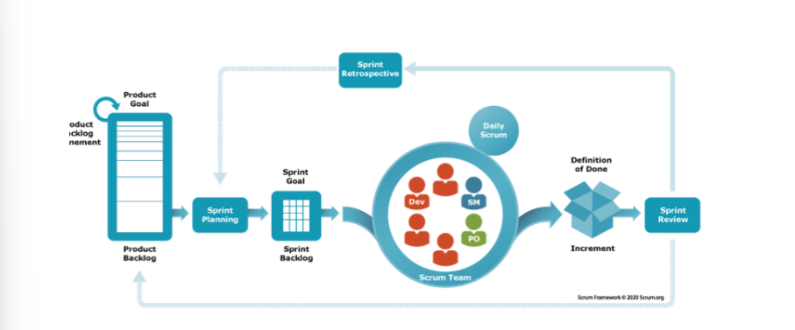

This project was developed using the Scrum model, which is part of the Agile framework for project development,

for the following reasons:

● The planning and documentation phases in advance allow large or changing teams to stay informed and work

towards a common goal.

● The force is structured and disciplined.

● Is simple to understand, follow and organise the tasks.

● Allows for easy implementation of early specification or design changes.

● Clearly define milestones and deadlines.

● Face to face meeting, online meeting.

● Work together to define and unify solutions.

### 2.2 Quality Management

To improve WeMealKit Project quality, we use the following approach:

* API convention:
* API paths must follow RestfulAPI conventions.
* Using suitable HTTP methods for each action.
* HTTP status code:
* 200, 201, 204: For success responses
* 400, 403, 404: For client error responses
* 500: For internal server error responses
* Error responses must include: Error code, Error name, Error details.
* Code convention:
* Team members must follow coding principles: SOLID, DRY,...
* Backend API folder structure must comply with Clean Architecture
* Team members must set meaningful names for packages, classes, methods, variables, constants,...
* Code comments must be included
* Testing
* CI/CD integration

***Figure 1. Github CI/CD***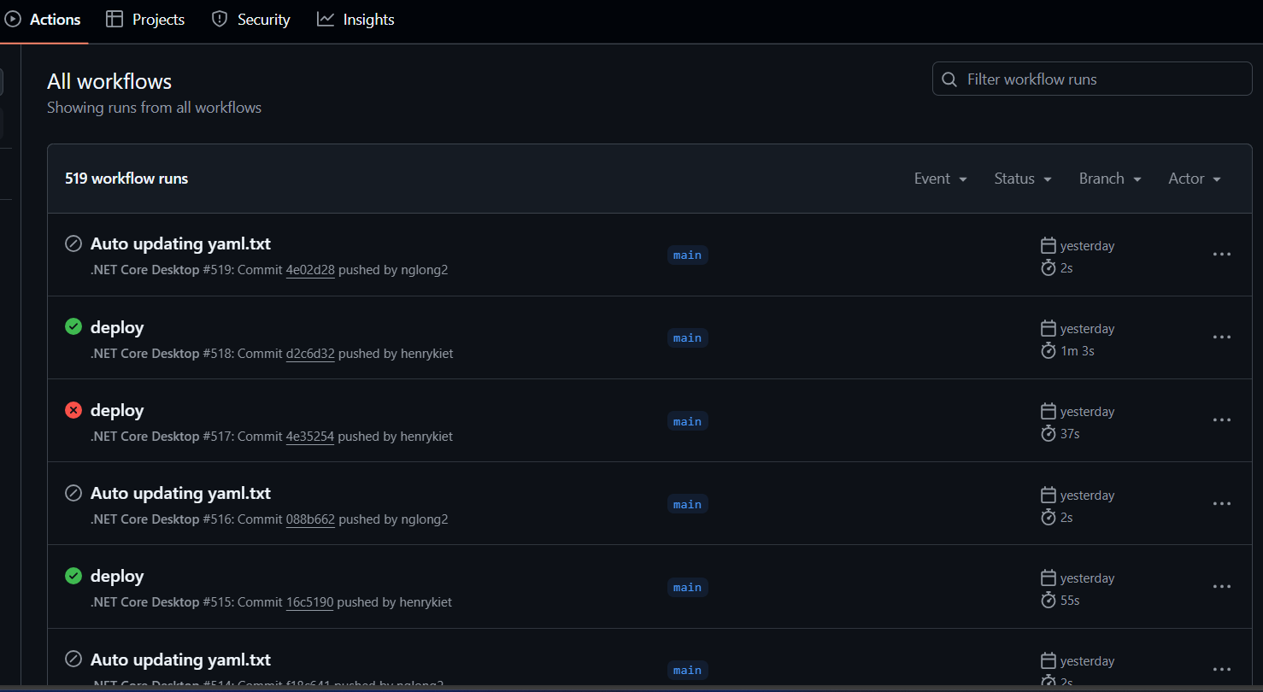

### 2.3 Training Plan

| ***N.o*** | ***Training Area*** | ***Participants*** | ***Duration*** | ***Waiver Criteria*** |
| --- | --- | --- | --- | --- |
| 1 | Project flow, Git | All team members | Week 1 - 3 days | Mandatory |
| 2 | C# Entity Framework | DanhLT, KietDT | Week 1 - 3 days | Mandatory |
| 3 | ReactJS, Typescript | KhanhVT, KietDT | Week 1 - 7 days | Mandatory |
| 4 | Flutter | LongNVH | Week 1 - 7 days | Mandatory |

## 3. Project Deliverables

| ***Sprint*** | ***Sprint objective*** | ***Duration*** | ***Deliverable*** |
| --- | --- | --- | --- |
| 1 | Project plan document, Technology Training | 14 days | Project planning, Technology Training |
| 2 | Design Document | 14 days | Architecture Design, Basic Design, Detail Design and Database Design |
| 3 | Build authentication, Deploy Back-end server | 14 days | Code & System test cases |
| 4 | Build Administrator features | 14 days | Code & System test cases |
| 5 | Build Staff features | 14 days | Code & System test cases |
| 6 | Build Manager features | 14 days | Code & System test cases |
| 7 | Build Customer features | 14 days | Code & System test cases |
| 8 | Build Shipper features | 14 days | Code & System test case |
| 9 | Test report, Guide document, Final Project Package | 14 days | Final code, documents and user manual guide |

## 

## 

## 4. Responsibility Assignments

### 4.1. Team & Structures

| ***Role*** | ***Full Name*** |
| --- | --- |
| Product Owner | Lê Thanh Danh |
| Scrum Master | Mrs. Thân Thị Ngọc Vân |
| Development team | * Lê Thanh Danh * Dương Tuấn Kiệt * Nguyễn Võ Hoàng Long * Võ Tuấn Khanh |

### 4.2. Roles & Responsibilities

| ***Role*** | ***Responsibilities*** |
| --- | --- |
| Product Owner | * Specify software requirements * Control and tracking the developing processes * Review products and documents * Evaluate and prioritise each develop process |
| Scrum Master | * Promoting open discussions and conflict resolution * Monitoring product and sprint backlogs * Conducting daily stand-up meetings, reviews, demos, and other project-related gatherings * Assisting team members with their tasks * Guiding the team on Scrum principles and best practices |
| Development team | * Assist in sprint planning and goal setting * Design database * Design system architecture * Design UI, prototypes * Implement code, testing, deploy products |

## 5. Project Communications

| ***Communication*** | ***Target*** | ***Purpose*** | ***Frequency*** | ***Method/Tool(s)*** |
| --- | --- | --- | --- | --- |
| Working in team | Team members | * Report working process. * Request team support. * Raise ideas or problems. | Everyday | * Zalo * Google meet * Face to face |
| Working with supervisor | Mrs. Thân Thị Ngọc Vân | * Review documentation. * Discuss system’s requirements. * Request for advice or feedback. * Demonstration * Check project’s progress | 1 time per week | * Face to face * Google Meet * Zalo |

## 6. Configuration Management

### 6.1 Document Management

Our team uses Google Drive for managing documents, sheets, and diagrams. We use the following tools to handling documents:

* **Google Docs** for document collaboration among team members.
* **Google Sheets** for data sheet collaboration among team members.
* **Draw.io** for diagram collaboration among team members.

### 6.2 Source Code Management

Our team uses **Github** for managing source code.

### 

### 

### 6.3 Tools & Infrastructures

| ***Type*** | ***Tools & Infrastructures*** |
| --- | --- |
| **Technologies** | * Dashboard website: ReactJS, Typescript * Mobile: Flutter * Backend: ASP.NET Core 8.0, Entity Framework Core |
| **Database** | Microsoft SQL Server Management 18 |
| **IDEs/Code Editors** | Android Studio, Visual Studio 2019/2022, Visual Studio Code |
| **Diagrams** | Draw.io |
| **Documents** | Google Docs, MS Office |
| **Deployment** | Github CI/CD, Docker, AWS, Vercel |
| **Source version control** | Github (Source codes), Google Drive (Documents) |

# III. Software Requirements Specification

## 1. Product Overview

WeMealKit system is a software system which helps people access new eating plans provided weekly. Customers can find a variety of recipes from different cultures all around the globe. Recipes divide into categories easy to find. They can create and manage their own personal plan and plans can be ordered in the form of raw ingredient packages. This document will describe software requirements listing features in the WeMealKit system.

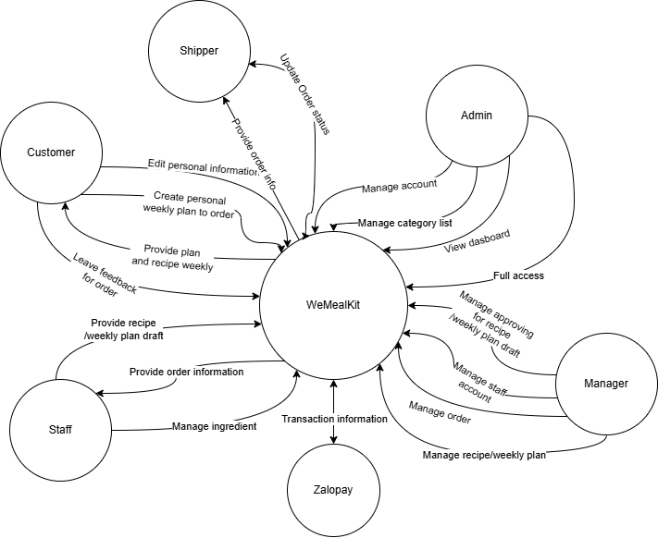

## 2. User Requirements

### 2.1 Actors

| ***N.o*** | ***Actor*** | ***Description*** |
| --- | --- | --- |
| 1 | Guest | Guest is an individual who possesses access to the WeMealKit mobile app without login. |
| 2 | Customer | Customer is an individual who possesses access to the WeMealKit mobile app, operating under the role of “Customer”. |
| 3 | Staff | Staff is an individual who processes access to the WeMealKit management web. Report, operating recipes and weekly plans under the role of “Staff”. This “Staff” with managerial functions, is a member of the system. |
| 4 | Shipper | Shipper is a staff member who will be responsible for delivering orders to customers. |
| 5 | Manager | Manager is an individual who processes access to the WeMealKit management web. This role will be incharge of viewing and confirming new recipes and weekly plans created by Staff. |
| 6 | Admin | Admin is an individual who processes access to the WeMealKit management web, operating under the role of “Admin”. This “Admin” has the ability to view the dashboard, manage food categories and is the admin of the system. |

### 2.2 Use Cases

#### 2.2.1 Diagram

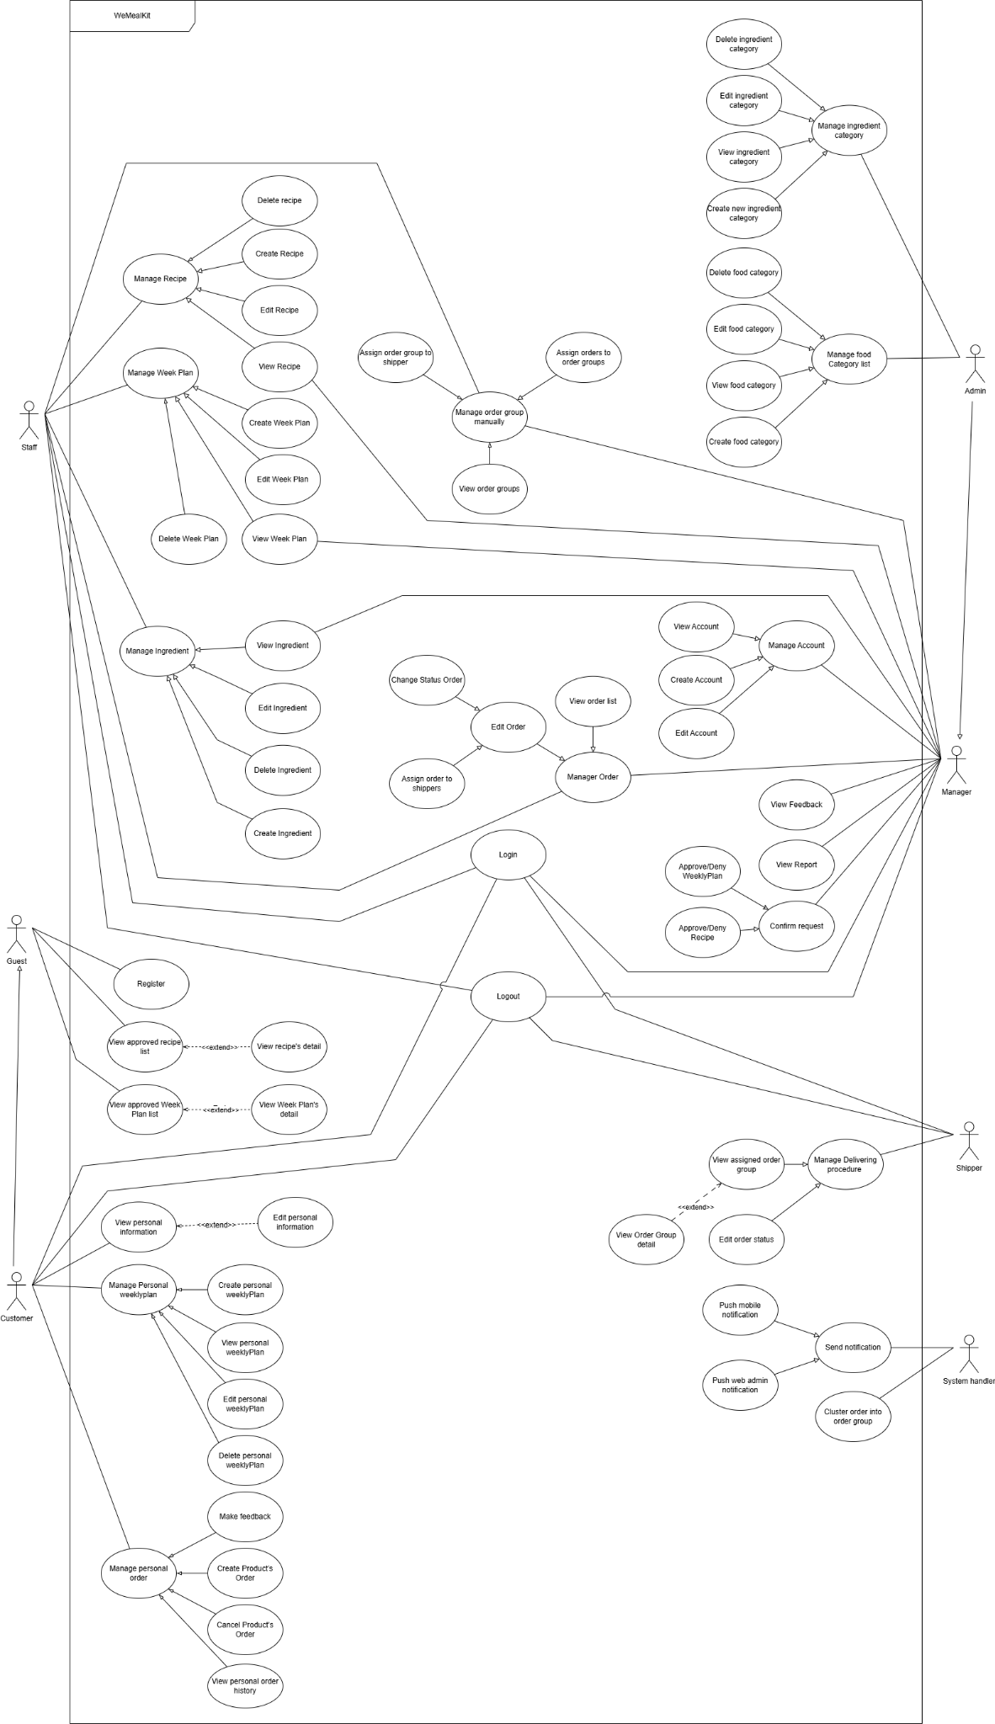[***Reference***](https://drive.google.com/file/d/1L0ecwKw6StnKN2OLNqGYFMHajXHr2P60/view?usp=sharing)

#### 2.2.2 Descriptions For Diagram

| **ID** | **Use Case** | **Actors** | **Use Case Description** |
| --- | --- | --- | --- |
| UC1 | Register | Guest | This use case allows the Guest to make new account on app and become a Customer |
| UC2 | Login | Customer, Staff, Manager, Admin, Shipper | This use case allows actors to login into system to perform authorised actions |
| UC3 | Logout | Customer, Staff, Manager, Admin, Shipper | This use case allows actors to logout from the system |
| UC4 | View recipe | Guest, Customer | This use case enables the Guest and Customer to search and view recipes in the WeMealKit app by recipe name, category |
| UC5 | View weekplan | Guest, Customer | This scenario allows a Guest, Customer to search and view weekly plans created by system |
| UC6 | View personal information | Customer | This use case allows users to view and edit their personal information |
| UC7 | Create personal weekplan | Customer | This use case allows the Customer to duplicate favourite weekly plans to make their own personal plans. |
| UC8 | View personal weekplan | Customer | Customer can view their personal plan |
| UC9 | Edit personal weekplan | Customer | Customer can edit their existing personal plan |
| UC10 | Delete personal weekplan | Customer | Customer can delete their chosen personal plan |
| UC11 | Create order | Customer | Customer can create new order |
| UC12 | Cancel order | Customer | Customer can cancel undelivered order |
| UC13 | View order history | Customer | Customer can view their buying history |
| UC14 | Make feedback from delivered order | Customer | Customer can make feedback about their delivered order |
| UC15 |  |  |  |
| UC16 | Create new ingredient | Staff | Staff can create new ingredient |
| UC17 | View ingredient | Staff, Manager | Staff can view current ingredient list |
| UC18 | Update ingredient | Staff | Staff can update chosen ingredient |
| UC19 | Delete ingredient | Staff | Staff can delete chosen ingredient |
| UC20 | View recipe | Staff, Manager | Staff and Manager can view current recipe list |
| UC21 | Create new Recipe | Staff | Staff can create new recipe |
| UC22 | Update recipe | Staff | Staff can update chosen recipe |
| UC23 | Delete recipe | Staff | Staff can delete chosen recipe |
| UC24 | View weekplan | Staff, Manager | Staff and Manager can view current weekplan list |
| UC25 | Create new weekplan | Staff | Staff can create new weekplan |
| UC26 | Update weekplan | Staff | Staff can update chosen weekplan |
| UC27 | Delete weekplan | Staff | Staff can delete chosen weekplan |
| UC28 | View order group list | Staff, Manager | Staff and Manager can view existing order group list |
| UC29 | Assign order to order group | Staff, Manager | Staff and Manager can assign new orders to order group |
| UC30 | Assign order group to shipper | Staff, Manager | Staff and Manager can assign order group to chosen shipper |
| UC31 | View order list | Staff, Manager | Staff and Manager can view current order list |
| UC32 | Change status order | Staff, Manager | Staff and Manager can edit order status based on specific situation |
| UC33 | Assign order to shipper | Staff, Manager | Staff and Manager can assign specific order to the chosen shipper |
| UC34 | Confirm request | Manager | Manager can confirm request (approve or deny) for newly created recipe/week plan |
| UC35 | Review report | Manager, Admin | Manager and Admin can view reports |
| UC36 | Review feedback | Manager, Admin | Manager and Admin can view Customer’s feedback to improve system in future |
| UC37 | Create new account | Manager, Admin | Manager and Admin can create new account |
| UC38 | View account list | Manager, Admin | Manager and Admin can view existing account list |
| UC39 | Edit account | Manager, Admin | Manager and Admin can edit chosen account |
| UC40 | View food category | Admin | Admin can view category |
| UC41 | Create new food category | Admin | Admin can create new food category |
| UC42 | Update food category | Admin | Admin can update chosen category |
| UC43 | Delete food category | Admin | Admin can delete category |
| UC44 | View ingredient category | Admin | Admin can view ingredient category |
| UC45 | Create new ingredient category | Admin | Admin can create new ingredient category |
| UC46 | Update ingredient category | Admin | Admin can update chosen ingredient category |
| UC47 | Delete ingredient category | Admin | Admin can delete chosen ingredient category |
| UC48 | Manage all account in system | Admin | Admin can manage all account exist in system |
| UC49 | View assigned order group | Shipper | Shipper can view his assigned order group to deliver order to Customer |
| UC50 | Edit assigned order status | Shipper | Shipper can change status of assigned order base on specific condition |
| UC51 | Push mobile notification | System handler | WeMealKit system automatically pushes notification to user |
| UC52 | Push web admin notification | System handler | WeMealKit system automatically pushes notification to user |
| UC53 | Assign order into order group | System handler | WeMealKit system will assign newly orders into pre-created order groups base on inputted radius |

## 3. Functional Requirements

### 3.1 System Functional Overview

#### 3.1.1 Screens Flow

##### **A. Staff Website Application**

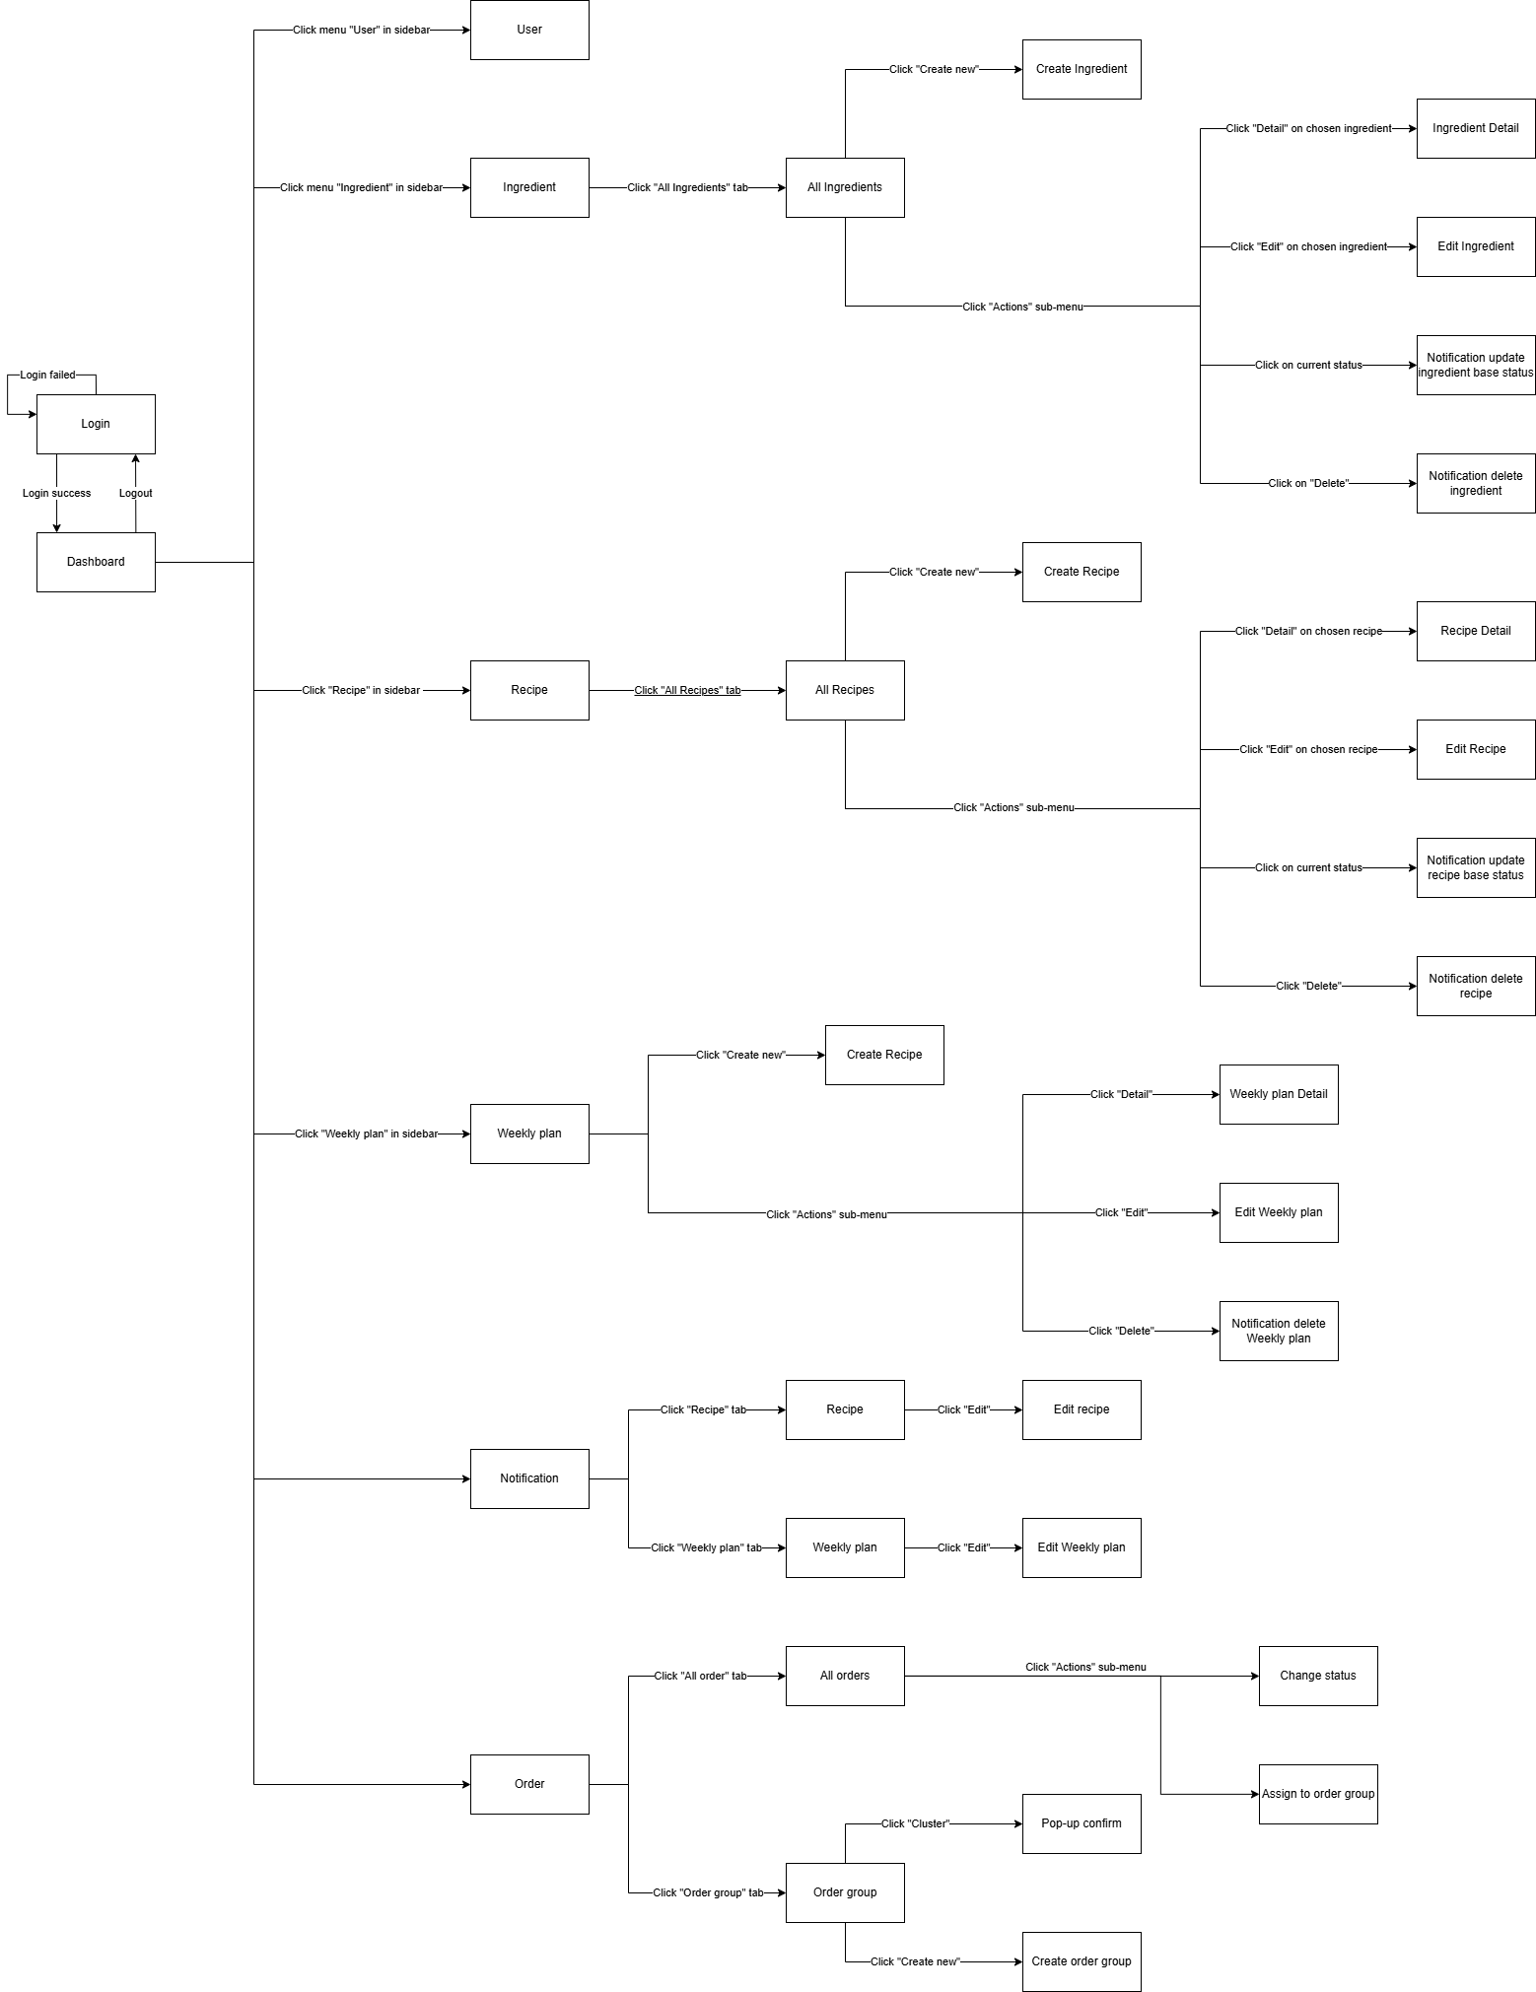[***Reference***](https://drive.google.com/file/d/1Vwf4PnUdvVMwnBOltdjAelBfN--SCPc7/view?usp=sharing)

##### **B. Management Website Application**

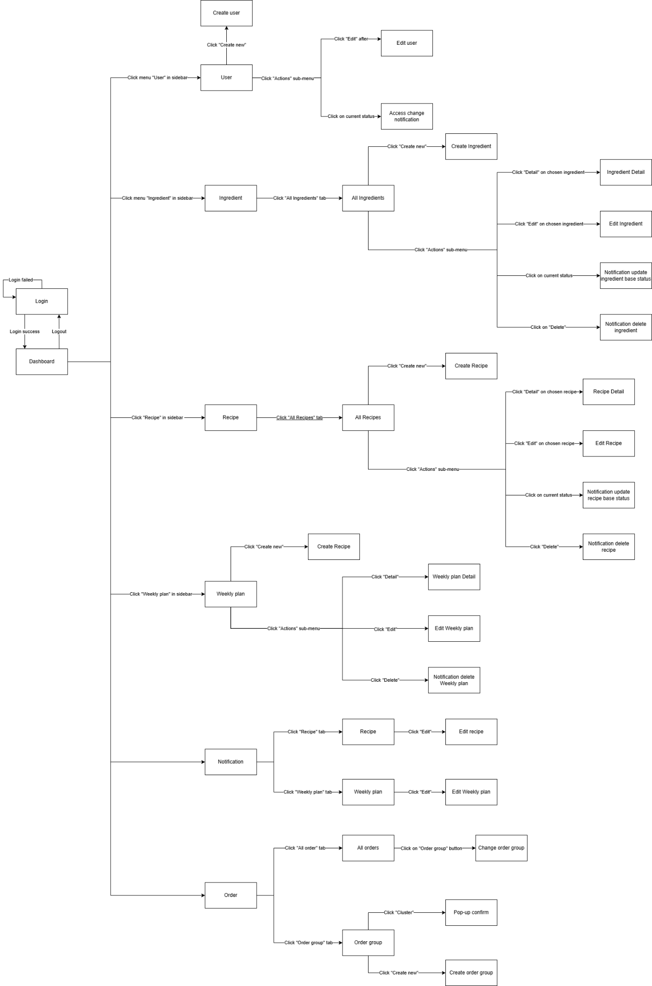[***Reference***](https://drive.google.com/file/d/1930dCgxLFMNLnV3KWVMwpZz5QwRS4Zev/view?usp=sharing)

##### **C. Admin Website Application**

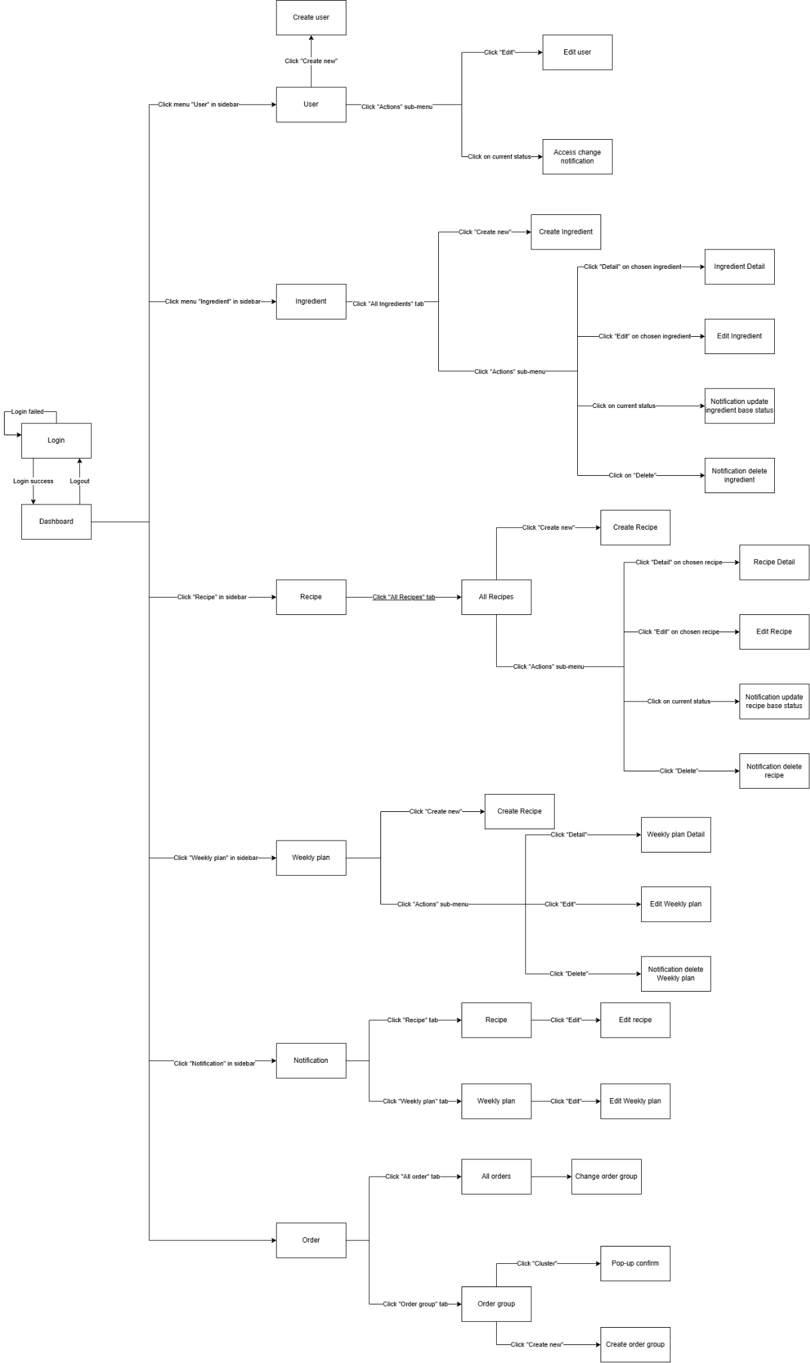

[***Reference***](https://drive.google.com/file/d/1CvK3C7S-ikrMQbT3LQtWAFmgLwzrm0lf/view?usp=sharing)

##### **D. Shipper Mobile Application**

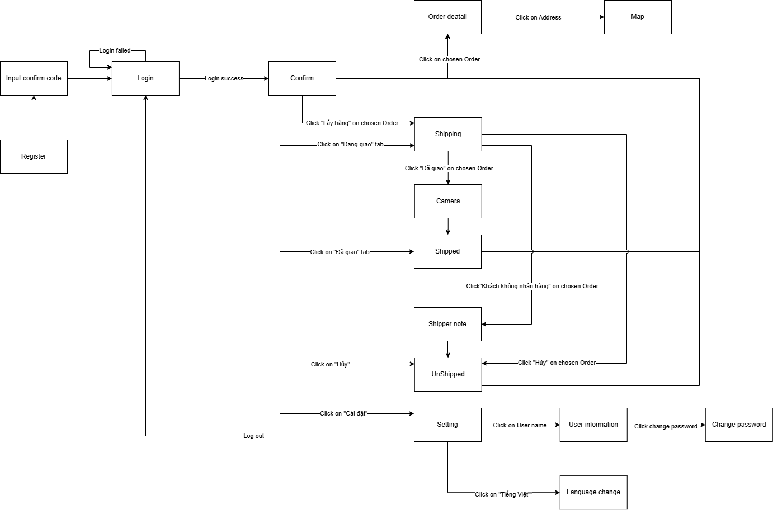[**Reference**](https://drive.google.com/file/d/1_CZvDhYZjdDmPBY22EHZKvQwDEMuUSnO/view?usp=sharing)

##### **E. Customer Mobile Application**

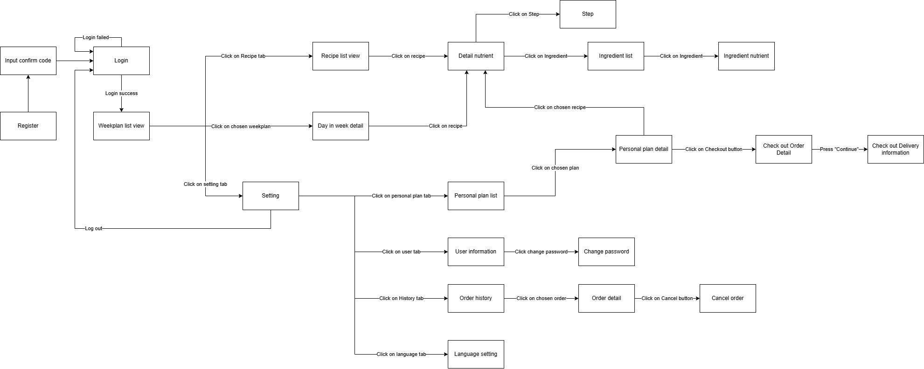

[**Reference**](https://drive.google.com/file/d/1RGkbcdeHXO7zOJKolfKP2C1nBiyh9Mo4/view?usp=sharing)

### 3.2 Functional Requirements

#### 3.2.1 Functional Requirements for Web admin

##### A. Authentication

#### 

| ***No*** | ***Actor*** | ***Function name*** | ***Purpose*** | ***Data requirements*** | ***Data validation*** | ***Business rules*** |
| --- | --- | --- | --- | --- | --- | --- |
| 1 | Administrator, Manager, Staff | Login website app | Login to web application | * Username * Password | * **Username**: * Type: test field (string) * **Password:** * Type: test field (string) * Length: 6 * Contains at least 1 Uppercase, 1 digit, 1 special character | BR-01  BR-02 |
| 2 | Customer, Shipper | Login mobile app | Login to WeMealKit mobile app | * Username * Password | * **Username:** * Type: text field (string) * **Password:** * Type: text field (string) * Length: 6 * Contains at least 1 Uppercase, 1 digit, 1 special character | BR-01  BR-02 |
| 3 | Customer | Verify code | Verify account with verification code | Verify code | **Verify code:**   * Type: text field * Length: 6 * Random code including Uppercase, Lowercase letter, digit | BR-03 |

##### B. Account Management

| ***No*** | ***Actor*** | ***Function name*** | ***Purpose*** | ***Data requirements*** | ***Data validation*** | ***Business rules*** |
| --- | --- | --- | --- | --- | --- | --- |
| 1 | Administrator, Manager, Staff | View Account list | View list of all account on system |  |  | BR-04 |
| 2 | Administrator, Manager | Update account status | Edit account status | User Id | **User Id:**   * Type: text(string). Fit with GUID format | BR-04  BR-11 |
| 3 | Administrator, Manager, Staff | Search account with Username | Search account with Username | Username | **Username:**   * Type: text field(string) | BR-04 |
| 3 | Manager  Administrator | Update account info | Update account info | * Email * First Name * Last Name * Role * Gender * Address * Phone | * **Email:** * Type: text field (string) * Validate with EmailValidator (Fluentvalidation)   Name:   * Type: text field (string) * **Role:** * Type: Dropdown list * Value: Shipper, Customer, * **Gender:** * Type: Switch * Value: Male, Female * **Address:** * Type: text * **Phone:** * Type: text * Must contains only digit | BR-04  BR-05  BR-06 |
| 4 | Manager  Administrator | Create new account | Create new account for user in system | * Email * First Name * Last Name * Role * Gender * Address * Phone | * **Email**: * Type: text field (string) * Validate with EmailValidator (Fluentvalidation) * **Name:** * Type: text field (string) * **Role:** * Type: Dropdown list * Value: Shipper, Customer, * **Gender:** * Type: Switch * Value: Male, Female * **Address**: * Type: text * **Phone:** * Type: text * Must contains only digit | BR-04  BR-06  BR-09  BR-10 |

##### 

##### C. Category Management

| ***No*** | ***Actor*** | ***Function name*** | ***Purpose*** | ***Data requirements*** | ***Data validation*** | ***Business rules*** |
| --- | --- | --- | --- | --- | --- | --- |
| 1 | Administrator  Manager | View Ingredient category list | View Ingredient category list in web admin |  |  | BR-04 |
| 2 | Administrator  Manager | View Recipe category list | View Recipe category list in web admin |  |  | BR-04 |
| 3 | Administrator  Manager | Search Recipe category | Search Recipe category by name | Recipe category name keyword | **Category name:**   * Type: text field (string) | BR-04 |
| 4 | Administrator  Manager | Search Ingredient category | Search Ingredient category by name | Ingredient category name keyword | **Category name:**   * Type: text field (string) | BR-04 |
| 5 | Administrator  Manager | Update Ingredient category status | Change Ingredient category’s status | Category Id | **Category Id:**   * Type: text field (string) * Must fit with GUID format | BR-04  BR-11 |
| 6 | Administrator  Manager | Update Recipe category status | Change Recipe category’s status | Category Id | **Category Id:**   * Type: text field (string) * Must fit with GUID format | BR-04  BR-11 |
| 7 | Administrator  Manager | Create Ingredient category | Create new Ingredient category | * Name * Description * Status | * **Name:** * Type: text field (string) * **Description:** * Type: text field (string) * **Status:** * Type: switch * Value: Available; Unavailable | BR-04  BR-09 BR-10  BR-12 |
| 8 | Administrator  Manager | Create Recipe category | Create new Recipe category | * Name * Description * Type | * **Name:** * Type: text field (string) * **Description:** * Type: text field (string) * **Type:** * Type: drop down * Value: Nation; Cooking Method; Classify; Meal in day | BR-04  BR-09  BR-10  BR-12  BR-41 |
| 9 | Administrator  Manager | Delete Ingredient category | Remove Ingredient category from system | Category Id | **Category Id:**   * Type: text field (string) * Must fit with GUID format | BR-04  BR-11 |
| 10 | Administrator  Manager | Delete Recipe category | Remove Recipe category from system | Category Id | **Category Id:**   * Type: text field (string) * Must fit with GUID format | BR-04  BR-11 |
| 11 | Administrator  Manager | Update Ingredient category info | Update information for Ingredient category | * Category Id * Name * Description | * **Category Id:** * Type: text field (string) * Must fit with GUID format * **Name:** * Type: text field (string) * **Description:** * Type: text field (string) | BR-04  BR-10  BR-11  BR-12  BR-13 |
| 12 | Administrator  Manager | Update Recipe category info | Update information for Recipe category | * Category Id * Name * Description * Type | * **Category Id:** * Type: text field (string) * Must fit with GUID format * **Name:** * Type: text field (string) * **Description:** * Type: text field (string) * **Type:** * Type: drop down * Value: Nation; Cooking Method; Classify; Meal in day | BR-04  BR-10  BR-11  BR-12  BR-13  BR-41 |

##### D. Ingredient Management

| ***No*** | ***Actor*** | ***Function name*** | ***Purpose*** | ***Data requirements*** | ***Data validation*** | ***Business rules*** |
| --- | --- | --- | --- | --- | --- | --- |
| 1 | Administrator  Manager  Staff | View Ingredient list | View Ingredients on web admin |  |  | BR-04 |
| 2 | Administrator  Manager  Staff | View Ingredient detail | View Ingredient detail information on web admin |  |  | BR-04 |
| 3 | Administrator  Manager  Staff | Search and filter Ingredient by name | Search Ingredient by name, filter by status on web admin | Ingredient name keyword | **Keywork:**   * Type: text field (string) | BR-04 |
| 4 | Administrator  Manager  Staff | Update Ingredient status | Change base status of Ingredient | Ingredient Id | **Ingredient Id:**   * Type: text field (string) * Must fit with GUID format | BR-04  BR-11 |
| 5 | Administrator  Manager  Staff | Update Ingredient info | Update Ingredient information | * Ingredient Id   + General info: * Category * Name * Image * Price * Unit * Packaging Method * Preservation Method   + Nutrient info: * Calories * Fat * Saturated Fat * Carbohydrate * Protein * Sugar * Dietary Fiber * Sodium | * **Ingredient Id:** * Type: text field (string) * Must fit with GUID format * **Category:** * Type: drop down * **Name** * Type: text field (string) * **Image:** * Type: text field (string) * **Price:** * Type: number * **Unit:** * Type: drop down * **Packaging Method:** * Type: text field (string) * **Preservation Method:** * Type: text field (string) * **Nutrient info:** * Type: float number * Can be left empty | BR-04  BR-11  BR-12  BR-13  BR-20 |
| 6 | Administrator  Manager  Staff | Create Ingredient | Create new Ingredient on web admin | * General info: * Category * Name * Image * Price * Unit * Packaging Method * Preservation Method * Nutrient info: * Calories * Fat * Saturated Fat * Carbohydrate * Protein * Sugar * Dietary Fiber * Sodium | * **Category:** * Type: drop down * **Name:** * Type: text field (string) * **Image:** * Type: text field (string) * **Price:** * Type: number * **Unit**: * Type: drop down * **Packaging Method:** * Type: text field (string) * **Preservation Method:** * Type: text field (string) * **Nutrient info:** * Type: float number * Can be left empty | BR-04  BR-09  BR-10  BR-12 |
| 7 | Administrator  Manager  Staff | Delete Ingredient | Delete Ingredient from system | Ingredient Id | * **Ingredient Id:** * Type: text field (string) * Must fit with GUID format | BR-04  BR-11 |

##### 

##### 

##### E. Recipe Management

| ***No*** | ***Actor*** | ***Function name*** | ***Purpose*** | ***Data requirements*** | ***Data validation*** | ***Business rules*** |
| --- | --- | --- | --- | --- | --- | --- |
| 1 | Administrator  Manager  Staff | View Recipe list | View recipes on web admin |  |  | BR-04 |
| 2 | Administrator  Manager  Staff | View Recipe detail | View Recipe detail information |  |  | BR-04 |
| 3 | Administrator  Manager  Staff | Search and filter Recipe on web admin | Search Recipe by name, filter by status, ServingSize, Popularity, ProcessStatus, Base status, Created Person | Recipe name keyword | **Keywork:**   * Type: text field (string) | BR-04 |
| 4 | Administrator  Manager  Staff | Update Recipe status | Change base status of recipe | Recipe Id | **Recipe Id**:   * Type: text field (string) * Must fit with GUID format | BR-04  BR-11 |
| 5 | Administrator  Manager  Staff | Update Recipe info | Update Recipe information | * Recipe Id * General info: * Category * Image * Name * Serving Size * Cooking Time * Difficulty * Description * Ingredient info: * Ingredient Id * Amount * Step info: * Step name * Description * Media Url * Image Link | * **Recipe Id**: * Type: text field (string) * Must fit with GUID format * **General info**:   + ***Category:*** * Type: drop down * Value: Nation; Cooking Method; Classify; Meal in day * Must have all four different category type   + ***Name:*** * Type: text field (string)   + ***Serving size:*** * Type: number   Cooking time:   * Type: number   + ***Difficulty:*** * Type: drop down * Value: Normal; Medium; Hard   + ***Description:*** * Type: text field (string) * **Ingredient info**:   + ***Ingredient Id:*** * Type: text (string) * Must fit with GUID format   + ***Amount*:** * Type: number * **Step info:**   + ***Step name:*** * Type: text (string)   + ***Description:*** * Type: text (string)   + ***Media Url:*** * Type: text (string)   + ***Image Link:*** * Type: text (string) | BR-04  BR-11  BR-12  BR-13  BR-15  BR-41 |
| 6 | Administrator  Manager | Confirm Recipe | Processing confirmingrecipe request | * Recipe Id * Process Status * Note | * **Recipe Id**: * Type: text field (string) * Must fit with GUID format * **Process Status:** * Value: Approved; Deny * **Note:** * Type: text (string) * Only need when Process Status is Deny | BR-04  BR-09  BR-11 BR-10  BR-14  BR-18 |
| 7 | Administrator  Manager  Staff | Create Recipe | Create new recipe | * **General info:**   + Category   + Image   + Name   + Serving Size   + Cooking   + Time   + Difficulty   + Description * **Ingredient info:** * Ingredient Id * Amount * **Step info:** * Step name * Description * Media Url * Image Link | * **General info**:   + ***Category:*** * Type: drop down * Value: Nation; Cooking Method; Classify; Meal in day * Must have all four different category type   + ***Name:*** * Type: text field (string)   + ***Serving size:*** * Type: number   Cooking time:   * Type: number   + ***Difficulty:*** * Type: drop down * Value: Normal; Medium; Hard   + ***Description:*** * Type: text field (string) * **Ingredient info**:   + ***Ingredient Id:*** * Type: text (string) * Must fit with GUID format   + ***Amount*:** * Type: number * **Step info:**   + ***Step name:*** * Type: text (string)   + ***Description:*** * Type: text (string)   + ***Media Url:*** * Type: text (string)   + ***Image Link:*** * Type: text (string) | BR-04  BR-09  BR-10  BR-12  BR-15  BR-41 |
| 8 | Administrator  Manager  Staff | Delete Recipe | Remove Recipe from system | Recipe Id | **Recipe Id:**   * Type: text field (string) * Must fit with GUID format | BR-04  BR-11 |

##### F. Weekplan Management

| ***No*** | ***Actor*** | ***Function name*** | ***Purpose*** | ***Data requirements*** | ***Data validation*** | ***Business rules*** |
| --- | --- | --- | --- | --- | --- | --- |
| 1 | Administrator  Manager  Staff | View Weekly Plan list on web admin | View Weekly plan on web admin |  |  | BR-04 |
| 2 | Administrator  Manager  Staff | View Weekly Plan detail | View detail information of weekly plan |  |  | BR-04 |
| 3 | Administrator  Manager  Staff | Search Weekly Plan on web admin | Search Weekly Plan by name | Keywork | **Keywork**   * Type: text (string) | BR-04 |
| 4 | Administrator  Manager  Staff | Update Weekly Plan information | Update Weekly Plan information | * Week plan Id * Image * Title * Description * Recipes: * Recipe Id * Amount | * **Week plan Id**: * Type: text field (string) * Must fit with GUID format * **Image**: * Type: text (string)   Title:   * Type: text (string) * **Description:** * Type: text (string) * **Recipes:**   + ***Recipe Id:*** * Type: GUID   + ***Amount:*** * Type: number | BR-04  BR-11  BR-13  BR-16  BR-17  BR-19 |
| 5 | Administrator  Manager | Confirm Weekly plan | Processing new weekly plan request | * Weekplan Id * Process Status * Note | * ***Week plan Id:*** * Type: text field (string) * Must fit with GUID format * **Process Status:** * Value: Approved; Deny * **Note:** * Type: text (string) * Only need when Process Status is Deny | BR-04  BR-11  BR-14  BR-16  BR-18 |
| 6 | Administrator  Manager  Staff | Create Weekly Plan | Create new weekly plan | * Image * Title * Description * Recipes: * Recipe Id * Amount | * **Image**: * Type: text (string) * **Title:** * Type: text (string) * **Description**: * Type: text (string) * **Recipes**:   + ***Recipe Id:*** * Type: GUID   + ***Amount:*** * Type: number | BR-04  BR-09  BR-17  BR-16  BR-11 BR-10  BR-19 |
| 7 | Administrator  Manager  Staff | Delete Weekly Plan | Remove weekly plan from system | Week play Id | **Week plan Id**:   * Type: text field (string) * Must fit with GUID format | BR-04  BR-11 |

##### 

##### G. Order Management

| ***No*** | ***Actor*** | ***Function name*** | ***Purpose*** | ***Data requirements*** | ***Data validation*** | ***Business rules*** |
| --- | --- | --- | --- | --- | --- | --- |
| 1 | Administrator  Manager  Staff | View Order list | View Order list on web admin |  |  | BR-04 |
| 2 | Administrator  Manager  Staff | Search Order | Search Order by delivery address |  |  | BR-04 |
| 3 | Administrator  Manager  Staff | Cluster orders | Group orders into Order group to optimise delivering progress |  |  | BR-04  BR-21  BR-22  BR-39 |
| 4 | Administrator  Manager  Staff | Search order | Search Order with delivery address | Keyword | **Keyword:**   * Type: text (string) | BR-04 |
| 5 | Administrator  Manager  Staff | Assign Order to specific Order group | Link one Order to a specific order group | * Order Id * Order Group Id | * **Order Id:** * Type: text field (string) * Must fit with GUID format * **Order group Id:** * Type: text field (string) * Must fit with GUID format | BR-04  BR-11  BR-22 BR-26  BR-39 |
| 6 | Administrator  Manager  Staff | Change order status | Change order status make from web, Based on specific situation | * Order Id * Status | * **Order Id:** * Type: text field (string) * Must fit with GUID format * **Status:** * Value: Confirm; Cancelled; Refund | BR-04  BR-11  BR-27  BR-28  BR-29  BR-31  BR-32  BR-33 |

##### 

##### H. Order Group Management

| ***No*** | ***Actor*** | ***Function name*** | ***Purpose*** | ***Data requirements*** | ***Data validation*** | ***Business rules*** |
| --- | --- | --- | --- | --- | --- | --- |
| 1 | Administrator  Manager  Staff | View group list | View order group list |  |  | BR-04 |
| 2 | Administrator  Manager  Staff | View order group detail | View grouped orders in Order group |  |  | BR-04 |
| 3 | Administrator  Manager  Staff | Create Order group | Create new order group | * Shipper Id * Longitude * Latitude * Location | * **Shipper Id** * Type: text field (string) * Must fit with GUID format * **Longitude:** * Type: float number * **Latitude**: * Type: float number * **Location:** * Type: text (strong) | BR-04  BR-10  BR-11  BR-34 |
| 4 | Administrator  Manager  Staff | Edit Order group | Edit order group including group area and linked shipper | * Order group Id * Shipper Id * Longitude * Latitude * Location | * **Order group Id:** * Type: text field (string) * Must fit with GUID format * **Shipper Id** * Type: text field (string) * Must fit with GUID format * **Longitude:** * Type: float number * **Latitude:** * Type: float number * **Location:** * Type: text (strong) | BR-04  BR-11 BR-10 |
| 5 | Administrator  Manager  Staff | Change Order group status | Change order group status | Order group Id | **Order group Id:**   * Type: text field (string) * Must fit with GUID format | BR-04 |
| 6 | Administrator  Manager  Staff | Delete Order group | Remove order group from the system | Order group Id | **Order group Id:**   * Type: text field (string) * Must fit with GUID format | BR-04 |

#### 

#### 3.2.2 Functional Requirements on Mobile application

##### A. Customer Mobile Application

| ***No*** | ***Actor*** | ***Function name*** | ***Purpose*** | ***Data requirements*** | ***Data validation*** | ***Business rules*** |
| --- | --- | --- | --- | --- | --- | --- |
| 1 | Guest | Register | Make new account | * Email * Password * Confirm password * First name * Last name * Phone number | * **Email:** * Type: text field (string) * Validate with EmailValidator (Fluentvalidation) * **Password:** * Type: text field (string) * Length: 6 * Contains at least 1 Uppercase, 1 digit, 1 special character * **Confirm password:** * Type: text field (string) * Length: 6 * Contains at least 1 Uppercase, 1 digit, 1 special character * **Must equal to Password** * First name; Last name: * Type: text (string) * **Phone number:** * Type: text (string) * Must contain only digit * Length: 10 | BR-05  BR-06  BR-08  BR-10 |
| 2 | Guest  Customer | View Weekly Plan list | View available Weekly Plan | Data show must have Base status is Available |  | BR-38 |
| 3 | Guest  Customer | View Recipe list | View available Recipe | * Data show must have Process status is Approved * Data show must have Base status is Available |  | BR-37 |
| 4 | Guest  Customer | Filter Weekly Plan on mobile app | Filter by status, ServingSize, Popularity, ProcessStatus, Base status, Created Person |  |  | BR-37 |
| 5 | Guest  Customer | Search and filter Recipe on mobile app | Search Recipe by name and filter with keyword on mobile app |  |  | BR-38 |
| 6 | Guest  Customer | View Weekly Plan detail | View recipe including in weekplan |  |  | BR-38 |
| 7 | Guest  Customer | View Recipe detail | View detail information about recipe |  |  | BR-37 |
| 8 | Customer | View Personal Weekly Plan list | View personal Week plan list to make order  Data show must have plan link with Customer ID | Customer Id | **Customer Id:**   * Type: text field (string) * Must fit with GUID format | BR-04  BR-37  BR-38 |
| 9 | Customer | Create Personal WeeklyPlan | Create personal plan use for ordering  Max number of week plans per customer is 5 | Week plan Id | **Weekplan Id:**   * Type: text field (string) * Must fit with GUID format | BR-04  BR-38 |
| 10 | Customer | View personal information | View personal information |  |  | BR-04 |
| 11 | Customer | Change password | Change password | * Customer Id * Old password * New password * Confirm new password | * **Customer Id:** * Type: text field (string) * Must fit with GUID format * **Old password:** * Type: text field (string) * Length: 6 * Contains at least 1 Uppercase, 1 digit, 1 special character * **New password:** * Type: text field (string) * Length: 6 * Contains at least 1 Uppercase, 1 digit, 1 special character * **Confirm new password:** * Type: text field (string) * Length: 6 * Contains at least 1 Uppercase, 1 digit, 1 special character * Must equal to Password | BR-04  BR-08 |
| 12 | Customer | Change family member number | Change the prefix family member. Help in ordering progress | * Customer Id * Family number | * **Customer Id:** * Type: text field (string) * Must fit with GUID format * **Family number:** * Type: digit * Value: from 1 to 10 | BR-04  BR-09 |
| 13 | Customer | Make order | Make order | * Customer Id * Weekplan Id * Receive name * Receive phone * Note * Img * Address * Total price * Longitude * Latitude * Transaction type * Recipe list | * **Customer Id:** * Type: text field (string) * Must fit with GUID format * **Week plan Id:** * Type: text field (string) * Must fit with GUID format * Receive name: String * Receive phone: String. * Only digit * Length: 10 * **Note:** * String * Can be empty * **Address:** * String * **Total price:** * Float number * **Longitude; Latitude:** * FLoat number * **Transaction type:** * Value: COD; ZaloPay * **Recipe list:** * List of recipe Id * Recipe must be available | BR-04  BR-40 |
| 14 | Customer | View Order history | View order history | Customer Id | **Customer Id:**   * Type: text field (string) * Must fit with GUID format | BR-04  BR-11 |
| 15 | Customer | Cancel order | Cancel order | * Order Id * Order status | * **Order Id:** * Type: text field (string) * Must fit with GUID format * **Order status:** * Value : Cancel | BR-04  BR-11  BR-28  BR-29 |

##### B. Shipper Mobile Application

| ***No*** | ***Actor*** | ***Function name*** | ***Purpose*** | ***Data requirements*** | ***Data validation*** | ***Business rules*** |
| --- | --- | --- | --- | --- | --- | --- |
| 1 | Shipper | View assigned order list | View assign order list to prepare for delivering procedure |  |  | BR-04 |
| 2 | Shipper | View assigned order detail | View Order detail |  |  | BR-04 |
| 3 | Shipper | Change order status | Change order status based on specific situation | * OrderId * Order status * Shipper note * Img | * **Order Id:** * Type: text field (string) * Must fit with GUID format * **Order status:** * Value : Shipping; Unshippied; Shipped * **Shipper note:** * String * Must have if shipper change order status to Unshipped Img: * String * Must have if shipper change order status to Shipped | BR-04  BR-23  BR-24  BR-25  BR-30 |
| 4 | Shipper | View personal information | View personal information |  |  | BR-04 |
| 5 | Shipper | Change password | Change password | * Shipper Id * Old password * New password * Confirm new password | * **Shipper Id:** * Type: text field (string) * Must fit with GUID format * **Old password:** * Type: text field (string) * Length: 6 * Contains at least 1 Uppercase, 1 digit, 1 special character * **New password:** * Type: text field (string) * Length: 6 * Contains at least 1 Uppercase, 1 digit, 1 special character * **Confirm new password:** * Type: text field (string) * Length: 6 * Contains at least 1 Uppercase, 1 digit, 1 special character * Must equal to Password | BR-04  BR-08 |

## 

## 4. Non-Functional Requirements

### 4.1 External Interfaces

### 4.2 Quality Attributes

#### 4.2.1 Usability

* All text, alerts, notification for front-end user on WeMealKit mobile app should be written in Vietnamese
* WeMealKit mobile application should be convenient and easy for end-users and to use without training.

#### 4.2.2 Probability

* WeMealKit mobile application should work with Android devices
* WeMealKit web admin should work with Chrome, Chrome-based browser and MsEdge as well

#### 4.2.3 Security

* Before being saved to database, all Input data should be verified
* Each role of users has specific permission to interact with the system.

## 5. Requirement Appendix

### 5.1 Business Rules

| **ID** | **Business Rule** |
| --- | --- |
| BR-01 | *Login Access token last for 7 days* |
| BR-02 | *WeMealKit system use JWT token for managing authenticated sessions* |
| BR-03 | *Verify code is created randomly every times user need verify code* |
| BR-04 | *Users must be authenticated to proceed this action* |
| BR-05 | *Email must merge with email format* |
| BR-06 | *Phone number's length is 10, only digit* |
| BR-07 | *Staff can not make change with Categories* |
| BR-08 | *Password must have at least 6 characters length, Including 1 upper case, 1 lowercase and 1 digit* |
| BR-09 | *Enum value must inclusive in Prefix values pool* |
| BR-10 | *No field is allowed to be null here* |
| BR-11 | *Id must fit with GUID format* |
| BR-12 | *Name can not duplicate with existing one* |
| BR-13 | *Old data can keep remained if it is no need to change* |
| BR-14 | *Confirm Deny must come with a note* |
| BR-15 | *System must show Recipe that need confirmation on Notification tab* |
| BR-16 | *System must show Weekly plan that need confirmation on Notification tab* |
| BR-17 | *Title can not duplicate with existing one* |
| BR-18 | *Confirmed information and status must show on Notification tab for staff to view and edit* |
| BR-19 | *Recipe list must come with at least 10 individual ID* |
| BR-20 | *Recipe which link with this Ingredient must be updated automatically* |
| BR-21 | *Order that come to be grouped by cluster algorithm need to be at status Processing* |
| BR-22 | *Order after been grouped will change status to Confirm excluding orders that transaction type is Zalopay and transaction's status is Pending* |
| BR-23 | *Order's status must be Confirm before change to Shipping* |
| BR-24 | *Order's status change to UnShipped must come with a Shipper note* |
| BR-25 | *Order's status change to Shipped must come with an confirm image took by shipper* |
| BR-26 | *Order can not change to other order group if Its status is Shipping* |
| BR-27 | *Order's status can change from Unshipped to Confirm to re do delivering procedure* |
| BR-28 | *Order's status can change from Processing to Canceled* |
| BR-29 | *Order's status can change from Unshipped to Canceled* |
| BR-30 | *Order's status can change from Shipping to Shipped* |
| BR-31 | *If Order status is Canceled, and Its transaction status is PAID. Then This order need to be refund* |
| BR-32 | *If Order status is Shipped, and Its transaction status is PAID. Then this order can still be refund within 4 days after delivered* |
| BR-33 | *Order is considered to be done when Its status changes Delivered or It is 4 days since status changed to Shipped. No more action is needed on this order* |
| BR-34 | *One Order group can only link to one Shipper at a time* |
| BR-35 | *Recipe and Weekly plan status must be Approved that it is able change Base status to Available* |
| BR-36 | *Weekly plans those are Customer personal plans can not be proceed if it is not the owner* |
| BR-37 | *Recipe must have Process status is Approved and Base status is Available then It is able to show on mobile app* |
| BR-38 | *Weekly plan must have Base status is Available then It is able to show on mobile app* |
| BR-39 | *Status of order group must be Available then Its is able to make order cluster* |
| BR-40 | *Longitude and Latitude will be get by using automatic google map api* |
| BR-41 | *Food category type must be fit with the prefix values pool. Which are “Nation”; “Classify”; “Cooking Method”; “Meal In Day”* |

### 5.2 Common Requirements

| **No** | **Function name** | **Purpose** | **Data requirement** | **Response** |
| --- | --- | --- | --- | --- |
| 1 | Show notification to WeMealKit web admin, WeMealKit mobile app automatically and periodically | Notify users when a certain task is performed such as staff’s account, order is created, order is overtime |  | Notification |

### 5.3 Application Messages List

| **Message code** | **Message type** | **Context** | **Content** |
| --- | --- | --- | --- |
| MSG-01 | Email | Email to get verify code | Confirm Mail, Đoạn code này dùng để xác minh tài khoản trong hệ thống WEMEALKIT: |
| MSG-02 | Email | Account has been deleted | "Xóa tài khoản" , "Tài khoản của bạn với vai trò * đã được bỏ khỏi hệ thống ! Liên hệ bộ phận chăm sóc khách hàng để được hỗ trợ. |
| MSG-03 | Toast notification | Email verify success | Email xác thực thành công |
| MSG-04 | Toast notification | Email has been used | Email này đã được sử dụng |
| MSG-05 | Toast notification | Email not verify yet | Email chưa được xác nhận |
| MSG-06 | Toast notification | Create new data success | Tạo * thành công |
| MSG-07 | Toast notification | Create new data unsuccess | Tạo * không thành công |
| MSG-08 | Toast notification | Update data success | Cập nhật * thành công |
| MSG-09 | Toast notification | Update data unsuccess | Cập nhật * không thành công |
| MSG-10 | Toast notification | Change status data success | Chuyển * thành công |
| MSG-11 | Toast notification | Change status data unsuccess | Chuyển * không thành công |
| MSG-12 | Toast notification | Remove data from system success | Xóa * thành công |
| MSG-13 | Toast notification | Remove data from system unsuccess | Xóa * không thành công |
| MSG-14 | Toast notification | Data input not valid | * không đúng |
| MSG-16 | Toast notification | Admin and Manager create new account | Tạo user * thành công với mật khẩu mặc định (User123@) |
| MSG-17 | Toast notification | Data are not the same when compared | * và * không khớp nhau |
| MSG-18 |  | Duplicated name | Trùng tên |
| MSG-19 | Toast notification | Input wrong format | * sai format |
| MSG-20 | Toast notification | Order not done yet | Đơn hàng chưa hoàn thành |
| MSG-21 | Toast notification | Customer create new order | Tạo đơn hàng thành công |
| MSG-22 | Toast notification | Input password not fit with condition | Mật khẩu chứa ít nhất 1 kí tự in hoa, 1 kí tự thường, 1 số, dài ít nhất 6 kí tự |
| MSG-23 | Toast notification | Customer create new personal success | Thêm vào kế hoạch cá nhân thành công |
| MSG-24 | Toast notification | Customer reach out of personal weekplan slot | Đã |
| MSG-25 | Confirm note | Customer create his new personal plan | Bạn có chắc muốn cập nhật kế hoạch |
| MSG-26 | Toast notification | Customer update personal plan success | Cập nhật thành công |
| MSG-27 | Toast notification | Customer and Shipper change password success | Đổi mật khẩu thành công |

# IV. Software Design Description

## 1. System Design

### 1.1 System Architecture

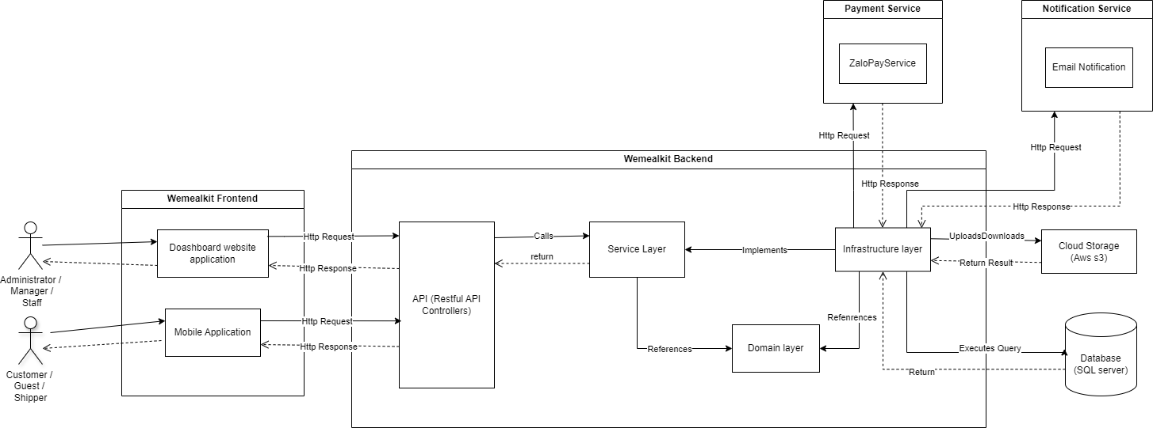

| **N.o** | **Name** | **Description** |
| --- | --- | --- |
| *1* | *Backend Server* | *A Backend Server processes all the system’s logic, data, and requests,...* |
| *1.1* | *API* | *- Processes requests from clients (Dashboard Website Application, Mobile Application) and returns responses to clients*  *- Handles request authorization*  *- Handles API logging* |
| *1.2* | *Service Layer* | *Processes all business logic. Contains all services in interfaces that are implemented in the Service Layer for loose coupling and separation of concerns.* |
| *1.3* | *Infrastructure Layer* | *Contains all classes that implement interfaces from the Service Layer for handling infrastructure systems such as database query, external services, I/O operations,...* |
| *1.4* | *Domain Layer* | *Contains all domain entities, enums and their specifications. This layer lies in the center of the architecture.* |
| *2* | *Payment Services* | *External services for payment processing* |
| *2.1* | *ZaloPay Service* | *Processes ZaloPay when customer chooses ZaloPay payment methods* |
| *3* | *Notification Services* | *External services for pushing notifications* |
| *3.1* | *Email Notification* | *Email sms notifications service is used in this project* |
| *4* | *Database* | *Stores data for entire system* |
| *5* | *Frontend* | *Client components for users to interact with the system thought UI components: Website Application, Mobile Application* |
| *5.1* | *Dashboard Website Application* | *A dashboard website application with the following features:*   * *For administrators: Manage all system resources: dashboard, stores, staff, services, orders, notifications, order groups, ...* * *For store managers: Manage the store’s resources: dashboard, staff, services, orders, notifications,...* |
| *5.2* | *Mobile Application* | *A mobile application with the following features:*   * *For staff: track and process store’s orders* * *For shipper: make delivery* * *For customers: reserve, track their own orders.* |
| *6* | *Cloud Storage* | *A cloud storage service stores media (images, files,...)* |
| *7* | *Actor - Administrator* | *System administrators manage the entire system’s resources* |
| *8* | *Actor - Store Manager* | *Store managers, who manage one store and that store’s resources* |
| *9* | *Actor - Shipper* | *Delivery man* |
| *10* | *Actor - Customer* | *Customers who use ATLaundry services* |

### 

### 1.2 Package Diagram

#### 1.2.1 Backend Package Diagram

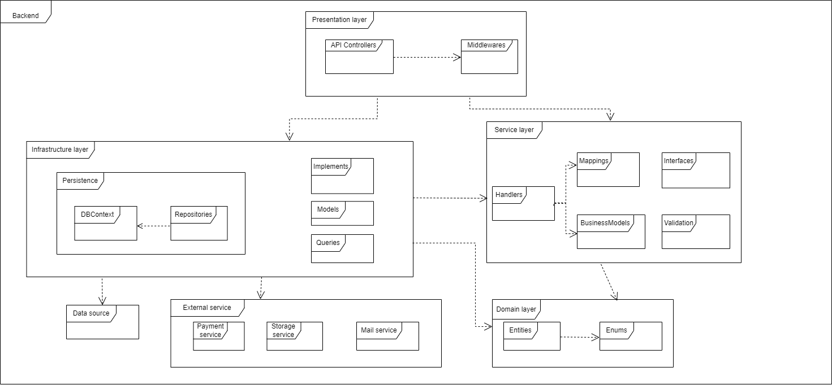

| **No** | **Package** | **Description** |
| --- | --- | --- |
| *1* | *Presentation Layer* | *Contains classes and interfaces that manage the flow of data (request, response) from user interactions (Middlewares and API Controllers)* |
| *2* | *Middlewares* | *Contains classes that are responsible for intercepting, filtering and manipulating the requests from clients and returned responses. They sit between clients (web application, mobile application) and the API Controller. In this application, Middlewares are used for Request Logging, Authorization Filter, …* |
| *3* | *API Controllers* | *Contains classes that are responsible for exposing API endpoints for clients, handling incoming HTTP requests and sending responses back to the clients.* |
| *4* | *Service Layer* | *Contains classes, interfaces are responsible for handling the business logic and defining abstractions in the form of interfaces. These interfaces are then implemented by outer layers (Service Layer). The Service layer depends on the Domain layer and acts as a bridge between the Domain layer and external layers (Presentation Layer and Infrastructure Layer). This package contains Handlers (Business services), Models (DTOs), Commands, Queries, …* |
| *5* | *Queries* | *Contains classes representing requests that handle read operations from the system, such as GetAllRecipesAsync, GetAllUsersAsync, …* |
| *6* | *Models* | *Contains classes represent that migration from the database, such as Recipe, User, WeeklyPlan, …* |
| *7* | *Mappings* | *Contain classes are responsible for mapping between BusinessModels and Models* |
| *8* | *Handlers* | *Contains classes are responsible for handling core business logic, work as services. They accept commands and queries and then return responses after handling business logic.* |
| *9* | *Interfaces* | *Contains interfaces that are implemented by outer layers (Infrastructure Layer)* |
| *10* | *Validation* | *Contains all system exceptions and exception handlers* |
| *11* | *Infrastructure Layer* | *Contains classes, interfaces that are the implementations of the interfaces defined in the Application layer. The classes defined in this layer communicate with external systems and technologies, such as databases, APIs, or external services. This layer should only interact with the domain layer through the application layer and should not contain any business logic or domain knowledge. The main goal of the infrastructure layer is to encapsulate the technical details of the application so that they can be easily changed or replaced without affecting the rest of the application* |
| *12* | *DBContext* | *An instance of DB Context represents a session with the database which can be used to query and save instances of entities to database* |
| *13* | *Repositories* | *Serves as a container or namespace for classes and components that are responsible for data management and storage within the system. It plays a crucial role in maintaining the integrity and accessibility of data and resources, ensuring that they are securely stored and efficiently retrieved when needed.* |
| *14* | *Implementations* | *Contains classes that are implementations of interfaces defined in Service Layer* |
| *15* | *Domain Layer* | *The core component of clean architecture, and it represents the domain and use-case-independent business logic of the system. This layer has no dependency on any technology, third-party library, or frameworks. It includes interfaces, entities, and enums. All other packages should depend on the Domain layer* |
| *16* | *Entities* | *This package is a fundamental part of the system, responsible for representing and encapsulating the core data structures and business objects that are central to the application domain. These entities capture the essential concepts, relationships, and attributes that define the system's data model and are crucial for understanding and manipulating the data within the application.* |
| *17* | *Enums* | *Contains all enums used in entities* |
| *18* | *External Services* | *Contains all classes, and interfaces that are responsible for handling external service tasks (Payment, email SMS, File, …)* |
| *19* | *Payment Service* | *Contains all classes, and interfaces that are responsible for processing payment tasks (ZaloPay)* |
| *20* | *Email*  *SMS Service* | *Contains all classes, interfaces that are responsible for push SMS notification (Zalo ZNS Notification)* |
| *21* | *Storage Service* | *Contains all classes, interfaces that are responsible for uploading files to external storage (AWS Storage)* |
| *22* | *Utils* | *Contains all helper classes that are used throughout the system for handling string, number, datetime, regex expressions, ...* |
| *23* | *Datasource* | *Database that stores entire data for the system* |

#### 1.2.2 Web dashboard package diagram

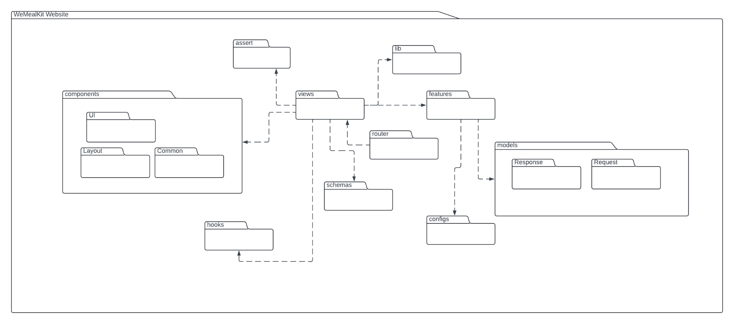

| ***No*** | ***Package*** | ***Description*** |
| --- | --- | --- |
| *1* | *Assert* | *Contains static assets like images, videos, and fonts.* |
| *2* | *Views* | *Holds the main application pages. Each view represents a specific webpage.* |
| *3* | *Lib* | *Contains shared utilities or modules such as helper functions and common logic.* |
| *4* | *Components* | *Contains reusable UI elements, divided into subfolders: ui, layout, and common.* |
| *5* | *Hooks* | *Stores custom hooks to manage state and handle side effects.* |
| *6* | *Router* | *Contains routing configurations for navigation within the app.* |
| *7* | *Schemas* | *Contains schemas used for data validation or structuring data models.* |
| *8* | *Configs* | *Holds configuration files, including API settings, themes, or environment files.* |
| *9* | *Models* | *Contains subfolders request and response, organising model definitions for API requests and responses.* |
| *10* | *Features* | *Where API services are called and feature-related logic is implemented.* |

#### 1.2.3 Mobile package diagram

[***diagram***](https://drive.google.com/file/d/1jXqqDigvjjmOgbMv9rmokbXwqOsTt0Tf/view?usp=sharing)

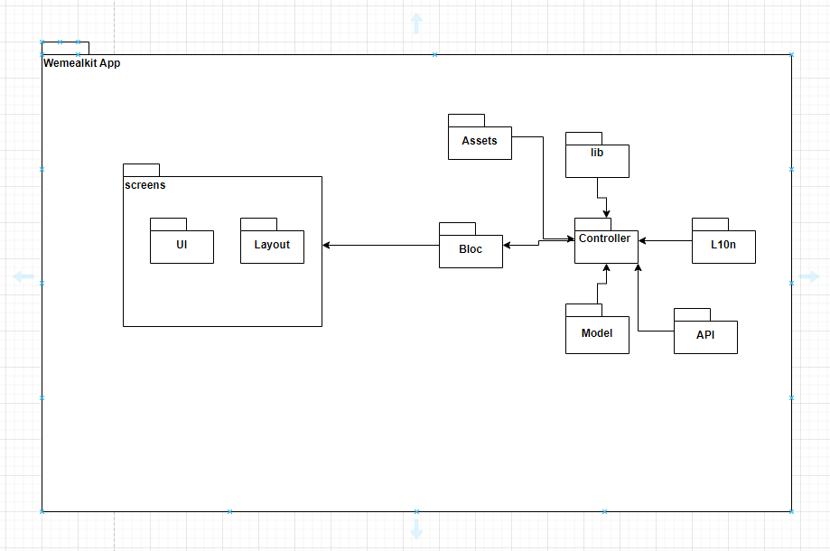

| **No** | **Package** | **Description** |
| --- | --- | --- |
| 1 | *L10n* | *Contains the application's translation files* |
| 2 | *Controller* | *Contains the main logic processing part of the app* |
| 3 | *Screens* | *Contains reusable UI elements, divided into subfolders: ui, layout, and common.* |
| 4 | *Assert* | *Contains static assets like images, videos* |
| 5 | *Models* | *Contains subfolders request and response, organising model definitions for API requests and responses.* |
| 6 | *Util* | *Contains utility functions or classes that provide reusable logic throughout the app, such as helpers, constants, or custom validators.* |
| 7 | *API* | *Contains services and logic related to API calls.* |
| 8 | *Bloc* | *Contains the BLoC (Business Logic Component) pattern implementation for state management.* |

## 2. Database Design

### 2.1 Database Diagram:

[**Reference**](https://drive.google.com/file/d/1zItUfHQp2SK6I9bJUwEkdNNh0abdMv-i/view?usp=sharing)

### 2.2 Data Dictionary

#### 2.2.1 User

| **N.o** | **Field name** | **Type** | **Unique** | **Not null** | **PK/FK** | **Notes** |
| --- | --- | --- | --- | --- | --- | --- |
| 1 | Id | Guid |  | x | PK | User primary key |
| 2 | Username | nvarchar |  | x |  | User’s username |
| 3 | Phone | nvarchar |  |  |  | User’s phone number |
| 4 | PasswordHash | nvarchar |  | x |  | User’s hashed password. |
| 5 | Role | integer |  | x |  | User’s role |
| 6 | Status | integer |  | x |  | User’s status |
| 7 | FirstName | nvarchar |  | x |  | User’s first name |
| 8 | LastName | nvarchar |  | x |  | User’s last name |
| 9 | Email | nvarchar |  | x |  | User’s email |
| 10 | EmailConfirm | integer |  | x |  | status of confirm email |
| 11 | Gender | integer |  | x |  | User’s gender |
| 12 | Code | nvarchar |  |  |  | code to reset password |
| 13 | Address | nvarchar |  |  |  | User’s address |
| 14 | AccessFailedCount | integer |  |  |  | Count number failed login |

#### 2.2.2 Order

| **N.o** | **Field name** | **Type** | **Unique** | **Not null** | **PK/FK** | **Notes** |
| --- | --- | --- | --- | --- | --- | --- |
| 1 | Id | Guid | x | x | PK | Order primary key |
| 2 | UserId | Guid | x | x | FK | User where the order belongs to. |
| 3 | OrderGroupId | Guid | x |  | FK | Order group where the order belongs to. |
| 4 | StanderdWeeklyPlanId | Guid | x |  | FK | Weekly plan where the order belongs to. |
| 5 | OrderCode | integer |  | x |  | Order code |
| 6 | Note | nvarchar |  |  |  | Note by customer |
| 7 | Message | nvarchar |  |  |  | Note by system user |
| 8 | Address | nvarchar |  | x |  | Order’s Address |
| 9 | Img | nvarchar |  |  |  | link img take when shipper delivered |
| 10 | ShipDate | datetime |  | x |  | Estimated delivery date |
| 11 | OrderDate | datetime |  | x |  | Order’s date |
| 12 | TotalPrice | float |  | x |  | Order’s total |
| 13 | Longitude | float |  | x |  | Order Longitude |
| 14 | Latitude | float |  | x |  | Order latitude |
| 15 | ReceiveName | nvarchar |  | x |  | Name of user receive |
| 16 | ReceivePhone | nvarchar |  | x |  | Phone of user receive |
| 17 | Status | integer |  | x |  | Order’s status |
| 18 | ShipperNote | nvarchar |  |  |  | Note of shipper |
| 19 | OrderImg | nvarchar |  |  |  | Order’s img |
| 20 | OrderTitle | nvarchar |  |  |  | Order title |

#### 2.2.3 OrderGroup

| **N.o** | **Field name** | **Type** | **Unique** | **Not null** | **PK/FK** | **Notes** |
| --- | --- | --- | --- | --- | --- | --- |
| 1 | Id | Guid | x | x | PK | Order group primary key |
| 2 | ShipperId | Guid | x |  | FK | Shipper where the order group belongs to. |
| 3 | Location | nvarchar |  | x |  | Order group location |
| 4 | Longitude | float |  | x |  | Order group Longitude |
| 5 | Latitude | float |  | x |  | Order group latitude |
| 6 | AsignAt | datetime |  | x |  | Time when assign order group |
| 7 | AsignBy | Guid | x | x |  | Id user when assign order group |
| 8 | Status | integer |  | x |  | Order’s status |

#### 2.2.4 OrderDetail

| **N.o** | **Field name** | **Type** | **Unique** | **Not null** | **PK/FK** | **Notes** |
| --- | --- | --- | --- | --- | --- | --- |
| 1 | Id | Guid | x | x | PK | Order detail primary key |
| 2 | OrderId | Guid | x | x | FK | Order where the order detail belongs to. |
| 3 | RecipeId | Guid | x | x | FK | Recipe where the order detail belongs to. |
| 4 | DayInWeek | integer |  | x |  | Day in week of plan |
| 5 | MealInDay | integer |  | x |  | Meal in day of plan |
| 6 | Quantity | integer |  | x |  | Quantity of each recipe |
| 7 | Price | float |  | x |  | Price of each recipe |

#### 2.2.5 RecipeIngredientOrderDetail

| **N.o** | **Field name** | **Type** | **Unique** | **Not null** | **PK/FK** | **Notes** |
| --- | --- | --- | --- | --- | --- | --- |
| 1 | Id | Guid | x | x | PK | Order detail primary key |
| 2 | OrderDetailId | Guid | x | x | FK | Order detail where the order recipe and ingredient detail belongs to. |
| 3 | RecipeId | Guid | x | x | FK | Recipe where the recipe and ingredient detail belongs to. |
| 4 | IngredientId | Guid | x | x | FK | Ingredient where the recipe and ingredient detail belongs to. |
| 5 | Amount | float |  | x |  | Number of ingredient |
| 6 | IngredientPrice | float |  | x |  | Quantity of ingredient |

#### 2.2.6 Weekly plan

| **N.o** | **Field name** | **Type** | **Unique** | **Not null** | **PK/FK** | **Notes** |
| --- | --- | --- | --- | --- | --- | --- |
| 1 | Id | Guid | x | x | PK | Weekly plan primary key |
| 2 | BeginDate | datetime |  |  |  | Weekly plan’s begin date. |
| 3 | EndDate | datetime |  |  |  | Weekly plan’s end date. |
| 4 | Description | nvarchar |  |  |  | Weekly plan’s description |
| 5 | UrlImage | nvarchar |  |  |  | Weekly plan’s Image. |
| 6 | Title | nvarchar |  | x |  | Weekly plan’s title. |
| 7 | Notice | nvarchar |  |  |  | Note for system user |
| 8 | CreateAt | datetime |  | x |  | Time to create a weekly plan. |
| 9 | CreatedBy | nvarchar |  | x |  | User id when creating a weekly plan. |
| 10 | BaseStatus | integer |  | x |  | Weekly plan’s status. |
| 11 | ProcessStatus | integer |  | x |  | Request status. |

#### 2.2.7 RecipePlan

| **N.o** | **Field name** | **Type** | **Unique** | **Not null** | **PK/FK** | **Notes** |
| --- | --- | --- | --- | --- | --- | --- |
| 1 | Id | Guid | x | x | PK | Order group primary key |
| 2 | RecipeId | Guid | x | x | FK | Recipe where recipe plan belongs to. |
| 3 | StandardWeeklyPlanId | Guid | x | x | FK | Weekly plan where recipe plan belongs to. |
| 4 | DayInWeek | integer |  | x |  | Day in week of recipe |
| 5 | MealInDay | integer |  | x |  | Meal in day of recipe |
| 6 | Quantity | nvarchar |  | x |  | Quantity of recipe |
| 7 | Price | nvarchar |  | x |  | Price of recipe |

#### 2.2.8 Recipe

| **N.o** | **Field name** | **Type** | **Unique** | **Not null** | **PK/FK** | **Notes** |
| --- | --- | --- | --- | --- | --- | --- |
| 1 | Id | Guid | x | x | PK | Recipe primary key |
| 2 | Name | nvarchar |  | x |  | Recipe’s name |
| 3 | ServingSize | integer |  | x |  | Recipe’s size of people |
| 4 | CookingTime | integer |  | x |  | Recipe’s time to cook |
| 5 | Difficulty | integer |  | x |  | Recipe’s difficulty |
| 6 | Description | nvarchar |  |  |  | Recipe’s description |
| 7 | Notice | nvarchar |  |  |  | Note for system user |
| 8 | Img | nvarchar |  |  |  | Recipe’s image |
| 9 | Price | float |  | x |  | Recipe’s price |
| 10 | Popularity | integer |  | x |  | Recipe’s popularity |
| 11 | CreatedAt | datetime |  | x |  | Time when create recipe |
| 12 | CreatedBy | nvarchar |  | x |  | User id when user create recipe |
| 13 | ProcessStatus | integer |  | x |  | Request status. |
| 14 | BaseStatus | integer |  | x |  | Recipe status |

#### 2.2.9 RecipeStep

| **N.o** | **Field name** | **Type** | **Unique** | **Not null** | **PK/FK** | **Notes** |
| --- | --- | --- | --- | --- | --- | --- |
| 1 | Id | Guid | x | x | PK | Recipe step primary key |
| 2 | RecipeId | Guid | x | x | FK | Recipe where recipe step belongs to |
| 3 | [Index] | integer |  | x |  | Index of recipe step |
| 4 | Name | nvarchar |  | x |  | Recipe step’s name |
| 5 | MediaURL | nvarchar |  |  |  | Recipe step’s link media |
| 6 | ImageLink | nvarchar |  |  |  | Recipe step’s link image |
| 7 | Description | nvarchar |  |  |  | Recipe step’s description |

#### 2.2.10 Recipe Nutrient

| **N.o** | **Field name** | **Type** | **Unique** | **Not null** | **PK/FK** | **Notes** |
| --- | --- | --- | --- | --- | --- | --- |
| 1 | Id | Guid | x | x | PK | Recipe nutrient primary key |
| 2 | RecipeID | Guid | x | x | FK | Recipe where recipe ingredient belongs to |
| 3 | Calories | float |  | x |  | Recipe nutrient’s calories |
| 4 | Fat | float |  | x |  | Recipe nutrient’s Fat |
| 5 | SaturatedFat | float |  | x |  | Recipe nutrient’s SaturatedFat |
| 6 | Sugar | float |  | x |  | Recipe nutrient’s Sugar |
| 7 | Carbonhydrate | float |  | x |  | Recipe nutrient’s Carbohydrate |
| 8 | DietaryFiber | float |  | x |  | Recipe nutrient’s DietaryFiber |
| 9 | Protein | float |  | x |  | Recipe nutrient’s Protein |
| 10 | Sodium | float |  | x |  | Recipe nutrient’s Sodium |

#### 2.2.11 Recipe Category

| **N.o** | **Field name** | **Type** | **Unique** | **Not null** | **PK/FK** | **Notes** |
| --- | --- | --- | --- | --- | --- | --- |
| 1 | Id | Guid | x | x | PK | Recipe category primary key |
| 2 | RecipeID | Guid | x | x | FK | Recipe where recipe category belongs to |
| 3 | CategoryId | Guid | x | x | FK | Category where recipe category belongs to |

#### 2.2.12 Category

| **N.o** | **Field name** | **Type** | **Unique** | **Not null** | **PK/FK** | **Notes** |
| --- | --- | --- | --- | --- | --- | --- |
| 1 | Id | Guid | x | x | PK | Category primary key |
| 2 | Type | nvarchar |  | x |  | Category’s type |
| 3 | Name | nvarchar |  | x |  | Category’s name |
| 4 | Description | nvarchar |  | x |  | Category’s description |
| 5 | Status | integer |  | x |  | Category’s status |

#### 2.2.13 RecipeIngredient

| **N.o** | **Field name** | **Type** | **Unique** | **Not null** | **PK/FK** | **Notes** |
| --- | --- | --- | --- | --- | --- | --- |
| 1 | Id | Guid | x | x | PK | Recipe ingredient primary key |
| 2 | RecipeID | Guid | x | x | FK | Recipe where recipe ingredient belongs to |
| 3 | IngredientId | float | x | x | FK | Ingredient where recipe ingredient belongs to |
| 4 | Amount | float |  | x |  | Amount of ingredient into recipe |

#### 2.2.14 Ingredient

| **N.o** | **Field name** | **Type** | **Unique** | **Not null** | **PK/FK** | **Notes** |
| --- | --- | --- | --- | --- | --- | --- |
| 1 | Id | Guid | x | x | PK | Ingredient primary key |
| 2 | IngredientCategoryId | Guid | x | x | FK | Category where ingredient belongs to |
| 3 | Name | nvarchar |  | x |  | Ingredient’s name |
| 4 | Price | float |  | x |  | Ingredient’s price |
| 5 | Img | nvarchar |  |  |  | Ingredient’s image |
| 6 | Unit | nvarchar |  | x |  | Ingredient’s unit |
| 7 | Status | integer |  | x |  | Ingredient’s status |
| 8 | PackagingMethod | nvarchar |  | x |  | Ingredient’s packaging method |
| 9 | PreservationMethod | nvarchar |  | x |  | Ingredient’s preservation |
| 10 | CreatedAt | datetime |  | x |  | Time when create ingredient |
| 11 | CreatedBy | nvarchar |  | x |  | user id when create ingredient |

#### 2.2.15 IngredientCategory

| **N.o** | **Field name** | **Type** | **Unique** | **Not null** | **PK/FK** | **Notes** |
| --- | --- | --- | --- | --- | --- | --- |
| 1 | Id | Guid | x | x | PK | Ingredient category primary key |
| 2 | Name | nvarchar |  | x |  | Ingredient category’s name |
| 3 | Description | nvarchar |  | x |  | Ingredient category’s description |
| 4 | Status | integer |  | x |  | Ingredient category’s status |

#### 2.2.16 IngredientNutrient

| **N.o** | **Field name** | **Type** | **Unique** | **Not null** | **PK/FK** | **Notes** |
| --- | --- | --- | --- | --- | --- | --- |
| 1 | Id | Guid | x | x | PK | Ingredient nutrient primary key |
| 2 | IngredientID | Guid | x | x | FK | Ingredient where ingredient nutrient belongs to |
| 3 | Calories | float |  | x |  | Ingredient nutrient’s calories |
| 4 | Fat | float |  | x |  | Ingredient nutrient’s Fat |
| 5 | SaturatedFat | float |  | x |  | Ingredient nutrient’s SaturatedFat |
| 6 | Sugar | float |  | x |  | Ingredient nutrient’s Sugar |
| 7 | Carbonhydrate | float |  | x |  | Ingredient nutrient’s Carbohydrate |
| 8 | DietaryFiber | float |  | x |  | Ingredient nutrient’s DietaryFiber |
| 9 | Protein | float |  | x |  | Ingredient nutrient’sProtein |
| 10 | Sodium | float |  | x |  | Recipe ingredient’s Sodium |

#### 2.2.17 Feedback

| **N.o** | **Field name** | **Type** | **Unique** | **Not null** | **PK/FK** | **Notes** |
| --- | --- | --- | --- | --- | --- | --- |
| 1 | Id | Guid | x | x | PK | Feedback primary key |
| 2 | OrderId | Guid | x | x | FK | Order where feedback belongs to |
| 3 | Rating | integer |  | x |  | Rating of order |
| 4 | Description | nvarchar |  |  |  | Feedback’s description |
| 5 | CreatedAt | datetime |  | x |  | Time when create feedback by customer |
| 6 | CreatedBy | nvarchar |  | x |  | Id customer when create feedback |

#### 2.2.18 Transaction

| **N.o** | **Field name** | **Type** | **Unique** | **Not null** | **PK/FK** | **Notes** |
| --- | --- | --- | --- | --- | --- | --- |
| 1 | Id | Guid | x | x | PK | Feedback primary key |
| 2 | OrderId | Guid | x | x | FK | Order where feedback belongs to |
| 3 | Type | integer |  | x |  | Type of transaction |
| 4 | Amount | float |  | x |  | Transaction’s price |
| 5 | TransactionDate | datetime |  | x |  | Transaction’s date |
| 6 | Notice | nvarchar |  |  |  | Transaction’s notice |
| 7 | ExtraData | nvarchar |  |  |  | Transaction’s data transfer |
| 8 | Signature | nvarchar |  |  |  | Transaction’s signature |
| 9 | Status | integer |  | x |  | Transaction’s status |

## 3. Detailed Design

### 3.1 Authentication

#### 3.1.1 Login WMK using username/email and password - All user

##### Class Diagram

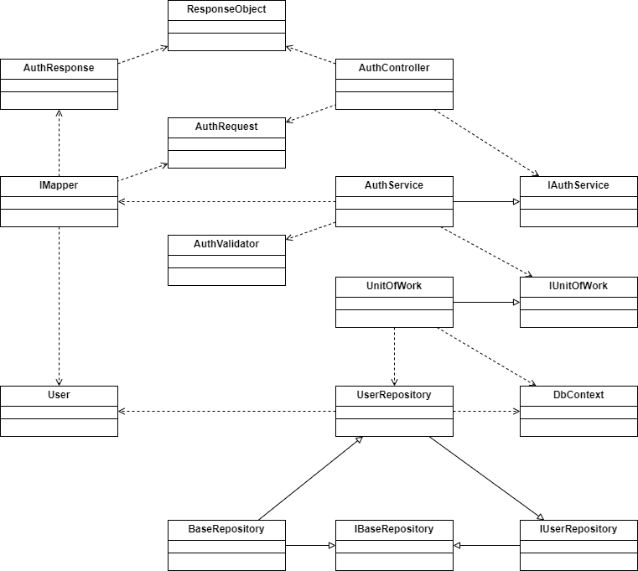

[***Reference***](https://drive.google.com/file/d/1ywdRfulkq1e4CYqv4Bqve2dWFSOKWxWu/view?usp=sharing)

##### Sequence Diagram

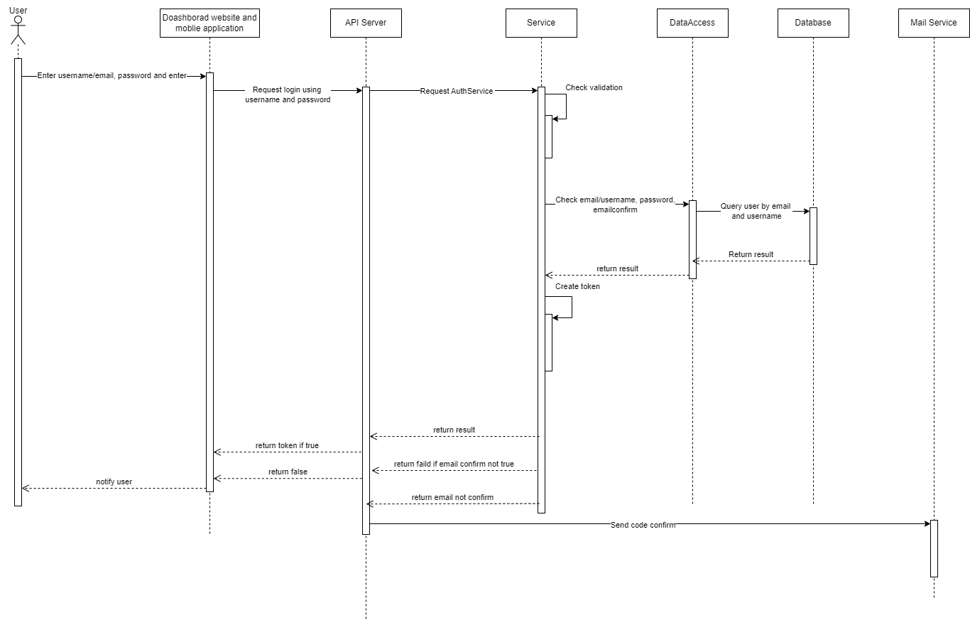

[***Reference***](https://drive.google.com/file/d/1XRzZeOYvmEdis-4p5YGq-VbHzhUij3VF/view?usp=sharing)

### 3.2 Order

#### 3.2.1 Create Order by customer

##### Class Diagram

[***Reference***](https://drive.google.com/file/d/1H1xkHpmwkRLu382Ei7LKIBILOqy6jzvq/view?usp=sharing)

##### Class Specification

**OrderController**

| ***N.o*** | ***Method*** | ***Description*** |
| --- | --- | --- |
| *1* | public async Task<IActionResult> Create([FromBody] CreateOrderRequest model) | Handle Create Order request from Mobile and Web application |

**OrderService**

| ***N.o*** | ***Method*** | ***Description*** |
| --- | --- | --- |
| *1* | public async Task<ResponseObject<OrderResponse>> CreateOrderAsync(CreateOrderRequest model) | Process create Order request from business logic |

**ITransactionService**

| ***N.o*** | ***Method*** | ***Description*** |
| --- | --- | --- |
| *1* | Task<ResponseObject<TransactionResponse>> CreateNewPaymentAsync(CreatePaymentRequest request); | Interface to call create transaction when create order |

**OrderValidator**

| ***N.o*** | ***Method*** | ***Description*** |
| --- | --- | --- |
| *1* | public class CreateOrderModelValidator : AbstractValidator<CreateOrderRequest> | Handle check validate request create model |

**OrderRepository**

| ***N.o*** | ***Method*** | ***Description*** |
| --- | --- | --- |
| *1* | Task<bool> CreateAsync(T entity) | Handle to query create order into database |
| 2 | Task<T?> GetByIdAsync(string? id); | Gandle to query exist order |

**UnitOfWork**

| ***N.o*** | ***Method*** | ***Description*** |
| --- | --- | --- |
| *1* | CompleteAsync() | Save all database changes from Database Context to Database |

##### Sequence Diagram

[Reference](https://drive.google.com/file/d/1tPmJAsNGUdUOuD1HTOyvVBAMZcSlsPI3/view?usp=sharing)

#### 

#### 3.2.2 Cluster order

##### Class Diagram

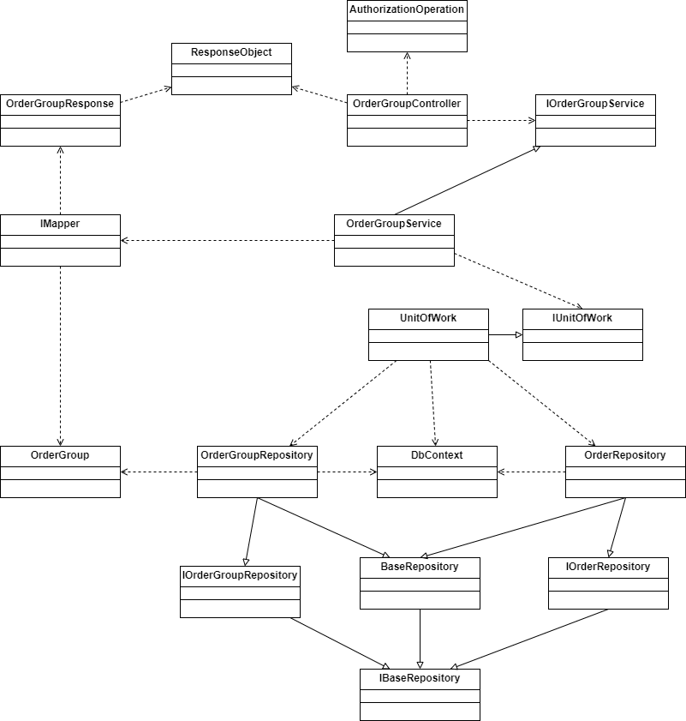

[***Reference***](https://drive.google.com/file/d/1H1xkHpmwkRLu382Ei7LKIBILOqy6jzvq/view?usp=sharing)

##### 

##### Class Specification

**AuthorizationOperation**

| ***N.o*** | ***Method*** | ***Description*** |
| --- | --- | --- |
| *1* | [Authorize(Roles = "Admin,Manager,Staff")] | Handle cluster order with staff, admin, manager |

**OrderGroupController**

| ***N.o*** | ***Method*** | ***Description*** |
| --- | --- | --- |
| *1* | public async Task<IActionResult> Cluster() | Handle cluster request from Web application |

**OrderGroupService**

| ***N.o*** | ***Method*** | ***Description*** |
| --- | --- | --- |
| *1* | public async Task<ResponseObject<List<OrderGroupsResponse>>> OrderGroupClusterAsync() | Process cluster all order processing status from business logic |
| **2** | private double CalculateEuclideanDistance(double[] point1 , double[] point2) | Calculate Euclidean distance |
| **3** | public int FindOptimalK(List<Order> orders , int maxK) | Calculate K to use K-means algorithm |
| **4** | private int GetClosestCentroidIndex(double[] point , double[][] centroids) | Calculate nearest cluster center index |

**ResponseObject**

| ***N.o*** | ***Method*** | ***Description*** |
| --- | --- | --- |
| ***1*** | public class ResponseObject<T> | Handle response order group |

**OrderGroupRepository**

| ***N.o*** | ***Method*** | ***Description*** |
| --- | --- | --- |
| ***1*** | Task<bool> UpdateRangeAsync(List<OrderGroup> orderGroups) | Handle to query update range order group into database |
| **2** | public IQueryable<T> Get(Expression<Func<T, bool>> expression) | Handle to query get order group has status Available from database |

**OrderRepository**

| ***N.o*** | ***Method*** | ***Description*** |
| --- | --- | --- |
| ***1*** | public IQueryable<T> Get(Expression<Func<T, bool>> expression); | Handle to query get all order has status processing from database |

**UnitOfWork**

| ***N.o*** | ***Method*** | ***Description*** |
| --- | --- | --- |
| ***1*** | CompleteAsync() | Save all database changes from Database Context to Database |

##### Sequence Diagram

[***Reference***](https://drive.google.com/file/d/1_CgqKSNWrNlQE8rrDbn7Bnzw5msGgFMZ/view?usp=sharing)

#### 3.2.3 Cancel Order

##### Class Diagram

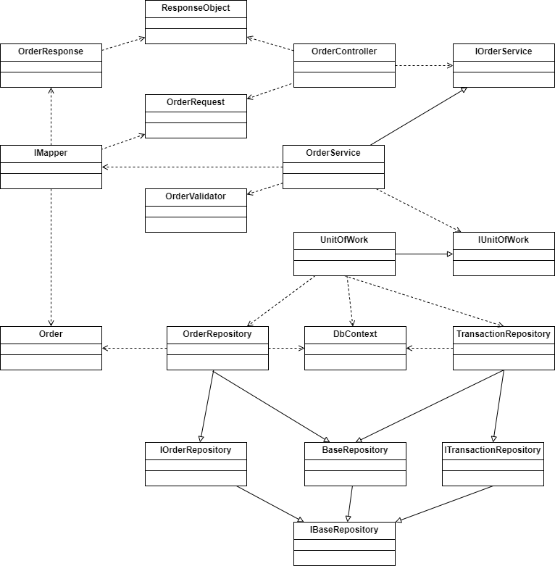

[***Reference***](https://drive.google.com/file/d/1H1xkHpmwkRLu382Ei7LKIBILOqy6jzvq/view?usp=sharing)

##### Class Specification

**OrderController**

| ***N.o*** | ***Method*** | ***Description*** |
| --- | --- | --- |
| ***1*** | public async Task<IActionResult> ChangeStatus(Guid id , [FromQuery] ChangeStatusOrderRequest model) | Handle cancel request from Web and Mobile application |

**OrderService**

| ***N.o*** | ***Method*** | ***Description*** |
| --- | --- | --- |
| ***1*** | public async Task<ResponseObject<OrderResponse>> ChangeStatusOrderAsync(Guid id , ChangeStatusOrderRequest model) | Process change order with cancel status from business logic |

**ResponseObject**

| ***N.o*** | ***Method*** | ***Description*** |
| --- | --- | --- |
| ***1*** | public class ResponseObject<T> | Handle response order |

**OrderRepository**

| ***N.o*** | ***Method*** | ***Description*** |
| --- | --- | --- |
| ***1*** | Task<T?> GetByIdAsync(string? id) | Handle to query get order into database |

**UnitOfWork**

| ***N.o*** | ***Method*** | ***Description*** |
| --- | --- | --- |
| ***1*** | CompleteAsync() | Save all database changes from Database Context to Database |

##### Sequence Diagram

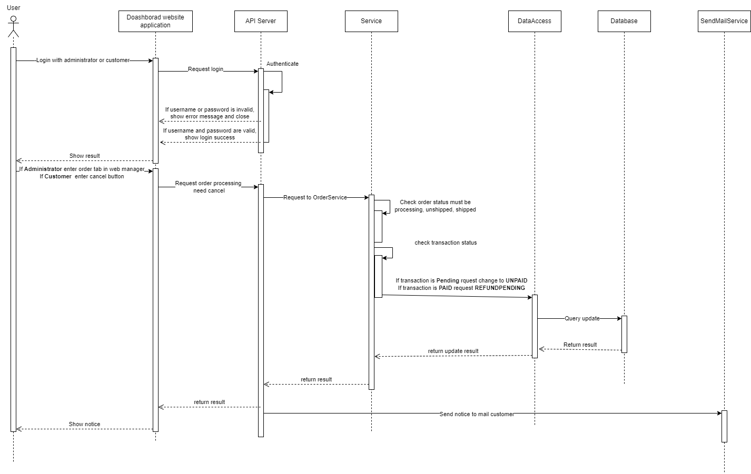

[Reference](https://drive.google.com/file/d/124LnJZi4ufDaDQixWCpBwAIPiM-ot57p/view?usp=sharing)

#### 3.2.4 Refund Order

##### Class Diagram

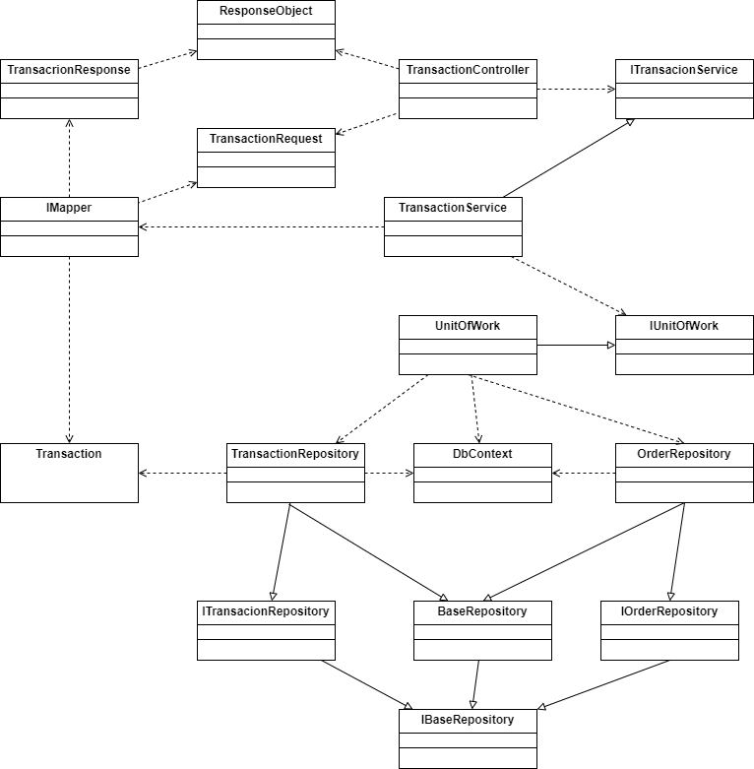

##### Class Specification

**TransactionController**

| ***N.o*** | ***Method*** | ***Description*** |
| --- | --- | --- |
| ***1*** | public async Task<IActionResult> RefundZaloPay([FromBody] RefundZaloPayRequest request)ChangeStatusOrderRequest model) | Handle refund request from Web application |

**TransactionService**

| ***N.o*** | ***Method*** | ***Description*** |
| --- | --- | --- |
| ***1*** | public async Task<ResponseObject<RefundZaloPayResponse>> RefundTransactionAsync(RefundZaloPayRequest request) | Process refund PAID order from business logic |
| **2** | public Task<string> GetStringAsync([StringSyntax("Uri")] string? requestUri , CancellationToken cancellationToken) | Handle call ZaloPay API |

**ResponseObject**

| ***N.o*** | ***Method*** | ***Description*** |
| --- | --- | --- |
| ***1*** | public class ResponseObject<T> | Handle response order |

**TransactionRepository**

| ***N.o*** | ***Method*** | ***Description*** |
| --- | --- | --- |
| ***1*** | Task<bool> UpdateAsync(T entity) | Handle to query update transaction into database |
| **2** | public IQueryable<T> Get(Expression<Func<T, bool>> expression) | Handle to query get transaction from database |

**OrderRepository**

| ***N.o*** | ***Method*** | ***Description*** |
| --- | --- | --- |
| ***1*** | Task<T?> GetByIdAsync(string? id) | Handle to query get order from database |

**UnitOfWork**

| ***N.o*** | ***Method*** | ***Description*** |
| --- | --- | --- |
| ***1*** | CompleteAsync() | Save all database changes from Database Context to Database |

##### Sequence Diagram

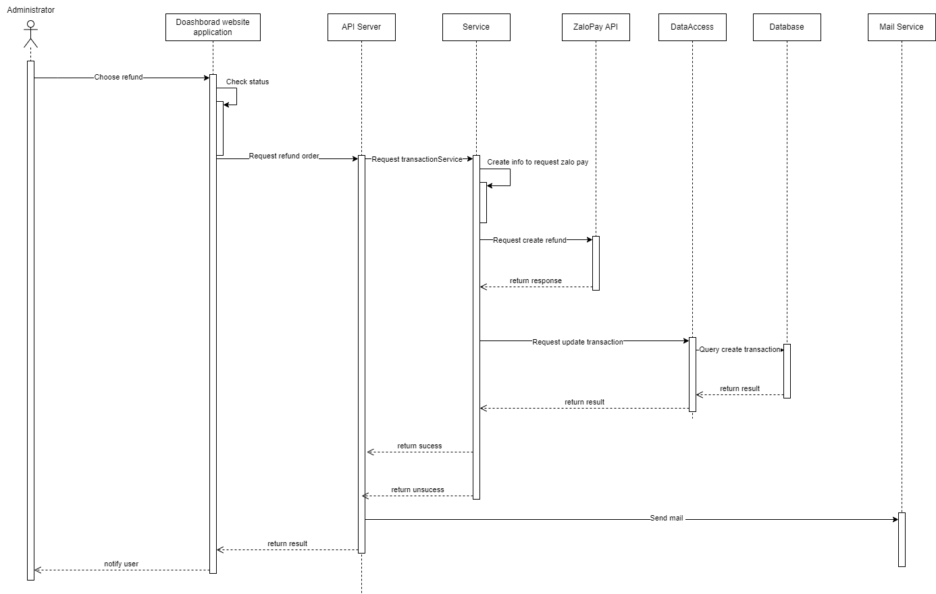

### 3.3 Recipe, Weekly plan and Ingredient

#### 3.3.1 Update ingredient

##### Class Diagram

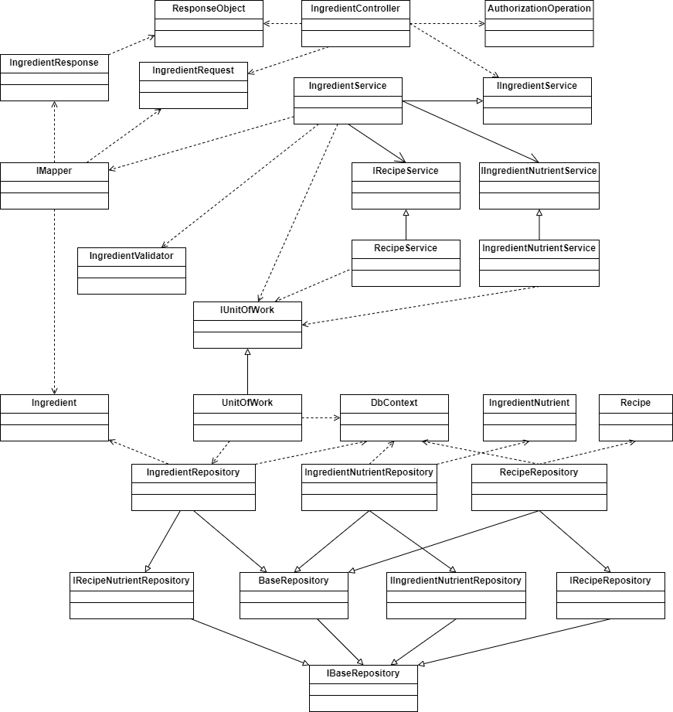

##### 

##### Class Specification

***AuthorizationOperation***

| ***N.o*** | ***Method*** | ***Description*** |
| --- | --- | --- |
| ***1*** | [Authorize(Roles = "Admin,Manager,Staff")] | Handle ingredient update need to login with staff, admin, manager |

**IngredientController**

| ***N.o*** | ***Method*** | ***Description*** |
| --- | --- | --- |
| ***1*** | public async Task<IActionResult> Update(Guid id , CreateIngredientRequest model) | Handle update ingredient request from Web application |

**IngredientService**

| ***N.o*** | ***Method*** | ***Description*** |
| --- | --- | --- |
| ***1*** | public async Task<ResponseObject<IngredientResponse>> UpdateIngredient( Guid id , CreateIngredientRequest ingredient) | Process update ingredient from business logic |

**IngredientNutrientService**

| ***N.o*** | ***Method*** | ***Description*** |
| --- | --- | --- |
| ***1*** | public async Task<ResponseObject<IngredientNutrientResponse>> Update(Guid idIngredientNutrient , IngredientNutrientRequest request)CreateIngredientRequest ingredient) | Process update ingredient nutrient from business logic |

***RecipeService***

| ***N.o*** | ***Method*** | ***Description*** |
| --- | --- | --- |
| ***1*** | public async Task<bool> AutoUpdateRecipeAsync(Guid? recipeId) | Process update all related recipes from business logic |

***ResponseObject***

| ***N.o*** | ***Method*** | ***Description*** |
| --- | --- | --- |
| ***1*** | public class ResponseObject<T> | Handle response order |

***IngredientRepository***

| ***N.o*** | ***Method*** | ***Description*** |
| --- | --- | --- |
| ***1*** | Task<bool> UpdateAsync(T entity) | Handle to query update ingredient into database |
| **2** | Task<T?> GetByIdAsync(string? id) | Handle to query get ingredient from database |

***UnitOfWork***

| ***N.o*** | ***Method*** | ***Description*** |
| --- | --- | --- |
| ***1*** | CompleteAsync() | Save all database changes from Database Context to Database |

##### Sequence Diagram

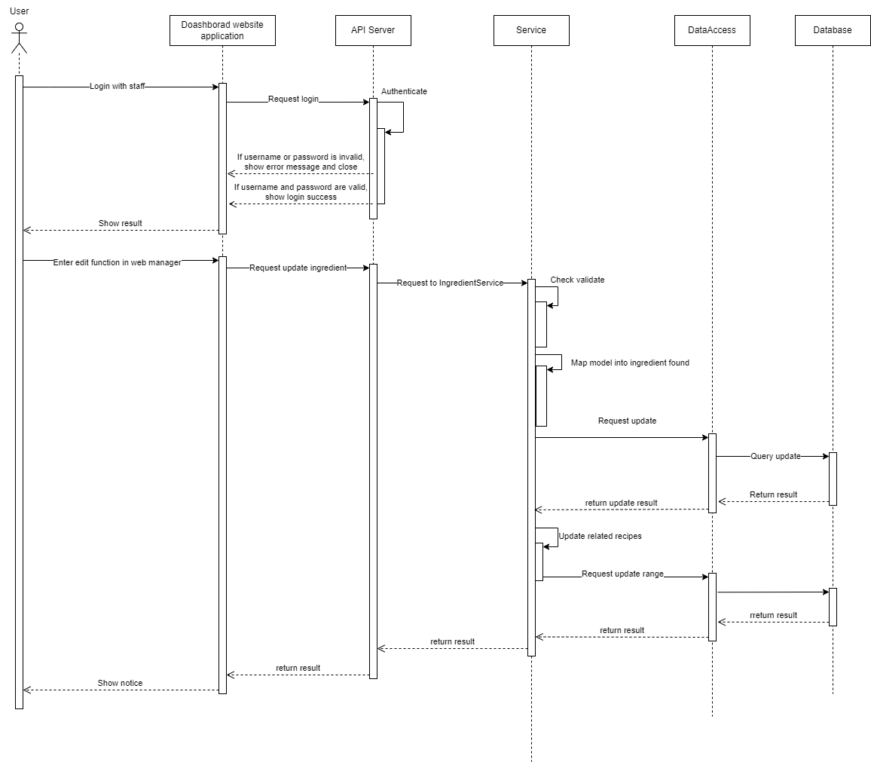

### 3.3 Recipe, Weekly plan and Ingredient

#### 3.3.2 Create Recipe and Weekly plan

##### A. Create Recipe

###### Class Diagram

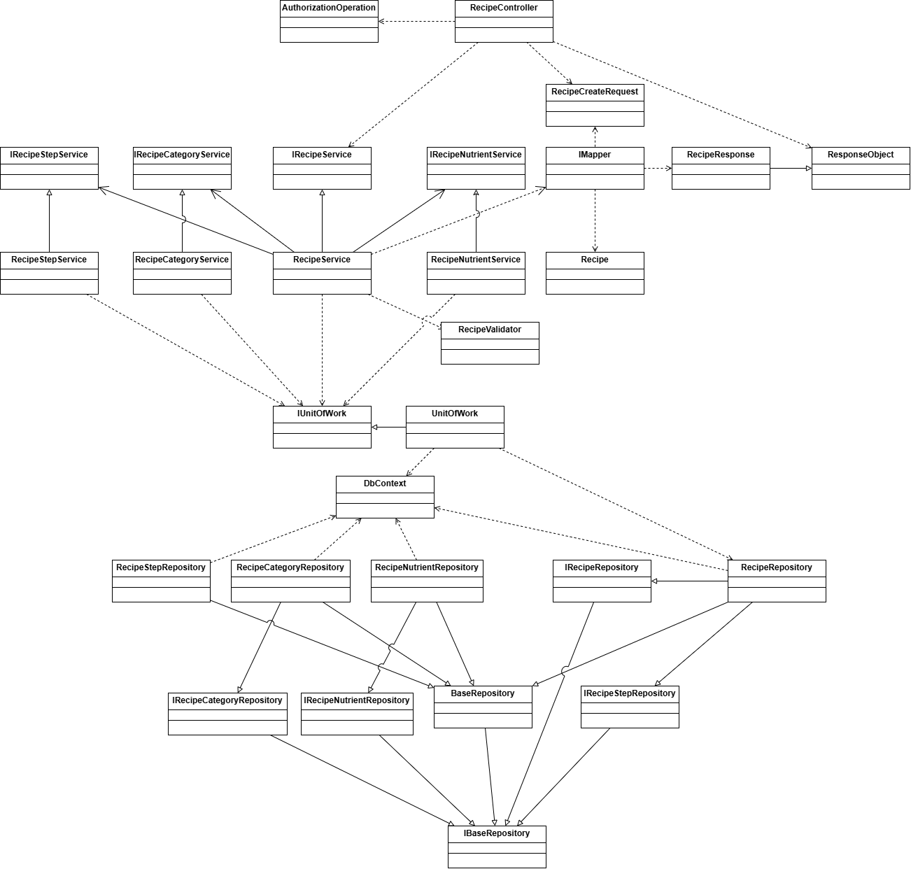

[***Reference***](https://drive.google.com/file/d/1UyH919ewQGFJ3oNJU9V8CruJEG8uhan4/view?usp=sharing)

##### 

###### Class Specification

***RecipeController***

| ***N.o*** | ***Method*** | ***Description*** |
| --- | --- | --- |
| ***1*** | Task<IActionResult> Create(Guid id , CreateRecipeRequest model) | Handle Create request from Web application |

***RecipeService***

| ***N.o*** | ***Method*** | ***Description*** |
| --- | --- | --- |
| ***1*** | Task<ResponseObject<RecipeResponse>> CreateRecipeAsync(string createdBy , CreateRecipeRequest recipe) | Process create new recipe from business logic |
| ***2*** | Task<bool> UpdatePrice(Guid recipeId) | Update correct price for recipe from business logic |
| ***3*** | private async Task<List<Recipe>> GetAllToProcess() | Get all recipe from database to proceed |

***RecipeCategoryService***

| ***N.o*** | ***Method*** | ***Description*** |
| --- | --- | --- |
| ***1*** | Task<ResponseObject<List<RecipeCategory>?>> Create(Guid recipeId , List<Guid> categoryList) | Process create new RecipeCategory from business logic |

***RecipeStepService***

| ***N.o*** | ***Method*** | ***Description*** |
| --- | --- | --- |
| ***1*** | Task<ResponseObject<List<RecipeStep>>> CreateRecipeSteps(Guid recipeId, List<CreateRecipeStepRequest> stepList); | Process create new RecipeStep from business logic |

***RecipeNutrientService***

| ***N.o*** | ***Method*** | ***Description*** |
| --- | --- | --- |
| ***1*** | public Task<bool> AutoUpdateNutrientByRecipe(Guid recipeId); | Process create new RecipeNutrient from business logic (if no nutrient found - Create new process will take in) |

***RecipeRepository***

| ***N.o*** | ***Method*** | ***Description*** |
| --- | --- | --- |
| ***1*** | GetByIdAsync(string Id) | Get recipe from database by Recipe Id |

***UnitOfWork***

| ***N.o*** | ***Method*** | ***Description*** |
| --- | --- | --- |
| ***1*** | Task CompleteAsync() | Save all database changes from Database Context to Database |

##### 

##### B. Create Weekly Plan

##### Class Diagram

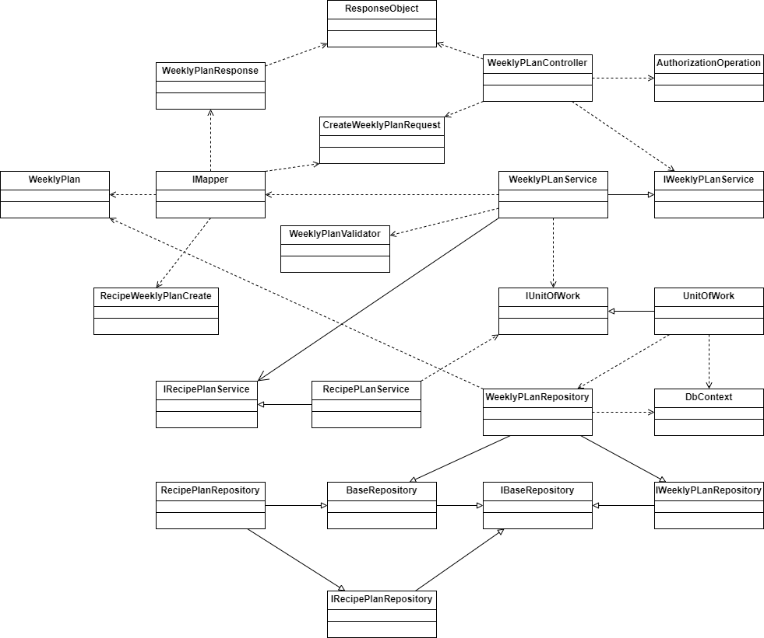

[***Reference***](https://drive.google.com/file/d/1ZfGUYWSRPeq-u8bJe4xk1CyX99B5ACOD/view?usp=drive_link)

##### 

##### Class Specification

**AuthorizationOperation**

| ***N.o*** | ***Method*** | ***Description*** |
| --- | --- | --- |
| ***1*** | [Authorize(Roles = "Admin,Manager")] | Handle order create need to login with staff, admin, manager |

**WeeklyPlanController**

| ***N.o*** | ***Method*** | ***Description*** |
| --- | --- | --- |
| ***1*** | Task<IActionResult> Create([FromBody] CreateWeeklyPlanRequest model) | Handle Create request from Web application |

**WeeklyPlanService**

| ***N.o*** | ***Method*** | ***Description*** |
| --- | --- | --- |
| ***1*** | Task<ResponseObject<WeeklyPlanResponseModel>> CreateWeeklyPlanAsync(CreateWeeklyPlanRequest model , string createdBy) | Process create new Weekly Plan from business logic |

##### 

***RecipePlanService***

| ***N.o*** | ***Method*** | ***Description*** |
| --- | --- | --- |
| ***1*** | Task<ResponseObject<List<RecipePLan>?>> CreateRecipePlanAsync(Guid weeklyPlanId, List<RecipeWeeklyPlanCreate> recipesId) | Process create new Recipe Plan from business logic |
| ***2*** | AddOrUpdateRecipePlan(List<RecipePLan> recipePlans , RecipePLan newRecipePlan) | Add new RecipePlan for WeekPlan |

##### 

***WeeklyPlanRepository***

| ***N.o*** | ***Method*** | ***Description*** |
| --- | --- | --- |
| ***1*** | Task<WeeklyPlan?> GetByIdAsync(string? id); | Get WeeklyPlan from database by Id |
| ***2*** | Task<List<WeeklyPlan?>> GetAllAsync(); | Get all WeeklyPlan from database |

##### 

***RecipeRepository***

| ***N.o*** | ***Method*** | ***Description*** |
| --- | --- | --- |
| ***1*** | Task<Recipe?> GetByIdAsync(string? id); | Get all recipe from database |

##### 

***RecipePlanRepository***

| ***N.o*** | ***Method*** | ***Description*** |
| --- | --- | --- |
| ***1*** | Task AddRangeAsync(IEnumerable<RecipePLan> recipePlans) | Add a list of RecipePlan for Weekly plan |

***UnitOfWork***

| ***N.o*** | ***Method*** | ***Description*** |
| --- | --- | --- |
| ***1*** | Task CompleteAsync() | Save all database changes from Database Context to Database |

##### 

##### C. Sequence Diagram

[***Reference***](https://drive.google.com/file/d/1pK_01zeEh_fSm27-AdYsm9vir8c-eXqv/view?usp=sharing)

### 3.3 Recipe, Weekly plan and Ingredient

#### 3.3.3 Approve Recipe and Weekly plan

##### Class Diagram

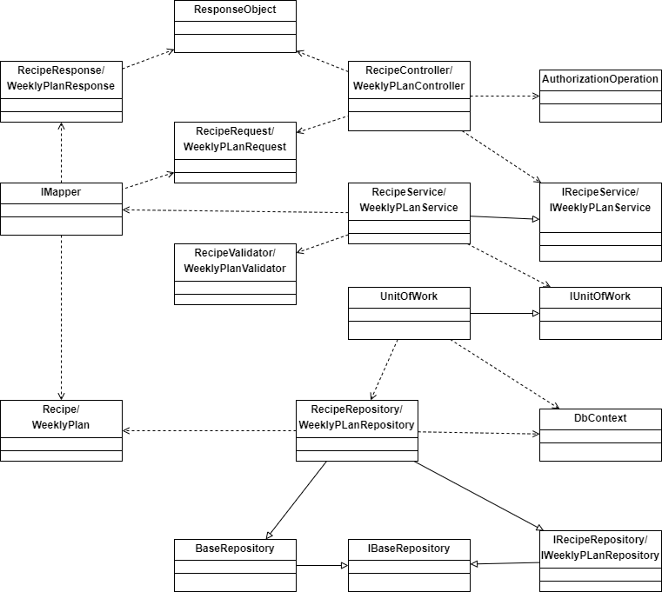

##### Class Specification

***AuthorizationOperation***

| ***N.o*** | ***Method*** | ***Description*** |
| --- | --- | --- |
| ***1*** | [Authorize(Roles = "Admin,Manager")] | Handle order create need to login with staff, admin, manager |

***ResponseObject***

| ***N.o*** | ***Method*** | ***Description*** |
| --- | --- | --- |
| ***1*** | public class ResponseObject<T> | Handle response order |

***RecipeController/WeeklyPlanController***

| ***N.o*** | ***Method*** | ***Description*** |
| --- | --- | --- |
| **1** | public async Task<IActionResult> UpdateStatusRecipe(Guid id , [FromBody] ChangeRecipeStatusRequest request) | Handle change recipe status form Web application |
| **2** | public async Task<IActionResult> ChangeStatus(Guid id , [FromBody] ChangeStatusWeeklyPlanRequest model) | Handle change weekly plan status form Web application |

***RecipeService/WeeklyPlanService***

| ***N.o*** | ***Method*** | ***Description*** |
| --- | --- | --- |
| **1** | public async Task<ResponseObject<RecipeResponse>> ChangeStatusProcessAsync(Guid id , ChangeRecipeStatusRequest recipe) | Process change recipe status from business logic (if approve then Approved, Denie then Denied) |
| **2** | public async Task<ResponseObject<WeeklyPlanResponseModel>> ChangeStatusWeeklyPlanAsync(string? userId , Guid id , ChangeStatusWeeklyPlanRequest model) | Process change weekly plan status from business logic (if approve then Approved, Denie then Denied) |

***RecipeService/WeeklyPlanService***

| ***N.o*** | ***Method*** | ***Description*** |
| --- | --- | --- |
| **1.1** | public async Task<ResponseObject<RecipeResponse>> ChangeStatusProcessAsync(Guid id , ChangeRecipeStatusRequest recipe) | Process change recipe status from business logic (if approve then Approved, Denie then Denied) |
| **1.2** | private async Task<bool> deleteRecipeFromWeeklyPlan(Guid recipeId , ProcessStatus processStatusExist , BaseStatus? baseStatusChange) | Process delete recipe from weekly plan if recipe UNAVAILABLE |
| **2** | public async Task<ResponseObject<WeeklyPlanResponseModel>> ChangeStatusWeeklyPlanAsync(string? userId , Guid id , ChangeStatusWeeklyPlanRequest model) | Process change weekly plan status from business logic (if approve then Approved, Denie then Denied) |

***RecipeRepository/WeeklyPlanRepository***

| ***N.o*** | ***Method*** | ***Description*** |
| --- | --- | --- |
| ***1.1*** | Task<bool> UpdateAsync(T entity) | Handle to query update recipe into database |
| ***1.2*** | Task<T?> GetByIdAsync(string? id) | Handle to query get recipe from database |
| **2.1** | Task<T?> GetByIdAsync(string? id) | Handle to query get ingredient from database |
| **2.2** | Task<bool> UpdateAsync(T entity) | Handle to query update weekly plan into database |

***UnitOfWork***

| ***N.o*** | ***Method*** | ***Description*** |
| --- | --- | --- |
| ***1*** | CompleteAsync() | Save all database changes from Database Context to Database |

##### 

##### Sequence Diagram

[***Reference***](https://drive.google.com/file/d/1fKCrA9WHgVZ7JszDyCGRWGbd_8omOBex/view?usp=sharing)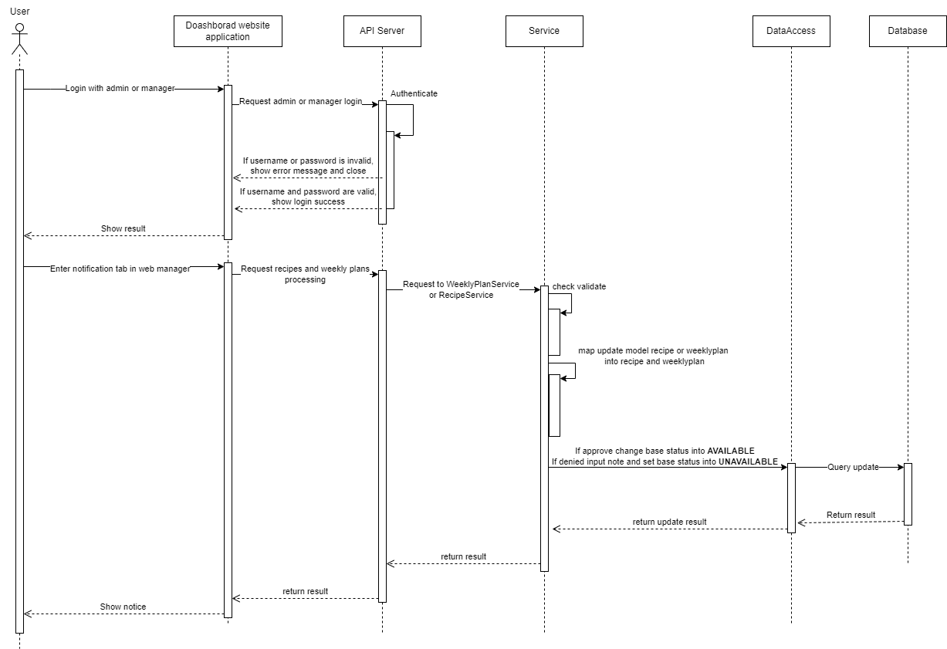

### 3.3 Recipe, Weekly plan and Ingredient

#### 3.3.4 Update Recipe and Weekly plan

##### A. Update Recipe

###### Class Diagram

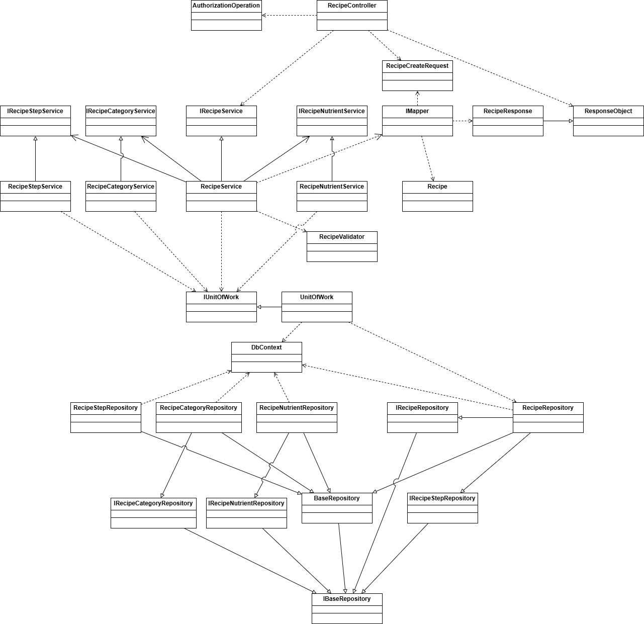

[***Reference***](https://drive.google.com/file/d/14NHtjFnDBm9qJ7j5HAztBWMRz9uhfwi2/view?usp=sharing)

##### 

###### Class Specification

***RecipeController***

| ***N.o*** | ***Method*** | ***Description*** |
| --- | --- | --- |
| ***1*** | Task<IActionResult> Update(Guid id , [FromBody] CreateRecipeRequest model) | Handle Update request from Web application |

***RecipeService***

| ***N.o*** | ***Method*** | ***Description*** |
| --- | --- | --- |
| ***1*** | Task<ResponseObject<RecipeResponse>> UpdateRecipeAsync(string updatedBy , Guid idRecipe , CreateRecipeRequest recipe); | Update with chosen Recipe to database |

***RecipeCategoryService***

| ***N.o*** | ***Method*** | ***Description*** |
| --- | --- | --- |
| ***1*** | Task<ResponseObject<List<RecipeCategory>?>> DeleteByRcipe(Guid recipeId); | Remove old RecipeCategory by Recipe Id |
| ***2*** | Task<ResponseObject<List<RecipeCategory>?>> Create(Guid recipeId , List<Guid> categoryList); | Create new data of RecipeCategories for Recipe |

***RecipeNutrientService***

| ***N.o*** | ***Method*** | ***Description*** |
| --- | --- | --- |
| ***1*** | public Task<bool> AutoUpdateNutrientByRecipe(Guid recipeId); | Update Nutrient if there is existing |

***RecipeIngredientService***

| ***N.o*** | ***Method*** | ***Description*** |
| --- | --- | --- |
| ***1*** | Task<ResponseObject<List<RecipeIngredient>?>> DeleteRecipeIngredientByRecipeAsync(Guid recipeId); | Remove old RecipeIngredient by Recipe Id |
| ***2*** | Task<ResponseObject<List<RecipeIngredient>?>> CreateRecipeIngredientAsync(Guid recipeId , List<CreateRecipeIngredientRequest> recipeIngredientRequest); | Create new data of RecipeIngredients for Recipe |

***RecipeStepService***

| ***N.o*** | ***Method*** | ***Description*** |
| --- | --- | --- |
| ***1*** | Task<ResponseObject<List<RecipeStep>>> DeleteRecipeStepsByRecipe(Guid recipeId); | Remove old data of Steps from Recipe Id |
| ***2*** | Task<ResponseObject<List<RecipeStep>>> CreateRecipeSteps(Guid recipeId, List<CreateRecipeStepRequest> stepList); | Create new Steps for recipe |

***UnitOfWork***

| ***N.o*** | ***Method*** | ***Description*** |
| --- | --- | --- |
| ***1*** | CompleteAsync() | Save all database changes from Database Context to Database |

##### B. Update Weekly Plan

###### Class Diagram

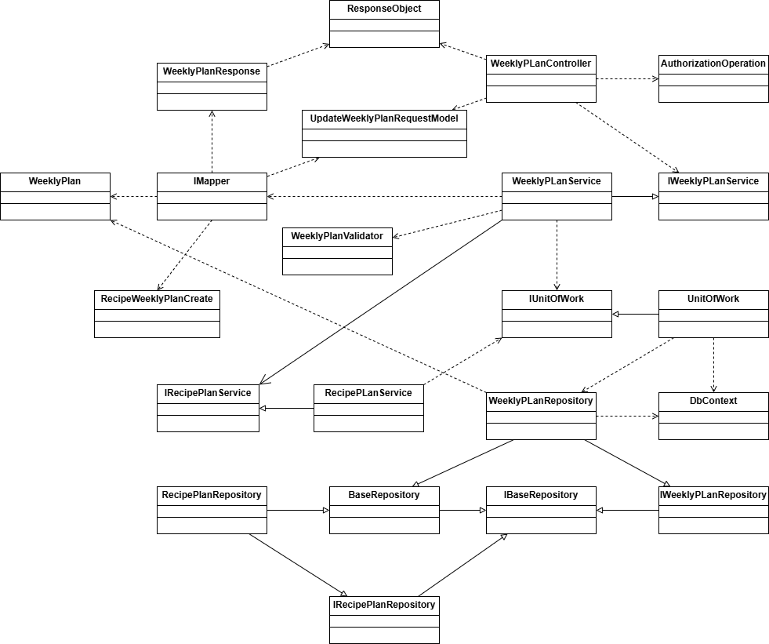

[***Reference***](https://drive.google.com/file/d/1J9TINvEKguXqbjZ4wFeg2Xuf9GWSw9o8/view?usp=sharing)

##### 

###### Class Specification

***WeekllyPlanController***

| ***N.o*** | ***Method*** | ***Description*** |
| --- | --- | --- |
| ***1*** | Task<IActionResult> Update(Guid id , [FromBody] UpdateWeeklyPlanRequestModel model) | Handle Update request from Web application |

***WeeklyPlanService***

| ***N.o*** | ***Method*** | ***Description*** |
| --- | --- | --- |
| ***1*** | Task<ResponseObject<WeeklyPlanResponseModel>> UpdateWeeklyPlanAsync(Guid id , UpdateWeeklyPlanRequestModel model); | Update chosen weekly plan |

***RecipePlanService***

| ***N.o*** | ***Method*** | ***Description*** |
| --- | --- | --- |
| ***1*** | RemoveRange(IEnumerable<RecipePLan> recipePlans); | Remove all old recipe plans, ready to update WeeklyPlan |
| ***2*** | Task<ResponseObject<List<RecipePLan>?>> CreateRecipePlanAsync(Guid weeklyPlanId, List<RecipeWeeklyPlanCreate> recipesId); | Create new recipe plans for weekly plan |

***UnitOfWork***

| ***N.o*** | ***Method*** | ***Description*** |
| --- | --- | --- |
| ***1*** | CompleteAsync() | Save all database changes from Database Context to Database |

##### C. Sequence Diagram

##### 

[***Reference***](https://drive.google.com/file/d/1UsuNRrx2HduiHweBR4-2LLle_dQIUf6B/view?usp=sharing)

# *V. Software Testing Documentation*

## 1. Scope of Testing

### 1.1 Test Model

In Wemealkit project, Incremental testing is implemented for various reasons:

* Each module assumes a definitive role in the overall project structure.
* Certain functional testing procedures can be initiated during the early stages of the development process.

### 1.2 Test Stages

#### 1.2.1 Integration Test

- In-charge: team members

- Inputs/time: Integrated code modules or components

- Focuses:

* Interaction between integrated components
* Data flow and communication between modules

- Acceptance criteria: Successful integration of components with no critical issues.

#### 1.2.2 System Test

- In-charge: team members

- Inputs/time: Complete integrated system

- Focuses:

* End-to-end functionalities
* Compatibility, performance, and reliability

- Acceptance criteria: The system meets specified requirements and operates without major issues.

### 1.3 Assumptions and Constraints:

#### 1.3.1 Assumptions

- Third-party integrations are stable and will not impact core functionality.

- The testing environment mirrors the production environment accurately.

#### 1.3.2 Constraints

- Limited testing environment resources.

- Fixed deadlines for testing phases.

## 2. Test Strategy

### 2.1 Testing Types

#### 2.1.1 Function Testing

Perform individual testing to verify each function of the major features against the functional requirements/specifications.

The detailed description of each test case will be described in the Test Report.

#### 2.1.2 User Interface Testing

Perform testing on the visual design and layout, and functionality of the user interface to verify if it meets the expected end-user requirements.

Further descriptions of each test case will be described in the Test Report.

#### 2.1.3 API testing

Perform testing for RESTful APIs implemented for web application and mobile application.

Perform testing on Postman using HTTP methods: GET, POST, PUT, and DELETE to verify the responses from Wemealkit server.

### 2.2 Test Levels

- Integration Testing: After completing a module/feature, the updated code must pass the CI/CD testing stage, all team members who are related to that function must be responsible for executing integration testing to ensure that the updated module/feature works correctly on both client-side and server-side.

- System Testing tests the complete and fully integrated Wemealkit system to evaluate the overall functionality and performance, and verifies if the system meets the end–to–end specifications and requirements.

| ***Type of Tests*** | ***Test Level*** | | | |
| --- | --- | --- | --- | --- |
| ***Unit*** | ***Integration*** | ***System*** | ***Acceptance*** |
| Function Testing |  | X | X |  |
| User Interface Testing |  | X | X |  |
| API Testing |  | X | X |  |

*Table 208. Test Levels*

## 

## 3. Test Plan

**3.1 Human Resources**

| ***Worker/Doer*** | ***Role*** | ***Specific Responsibilities/Comments*** |
| --- | --- | --- |
| Lê Thanh Danh | Leader | Manage test/human resources  Assign test task  Execute tests and report  Review test cases  Verify test results |
| Võ Tuấn Khanh | Member | Execute tests and report  Review test cases  Verify test results |
| Dương Tuấn Kiệt | Member | Create test plan  Execute tests and report  Review test cases  Verify test results |
| Nguyễn Võ Hoàng Long | Member | Execute tests and report  Review test cases  Verify test results |

*Table 209. Human Resources*

### 3.2 Test Environment

| **Purpose** | **Tool** | **Provider** |
| --- | --- | --- |
| View logs of web application | Chrome DevTools | Chrome |
| Test case management | Microsoft Excel | Microsoft |
| Manage API list and manual  API testing | Postman | Postman |
| WebAdmin IDE | Visual Studio Code | Microsoft |
| Backend Api IDE | Visual Studio | Microsoft |
| Mobile Application IDE | Visual Studio Code | Microsoft |
| Execution hardware | Testing is implemented on  computers with the  following specifications:  - CPU: Intel i5/i7  - RAM: ≥4GB  - Storage device:  HDD or SSD | Any providers |
| *Communication* | *Google Meet*  *Messenger* | *Google*  *Facebook* |

*Table 210. Test Environment*

### 3.3 Test Milestones

| **Milestone Task** | **Due Date** |
| --- | --- |
| **Final Test Document** | |
| *Test Report* | *21/09/2024* |

*Table 211. Test Milestones*

## 4. Test Cases and Test Reports

| **Testing Level** | **File Name** |
| --- | --- |
| System Test | [Report_Test Report_Mobile Application](https://docs.google.com/spreadsheets/d/1_3P6mgtjRoQ2uGzw73d5exIuFIcHgzvnynXAev6rzTg/edit?gid=1642106646#gid=1642106646)  [Report_Test Report_Web Dashboard](https://docs.google.com/spreadsheets/d/1kCQNQZhJHI7IC225zb4mK7Ye9trQJ4cuEopKizdL-uE/edit?gid=1799464206#gid=1799464206) |

*Table 212. Test Cases and Test Reports*

# VI. Release Package & User Guides

## 1. Deliverable Package

| **No.** | **Deliverable Item** | **Sub-Items** | **Type** | **Version** |
| --- | --- | --- | --- | --- |
| **Code package** | | | | |
| 1 | WeMealKit Back-end | API service | Modify | 1.0 |
| 2 | WeMealKit Website | Dashboard website application | Modify | 1.0 |
| 3 | WeMealKit Mobile Application | Mobile application | Modify | 1.0 |
| **Database** | | | | |
| 4 | Database Script(s) | wemealkit.sql | Modify | 1.0 |
| **Documents** | | | | |
| 5 | Final Report Document | Report7-Final-Project-Report.docx | Modify | 1.0 |
| 6 | Test Cases Document | Report5-Test-Report.xlsx | Modify | 1.0 |
| 7 | Slide | WeMealKit-Final-Slides.pptx | Modify | 1.0 |

## 2. Installation Guides

### 2.1 System Requirements

| **Component** | **Minimum** | **Recommended** |
| --- | --- | --- |
| **For PCs** | | |
| Network | Internet Connection | Internet Connection |
| Operating System | Windows 7 | Windows 10 |
| Memory | 4GB RAM | 8GB RAM or more |
| Web Browser | Chromes/Edge | Chrome/Edge latest stable version |
| **For Mobiles** | | |
| Network | Internet Connection | Internet Connection |
| Operating System | Android 6.0/iOS 10.0 | Android 6.0/iOS 10.0 or higher |
| Storage | 1GB | 2GB |
| Memory | 4GB RAM | 8GB RAM |

### 

### 2.2 Installation Instruction

#### 2.2.1. Environment setup

* Download and install Nodejs 18.20.4 and up
* Download and install SQL Server
* Download and install Visual Studio 2019 (or 2022)
* Download and install Visual Studio Code
* Download and install Android Studio
* Download and install git
* Connect to git repository with Github account
* Pull code from Github to local

#### 2.2.2. Run Back-end server

* Pull code from Github repository[here](https://github.com/DanhThanhLe/WMK_BE_01).
* Open project with Visual Studio 2019 (or 2022).
* Config start-up project to WMK_BE_RecipesAndPlans_Controller.
* Run the project, then you will be navigated to [Swagger UI](http://localhost:5035/swagger/index.html) for API.

#### 2.2.3. Run Dashboard website application

* Pull code from Github repository [here](https://github.com/KhanhVT2710/WMK_WebAdmin).
* Create a file name .env.local, edit with Notepad/Notepad++ the add some texts:

VITE_API_URL_BE=https://api.wemealkit.ddns.net

VITE_API_KEY_GEO=c2abc0542a2e4823b3db665fdc0acb2c

VITE_API_BASE_NAME=

* **VITE_API_URL_BE** value will be your [Swagger UI](http://localhost:5035/swagger/index.html) if run website application in local.
* **VITE_API_KEY_GEO** value can be obtained from [here](https://developers.google.com/maps/documentation/geolocation/overview).
* Copy .env.local then paste into the project.
* Open project Visual Studio Code.
* Open the Terminal (Ctrl + Shift + `).
* Enter commands in order to run project:
* **bun -i** (for installing packages and set up the .env.local file).
* **bun run dev** (for running project).
* Navigate http://localhost:5173/ in the Terminal console to open the local website.

Run web on link [wemealkit-dashboard.vercel.app](https://wemealkit-dashboard.vercel.app/sign-in)

#### 2.2.4. Run Mobile application

* Pull code from Github repository [here](https://github.com/nglong2/It-Can-Cook).
* Open project with Visual Studio Code

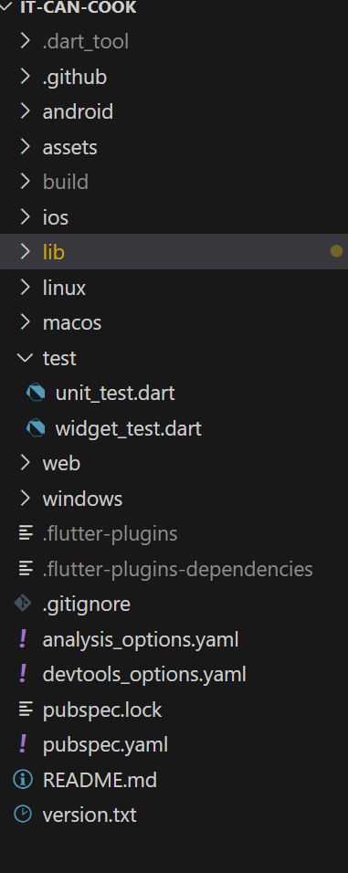

* Run cmd flutter pub get

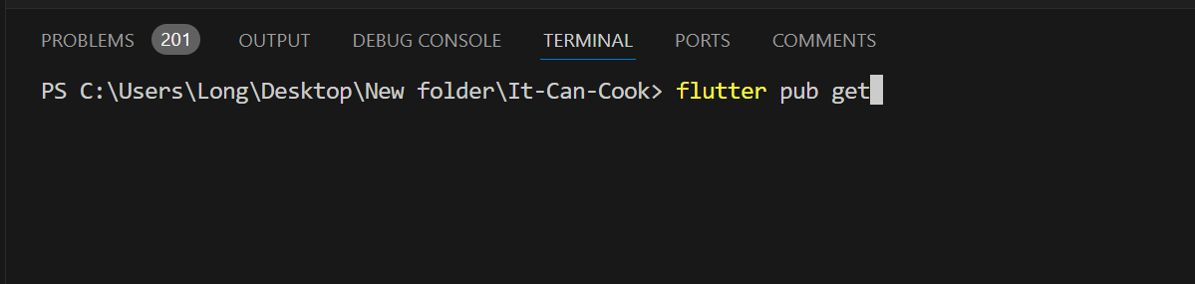

* Connect to android device or run virtual device
* Run cmd flutter run

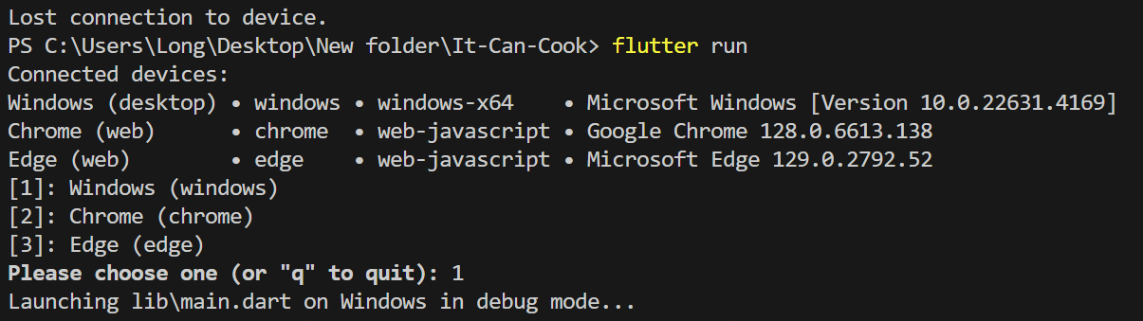

* Application will show on screen



## 3. User Manual

### 3.1 Overview

### Mobile Workflow:

#### 3.1 Workflow 1 - Order on Mobile application

##### ***3.1 View app by Guest***

1. View list Weekly plan and list Recipe

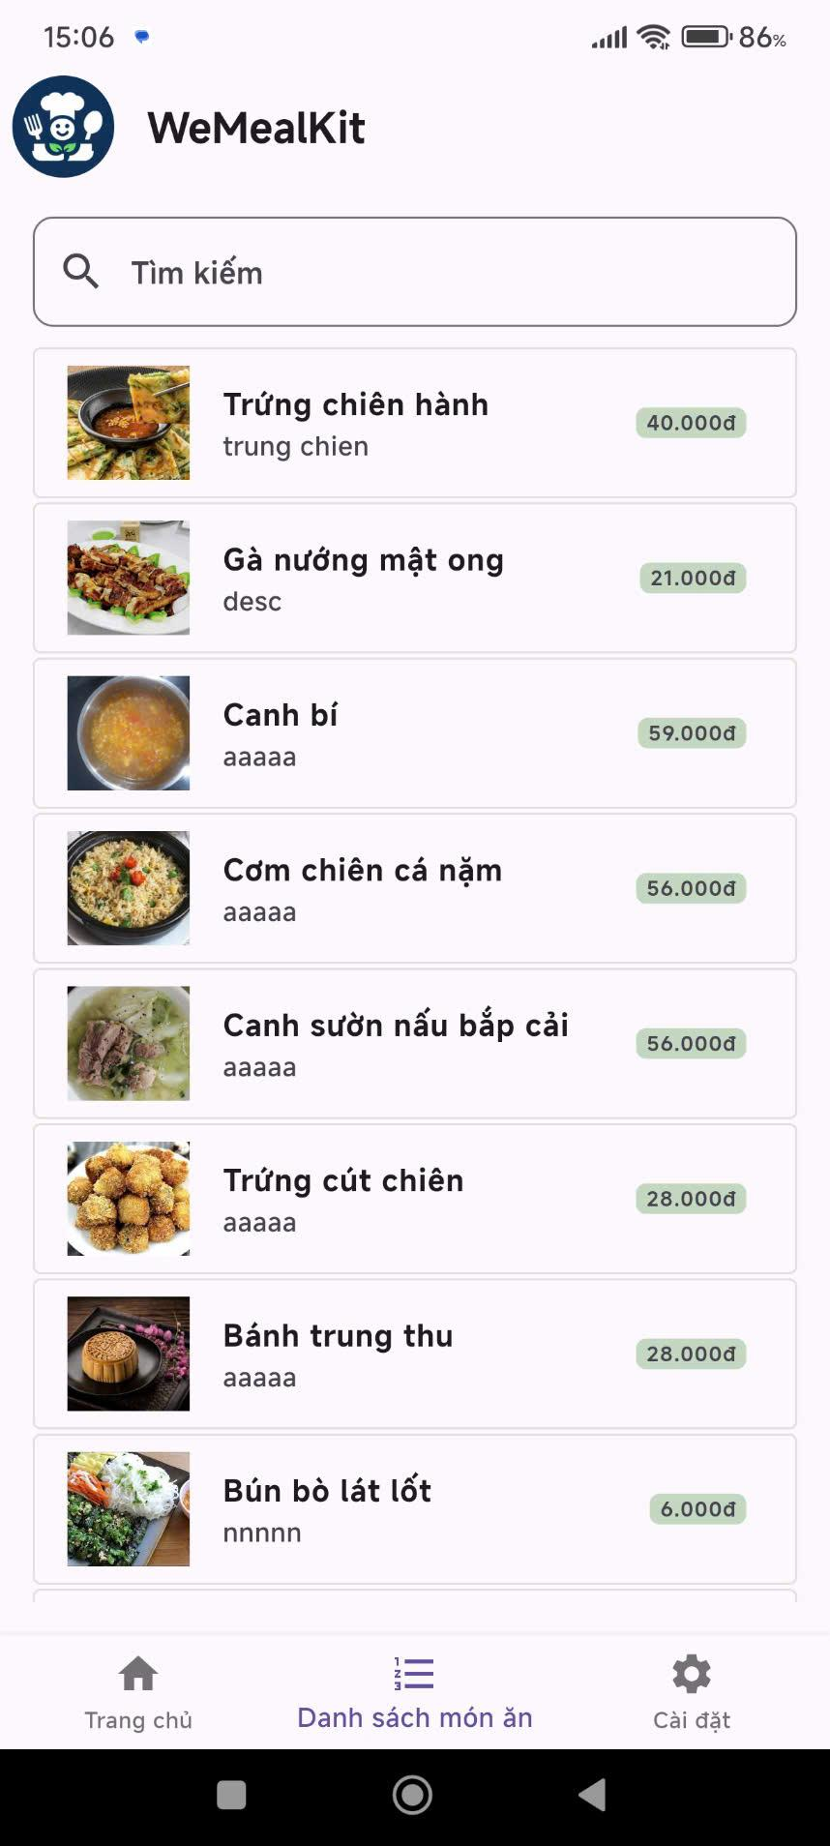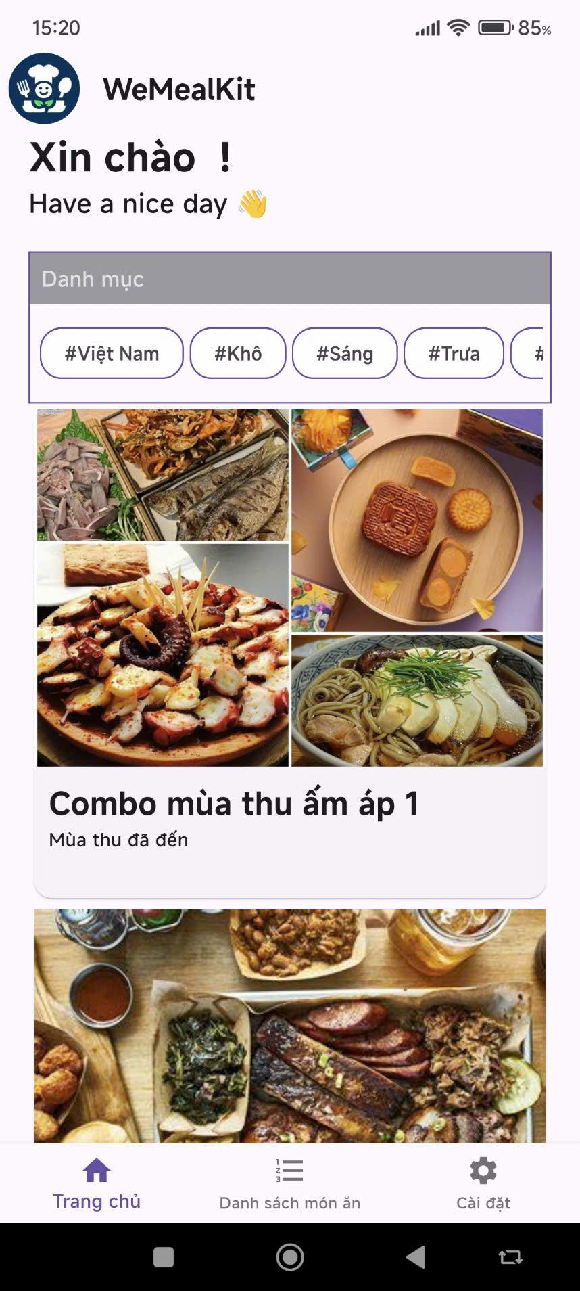

1. View Weekly plan detail by pressing on chosen weekly plan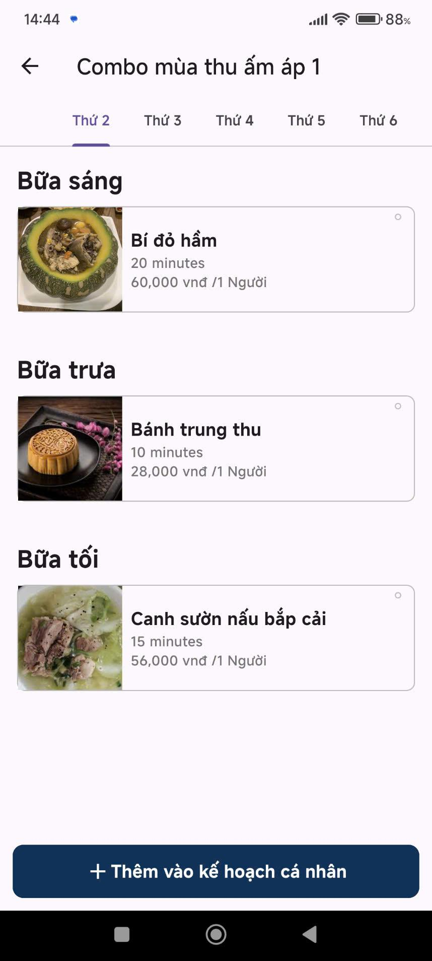

3.Click on a recipe to view its detail

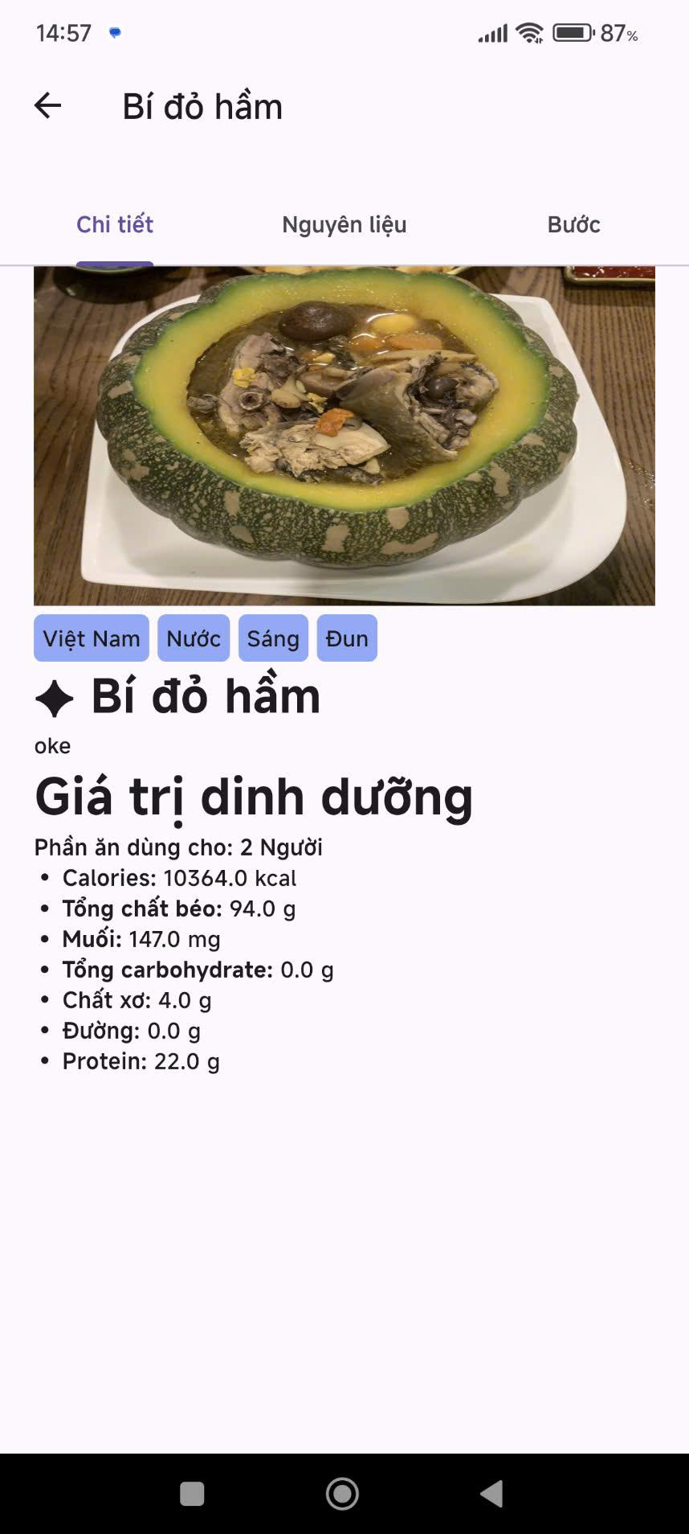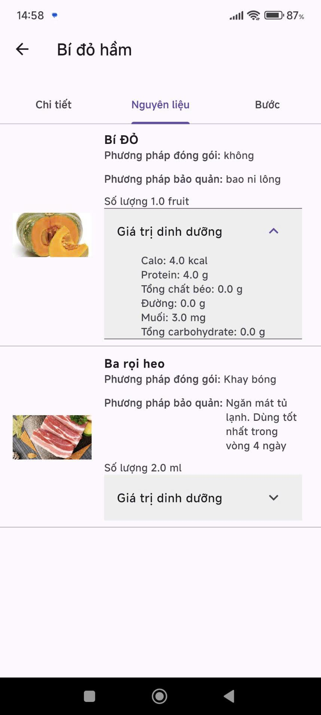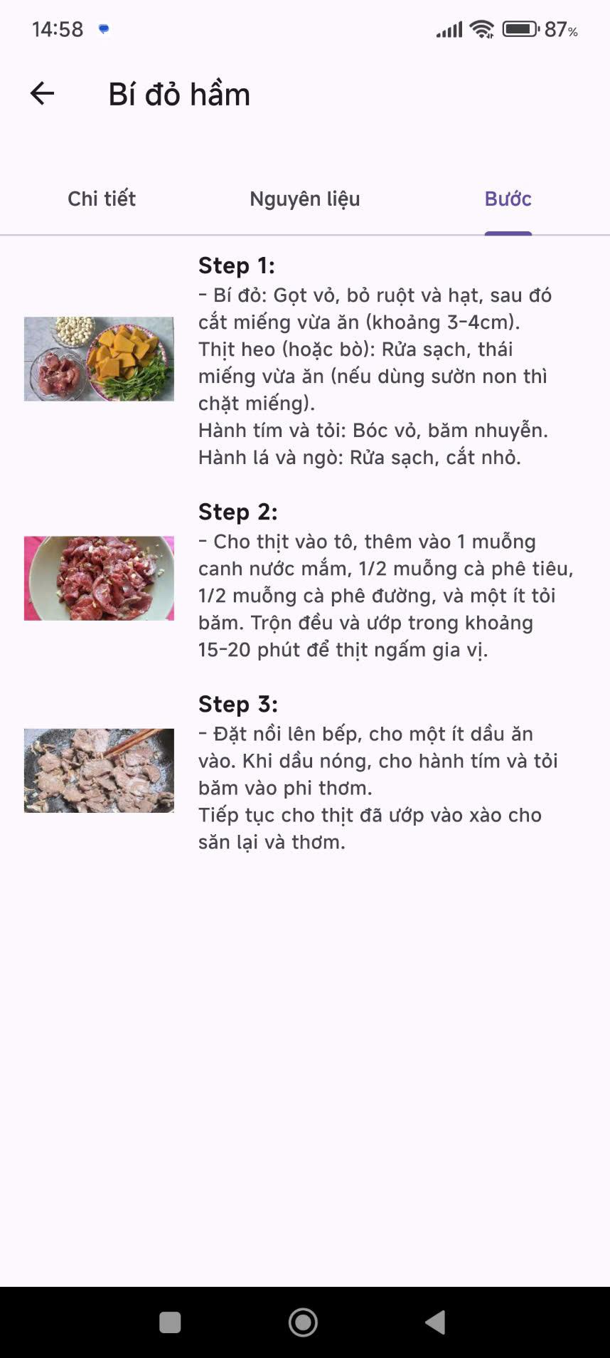

5. Register

Register Success will turn back to Login form

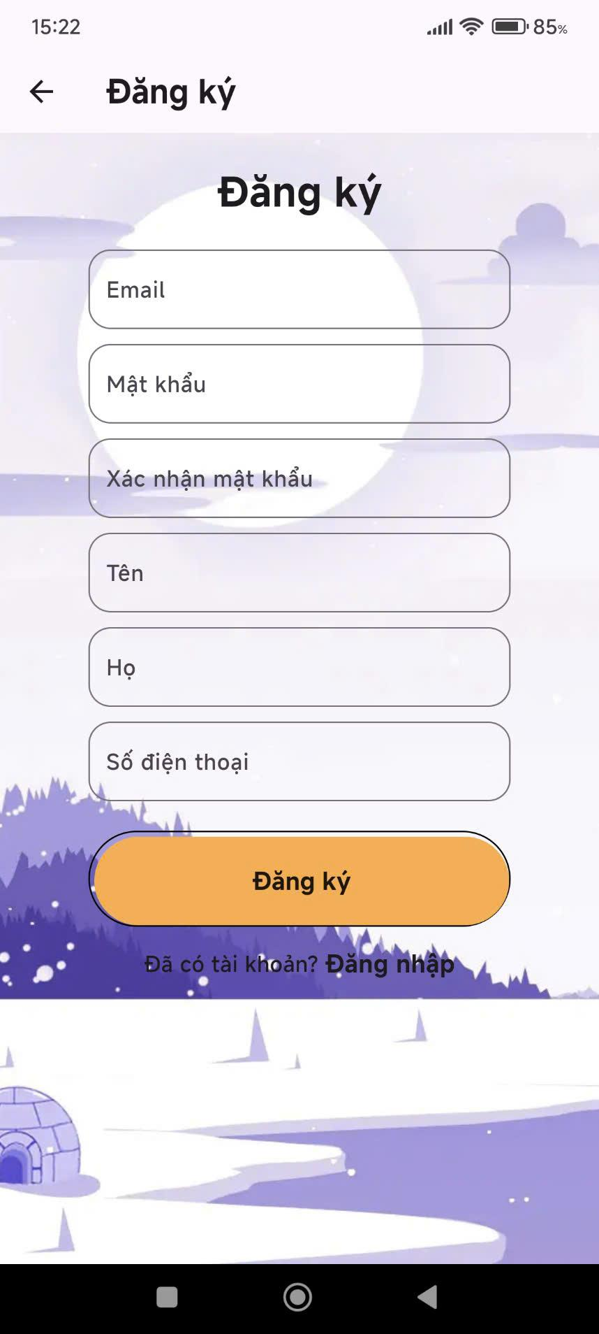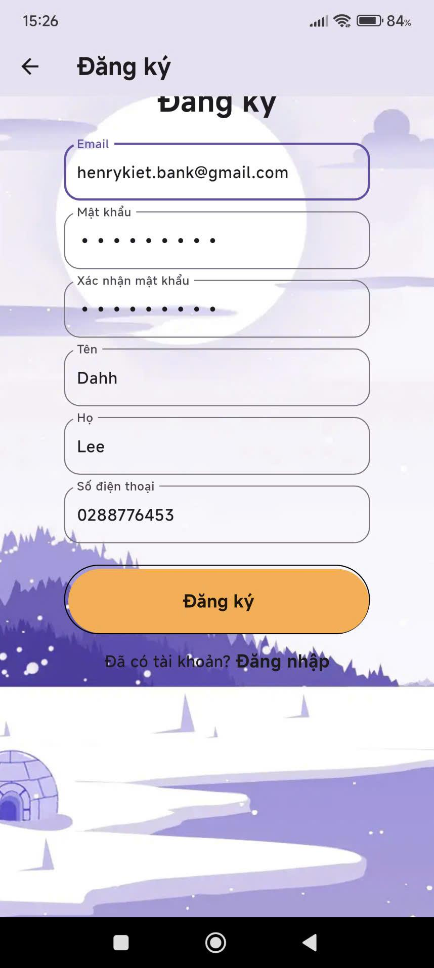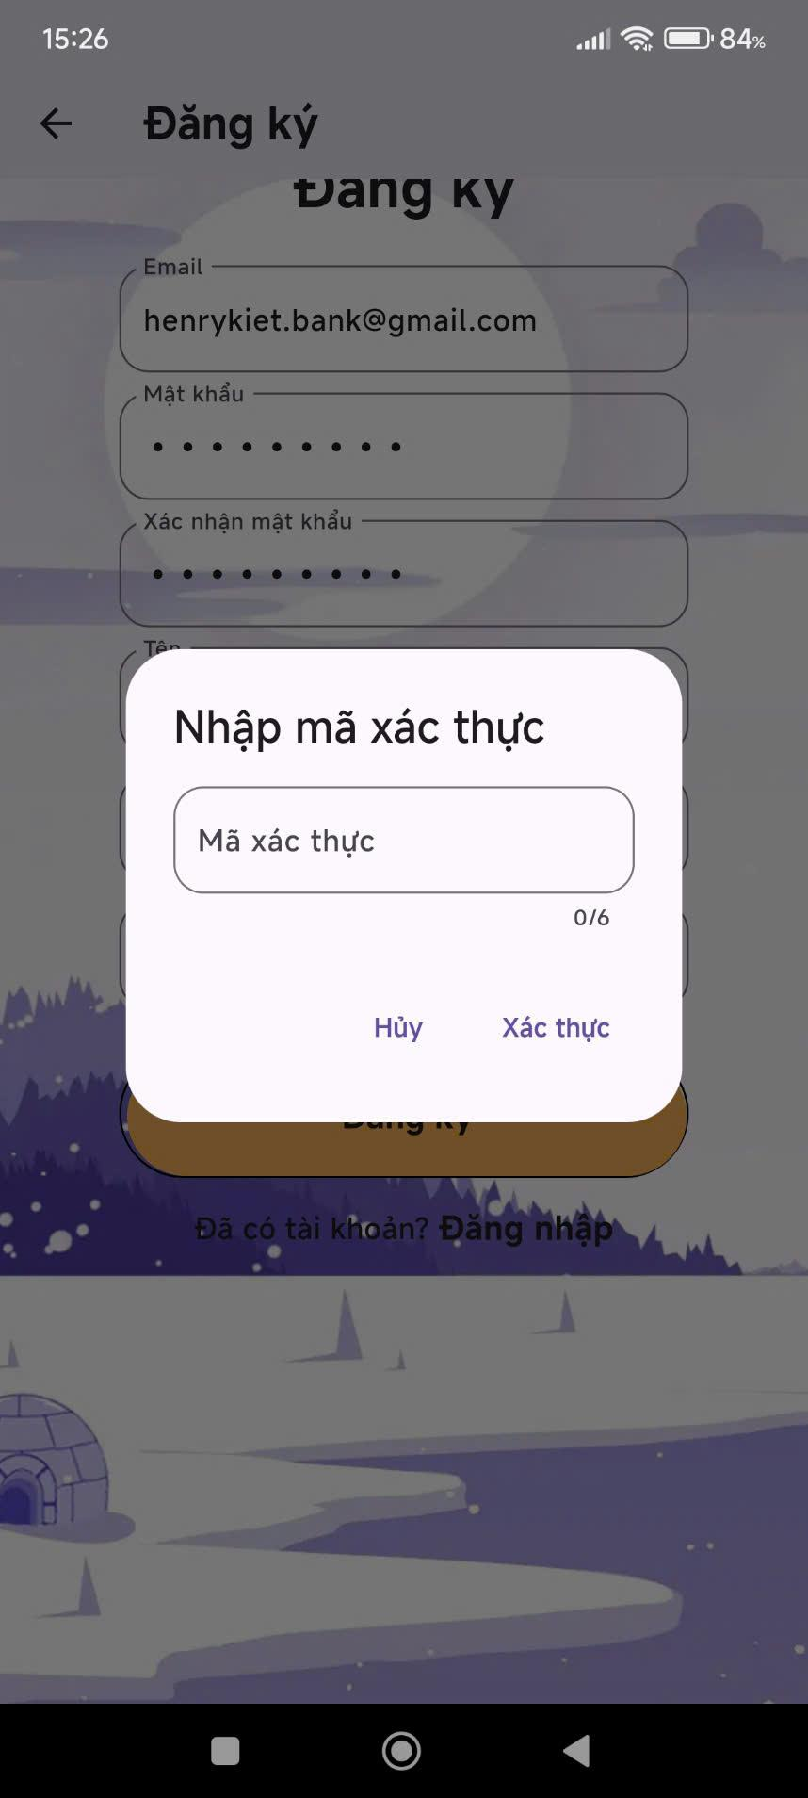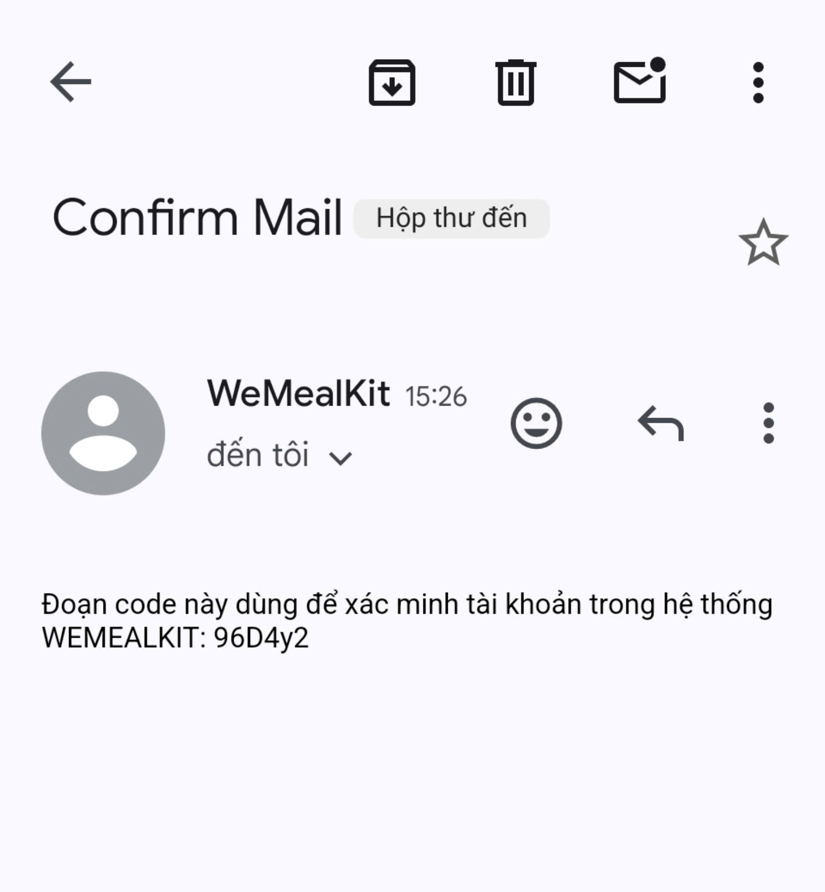

6. Login

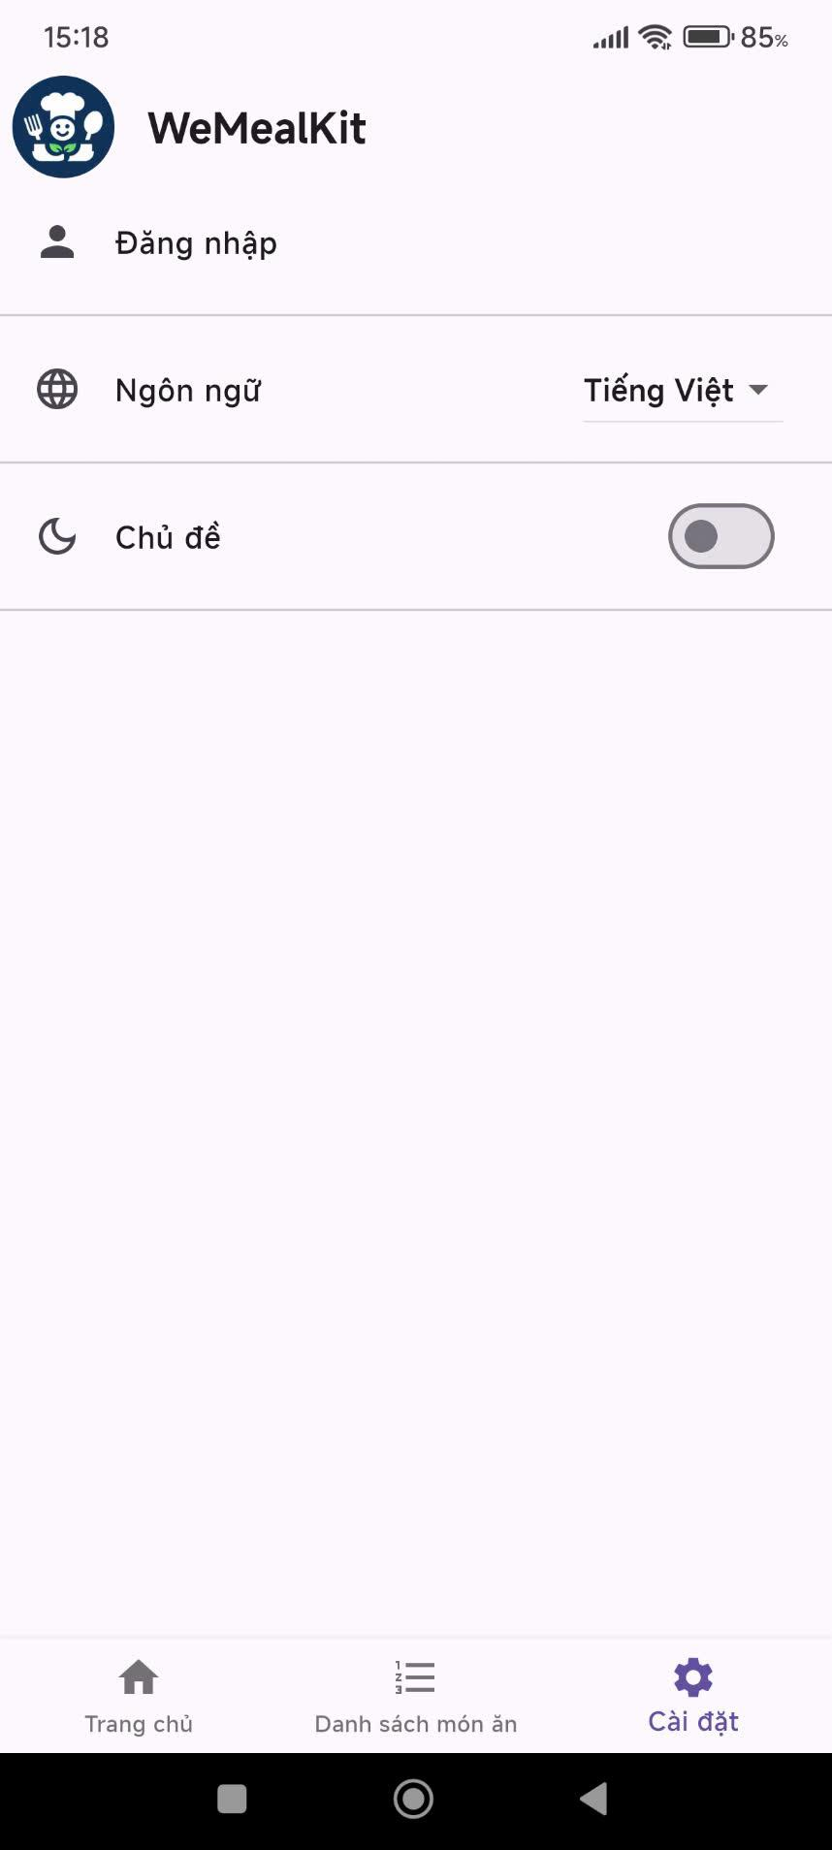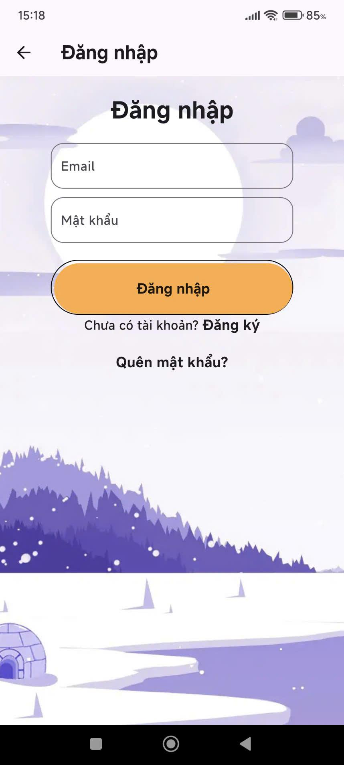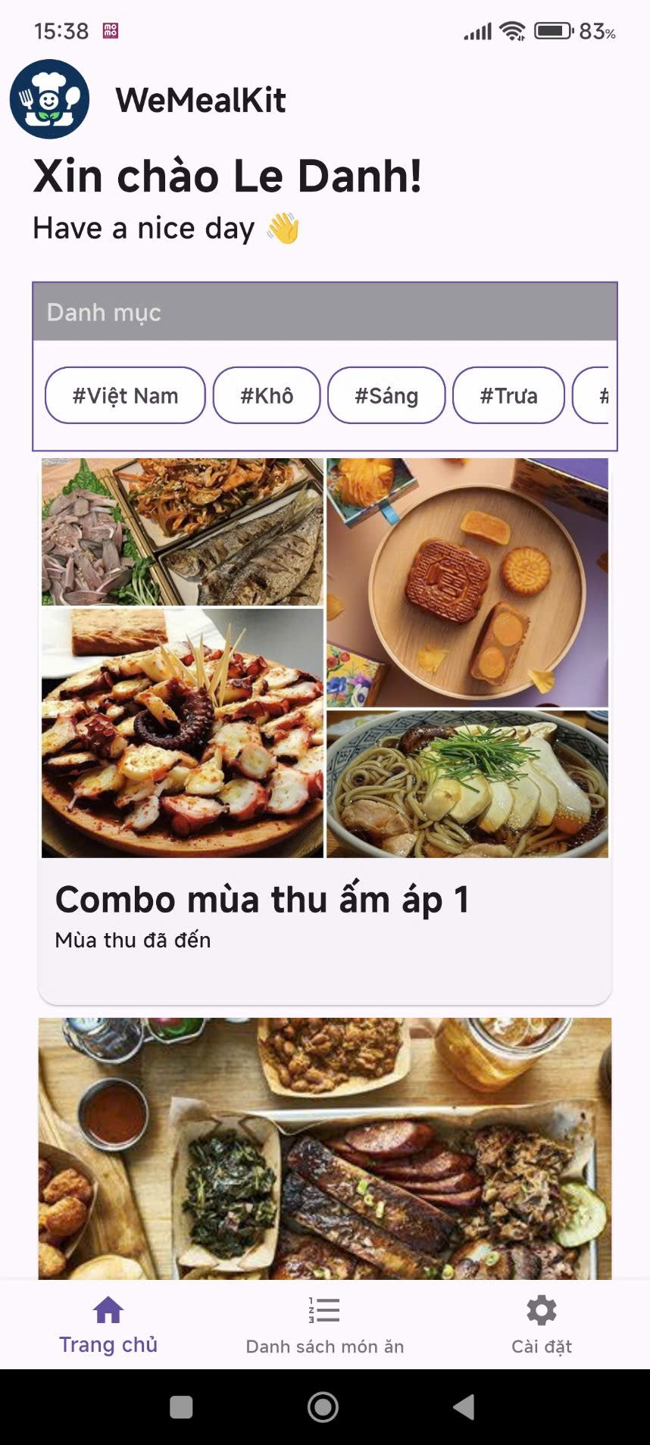

7. Add weekly plan to wish list

7.1 Wish list full show error

### 

7.2 Delete wish list

### 

7.3 Add to wish list success

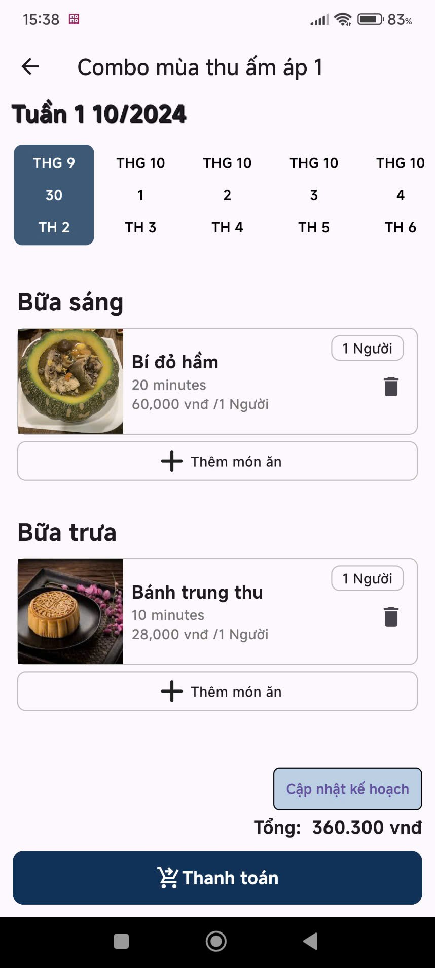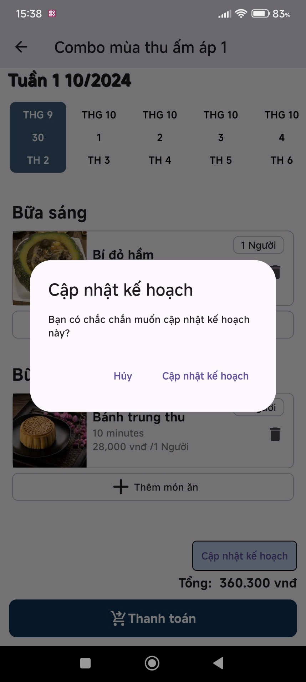

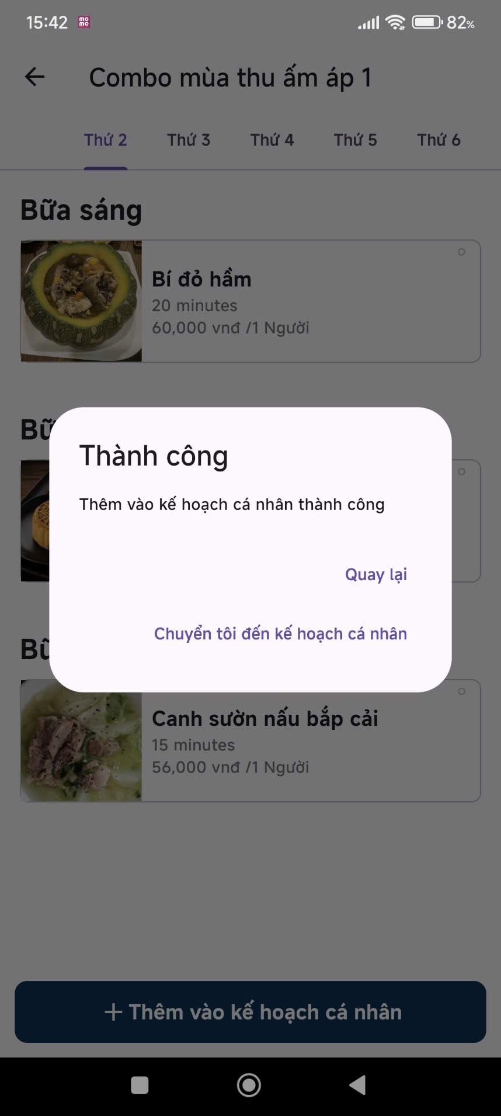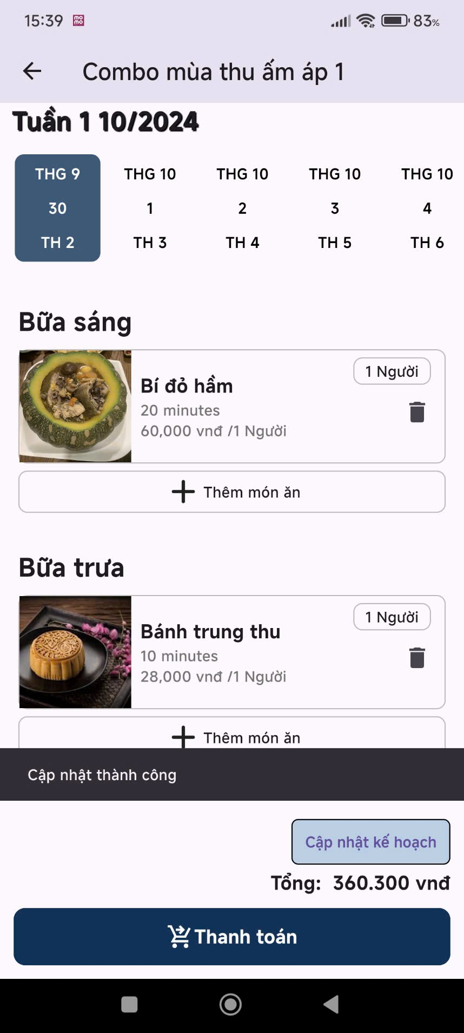

8. Create order weekly plan

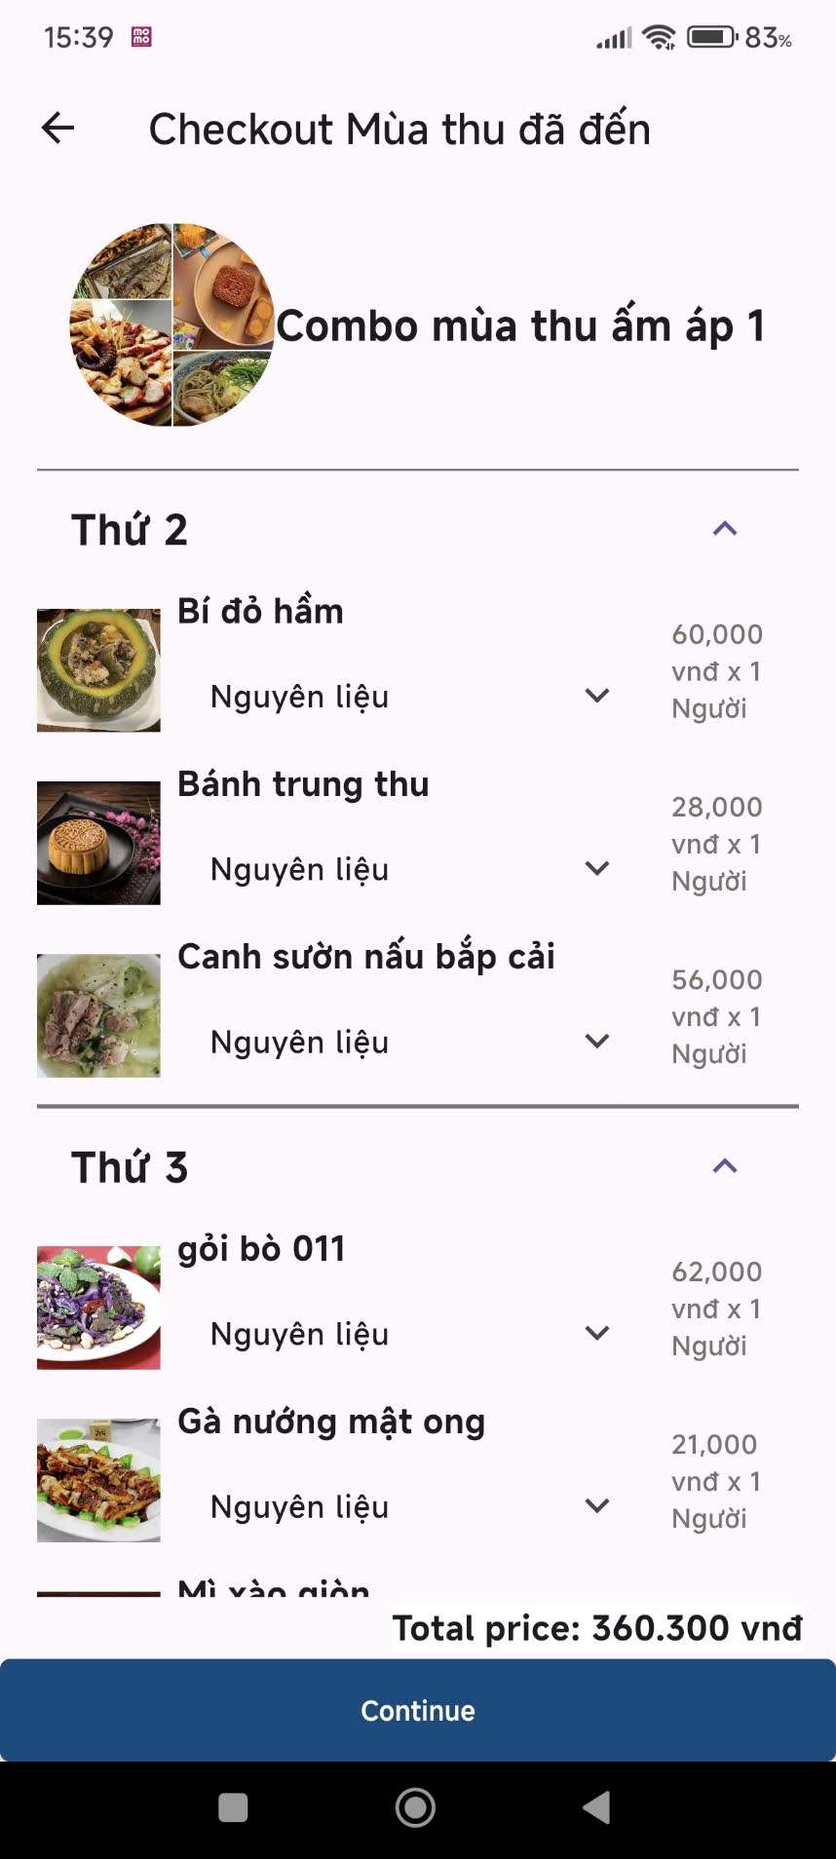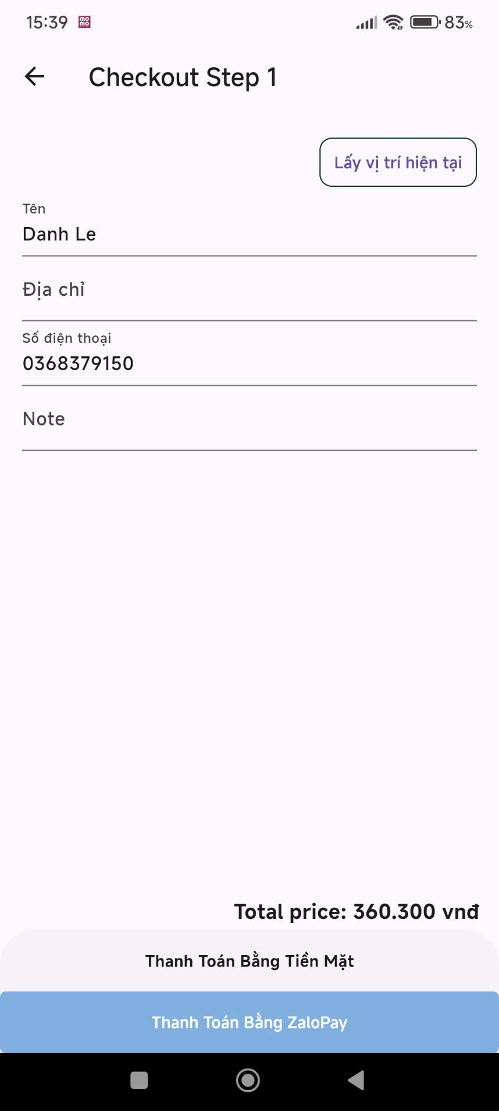

Push “Lấy vị trí hiện tại” to get current location

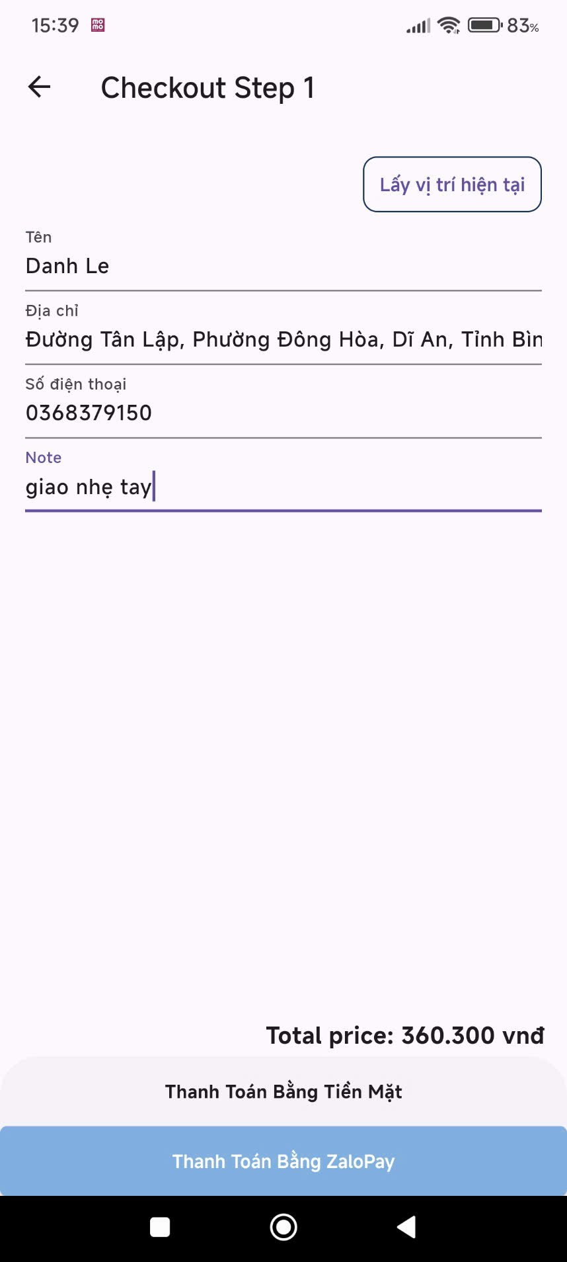

9. Payment with ZaloPay

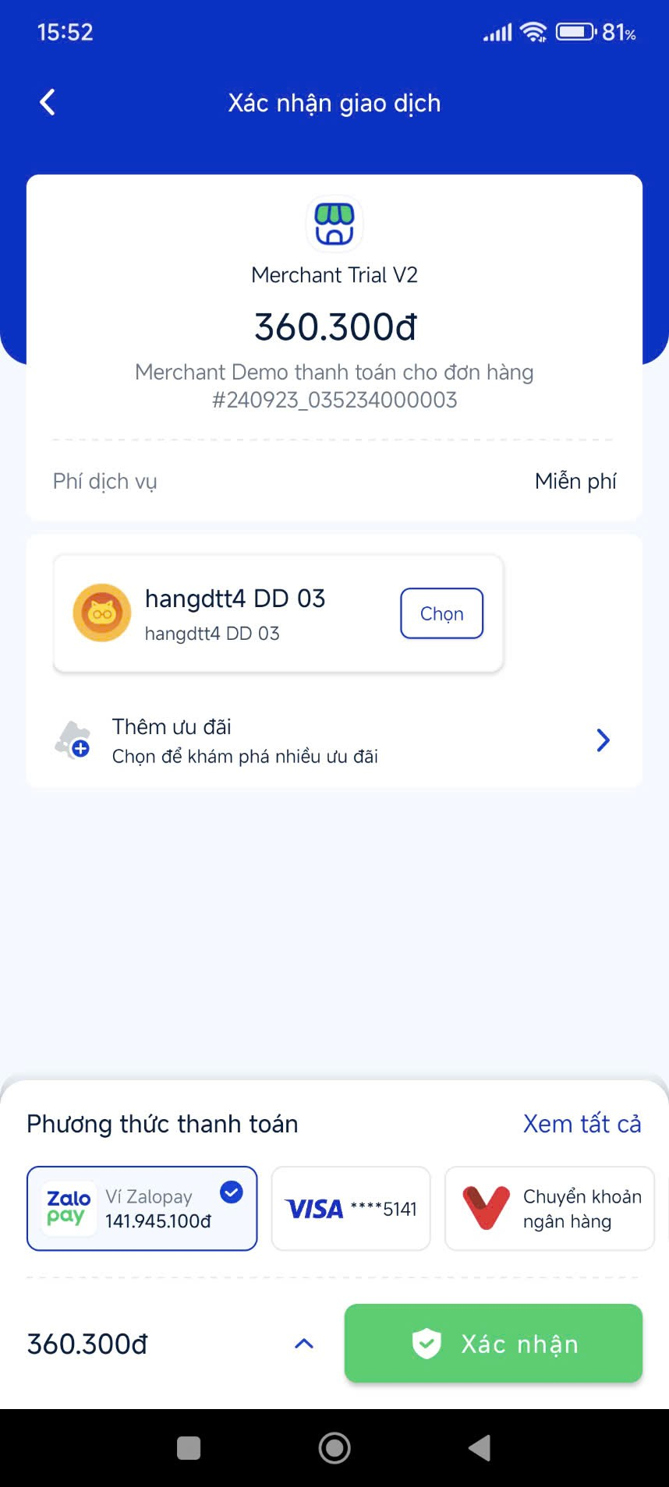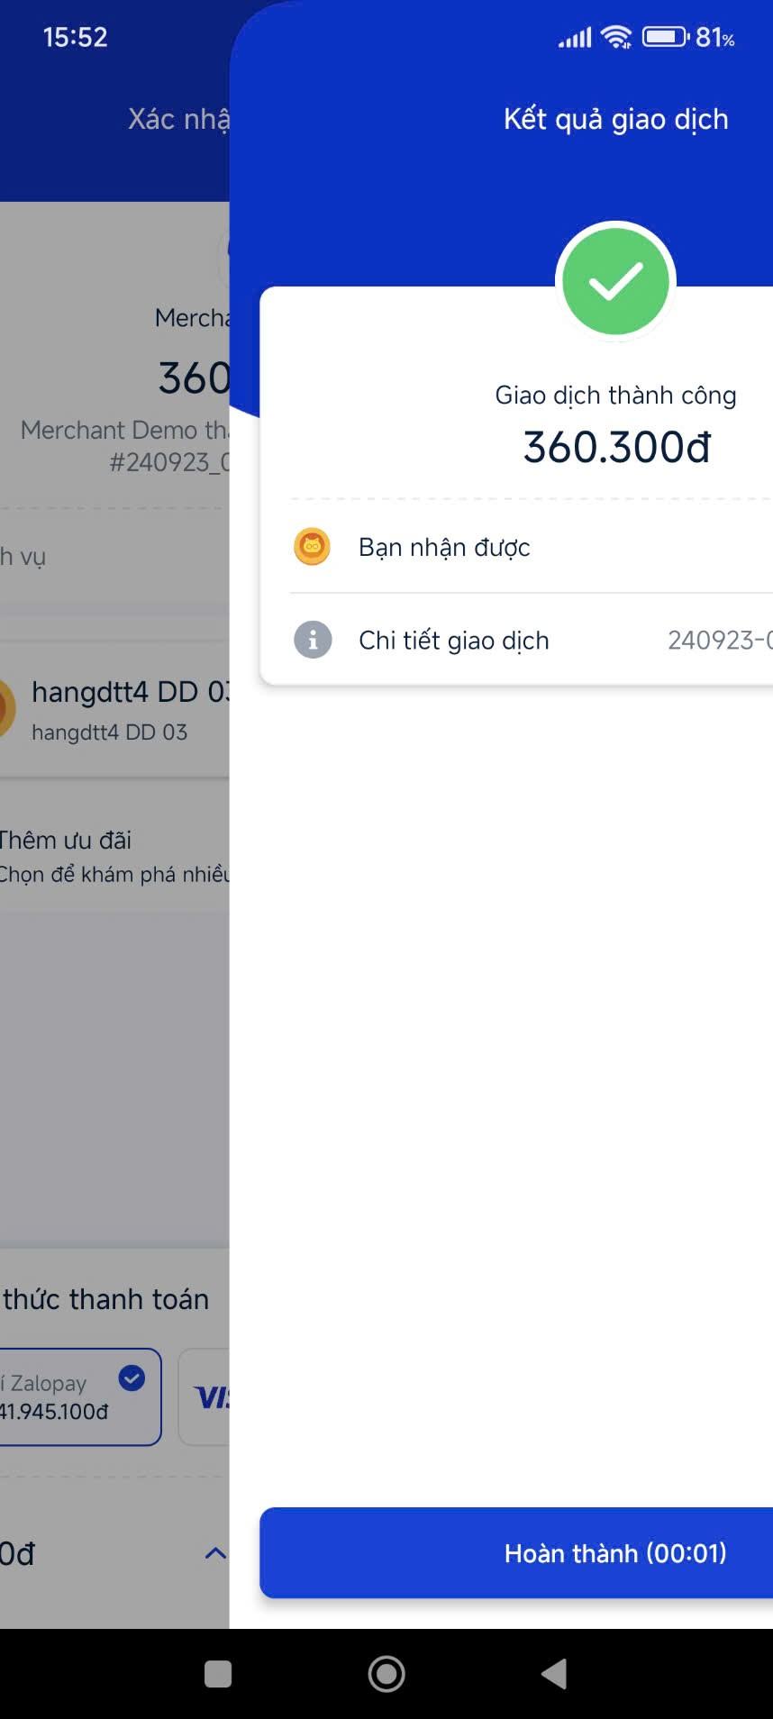

If COD then success and postpaid

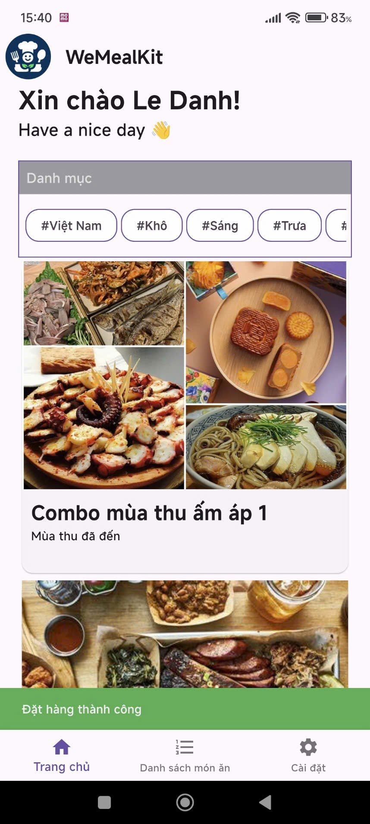

#### 3.2 Workflow 2 - Shipper delivery on Mobile application

3.2.1 View and Take order

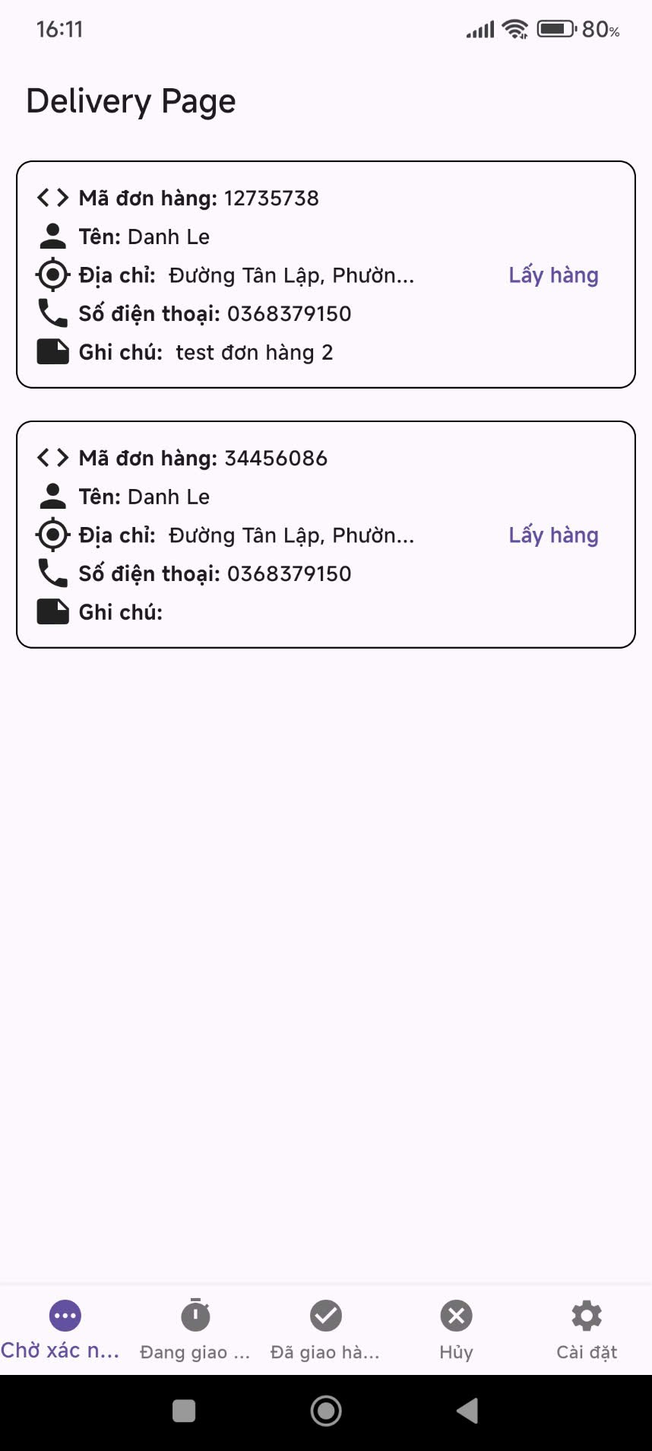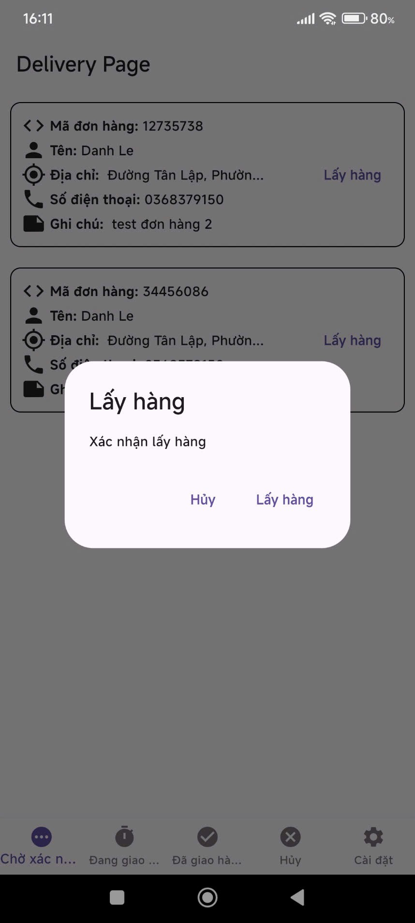

3.2.2 Shipping

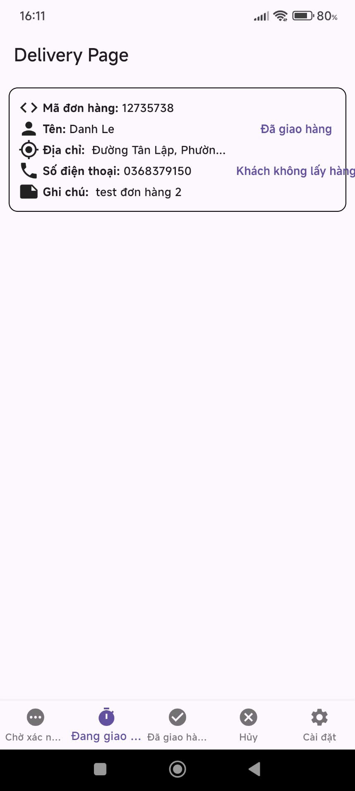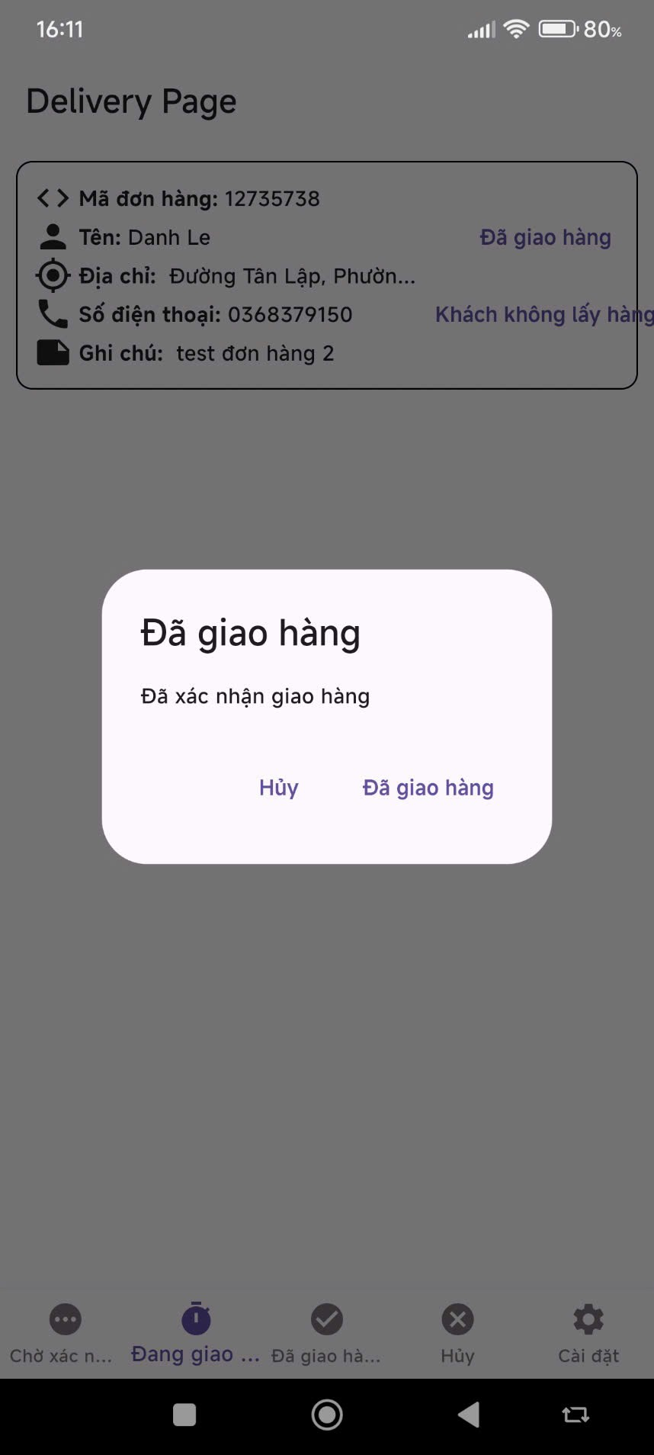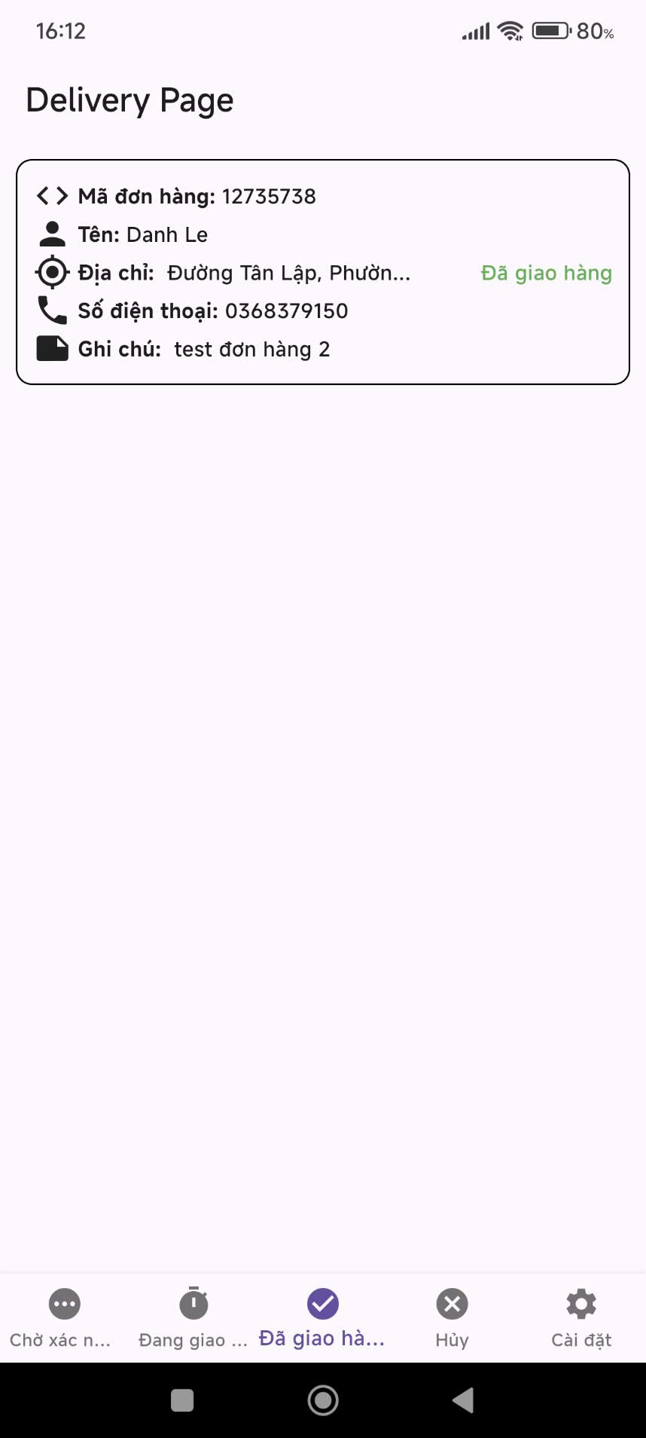

### If delivery un success

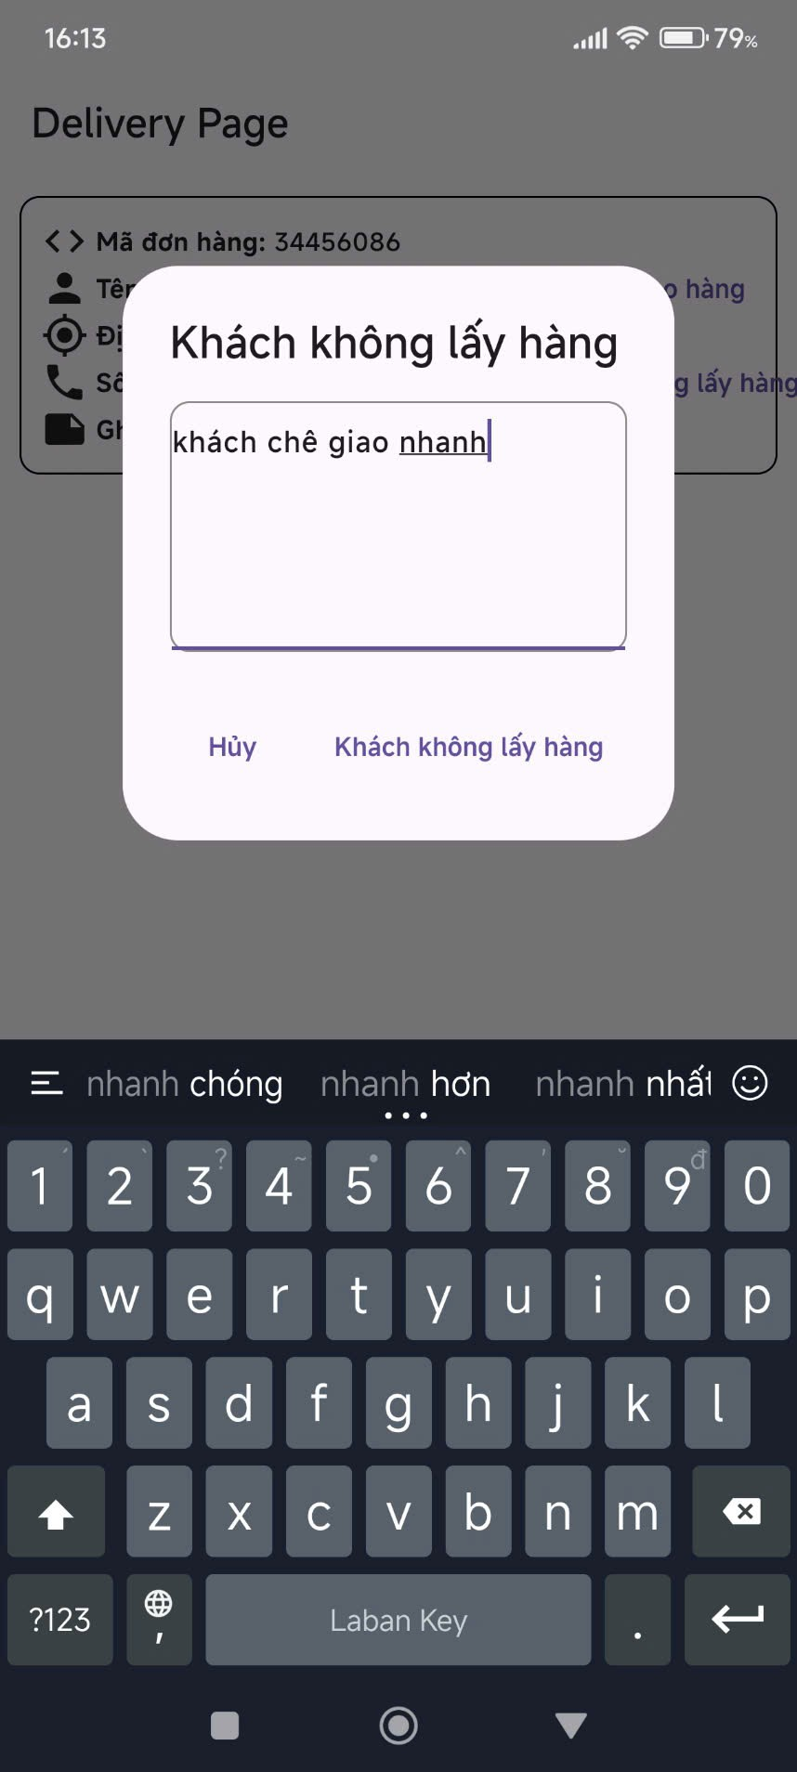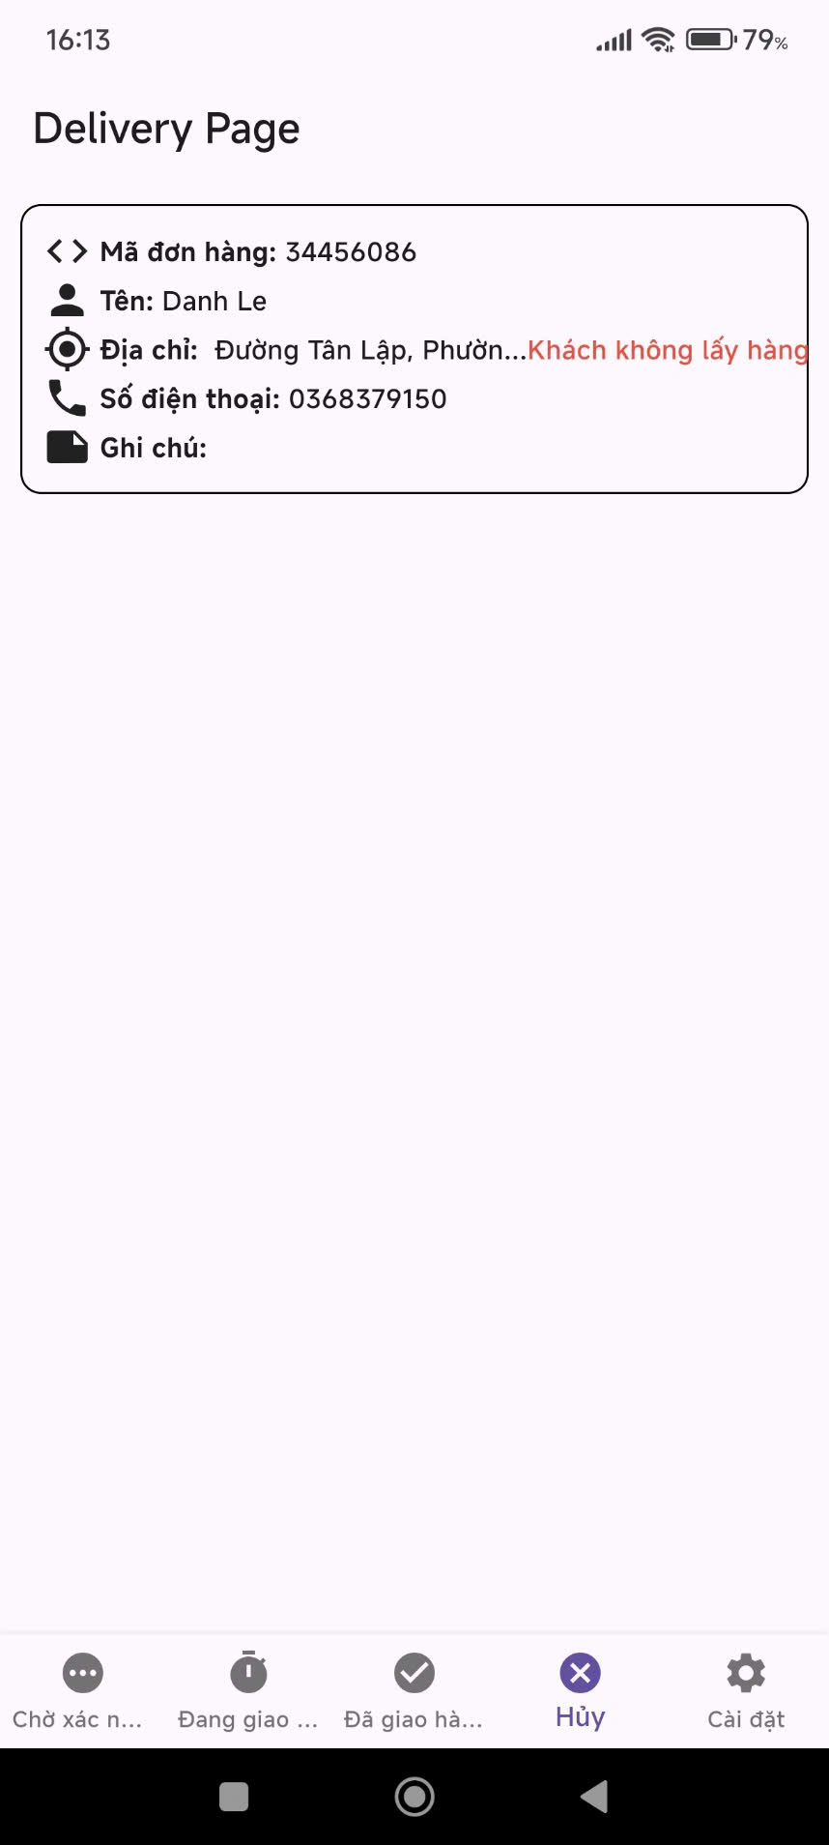

**3.3 Workflow 3 - Customer view history order**

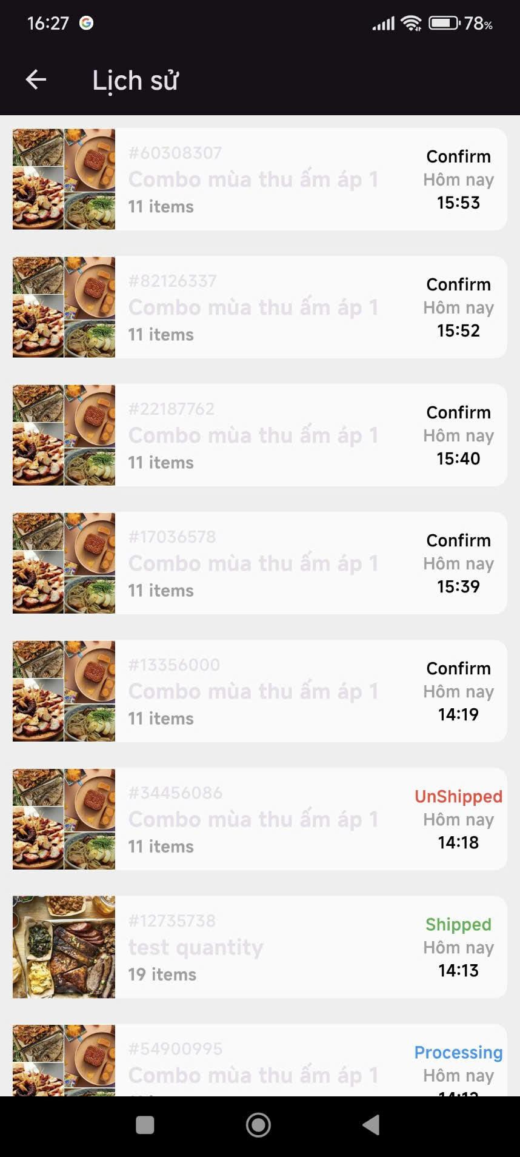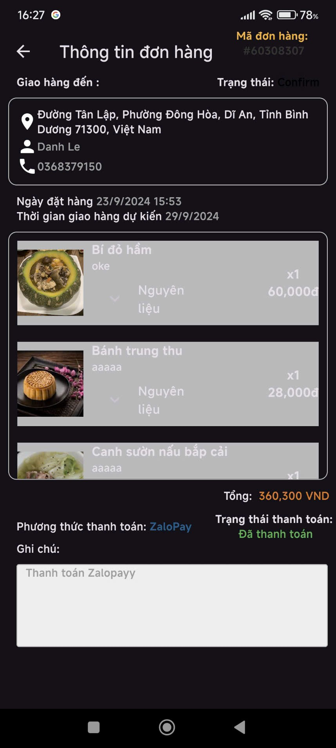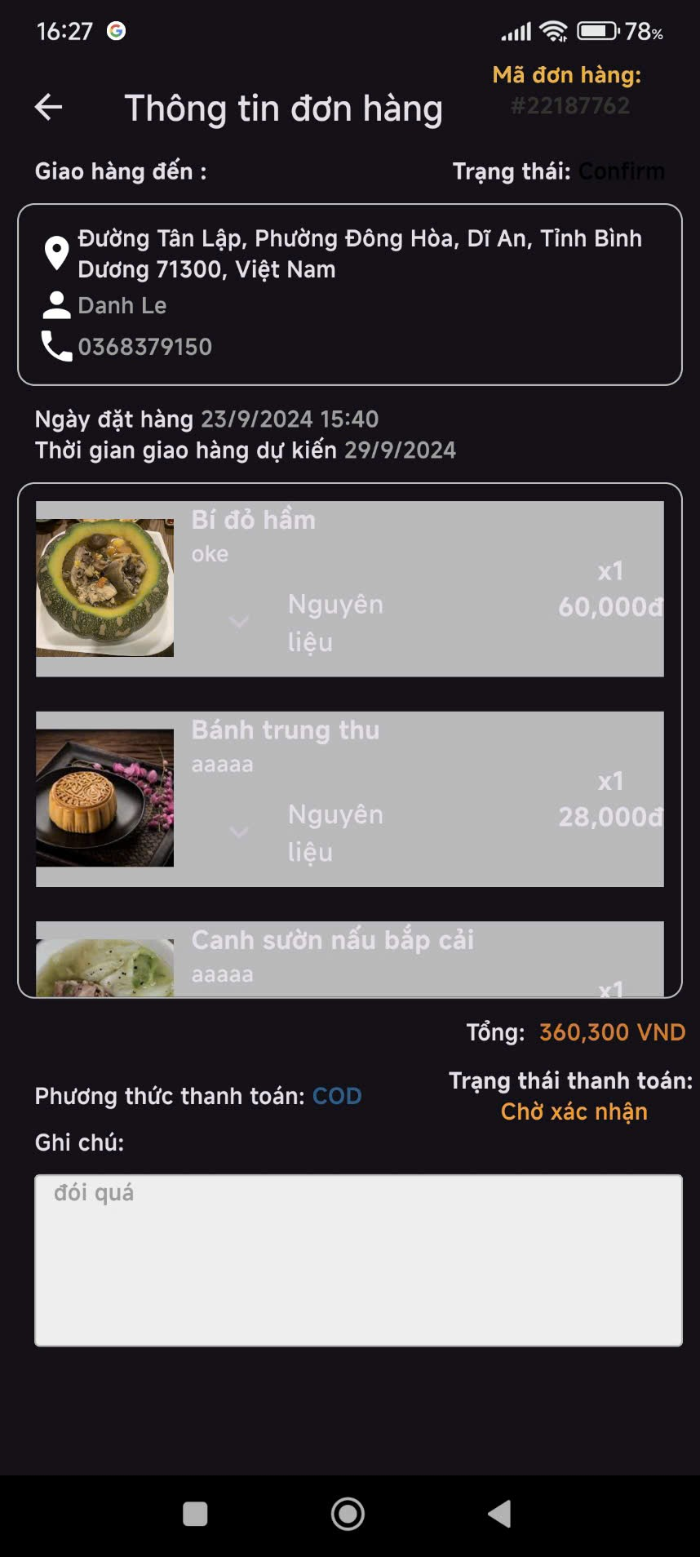

### 

### 

### B. Website Workflow:

#### 3.2 Workflow 1

***3.2.1. Login account***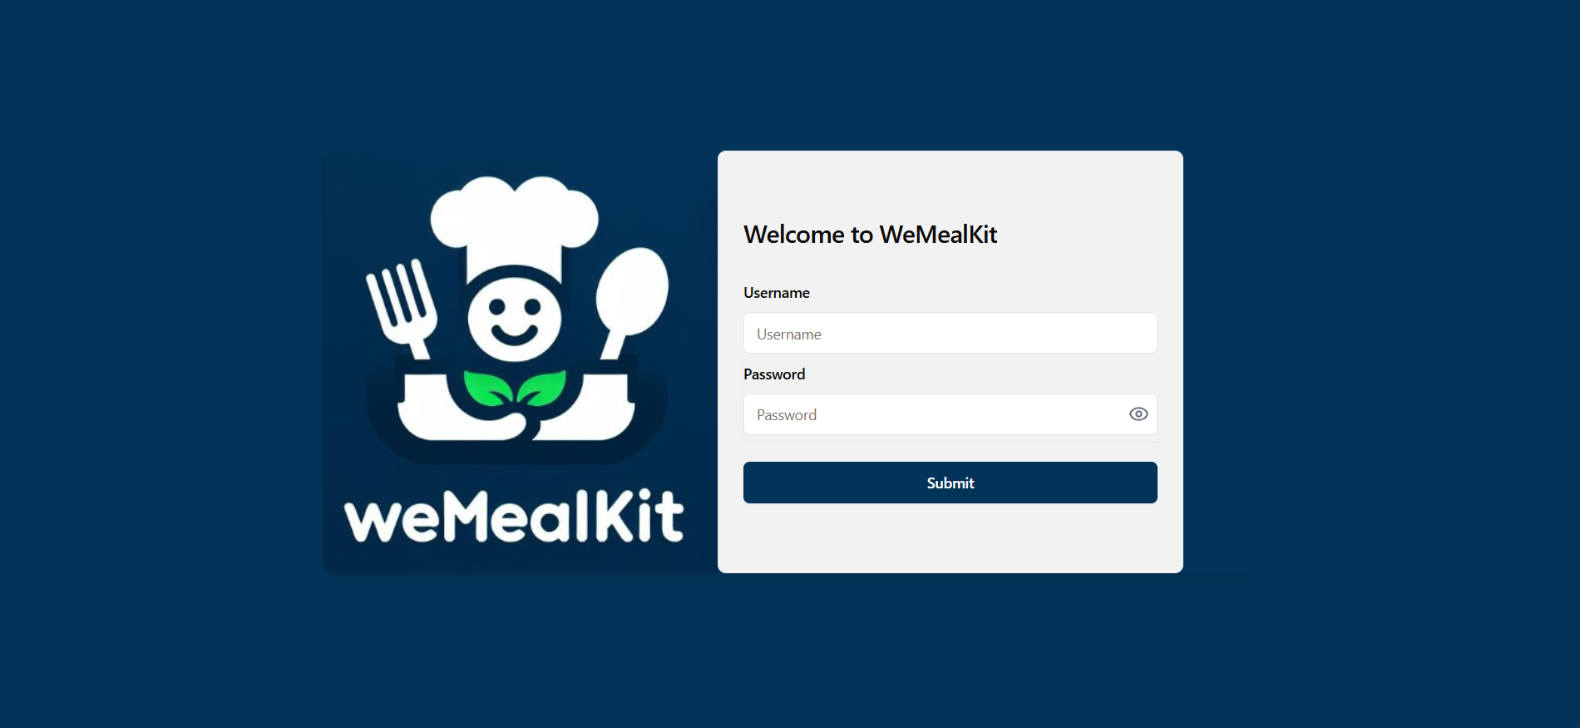

1. If the user logs in with the wrong account, the error pop-up displays, it will be rejected.

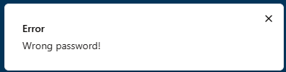

1. If the user log in with admin account, the interface will appear:

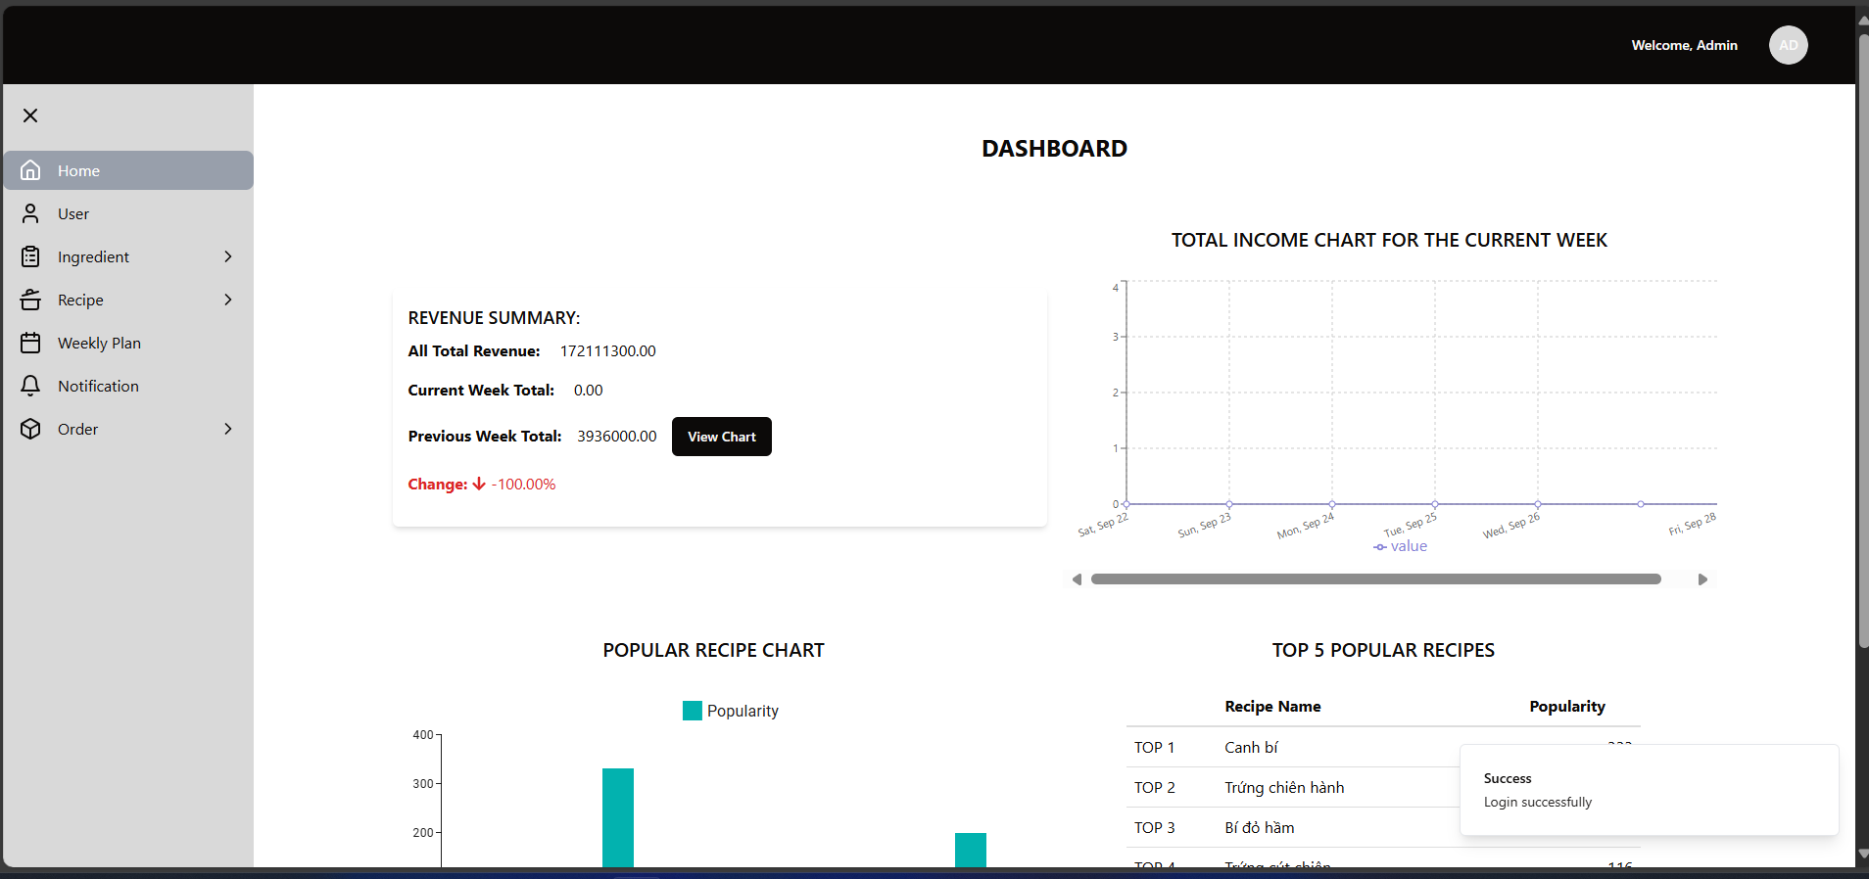

1. If the user log in with manager account, the interface will appear:

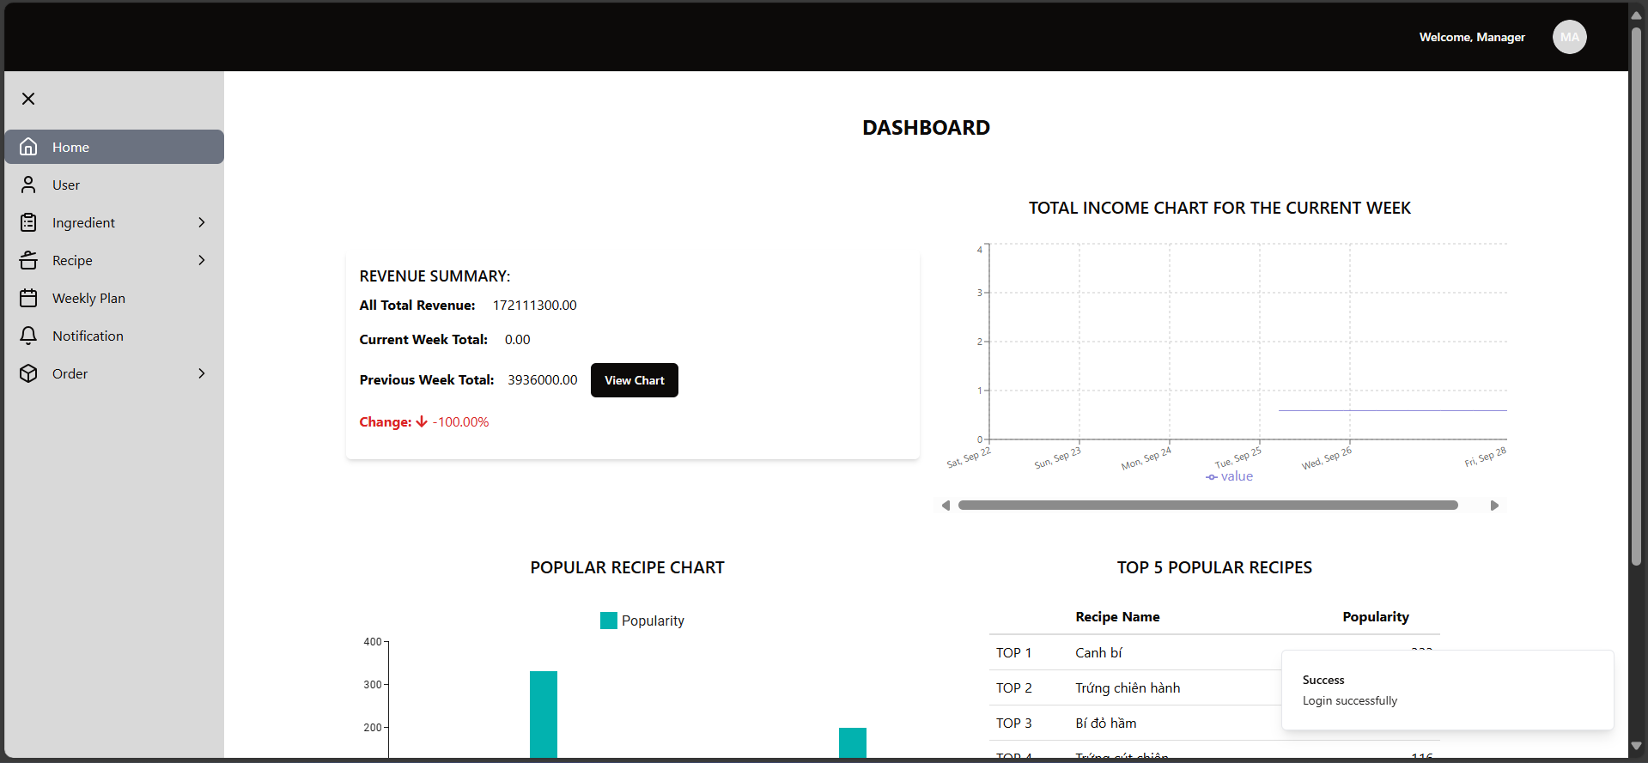

1. If the user log in with staff account, the interface will appear:

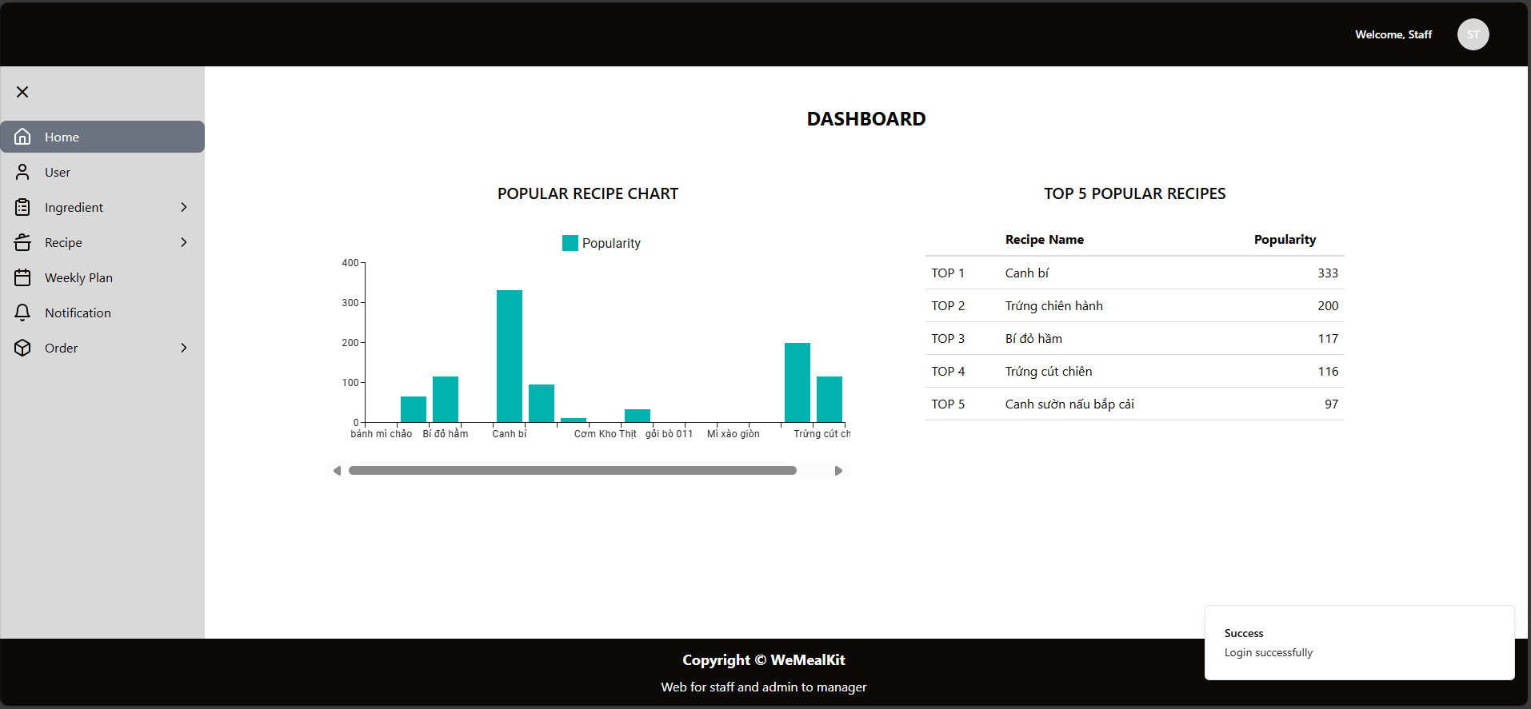

### 3.2. Workflow 2

***3.2.1 Account Management (for Admin)***

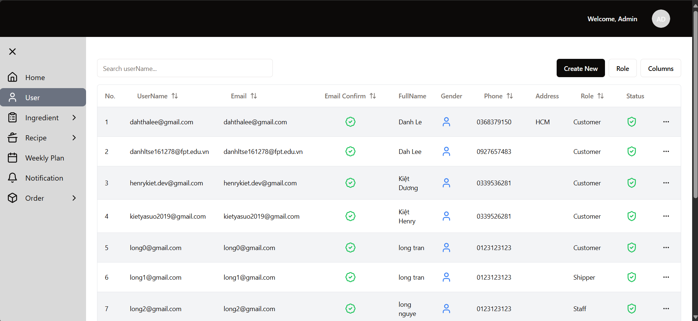

***3.2.2 Change account’s role (for Admin)***

1. Click button



to open Action Menu

1. Choose the role want to change

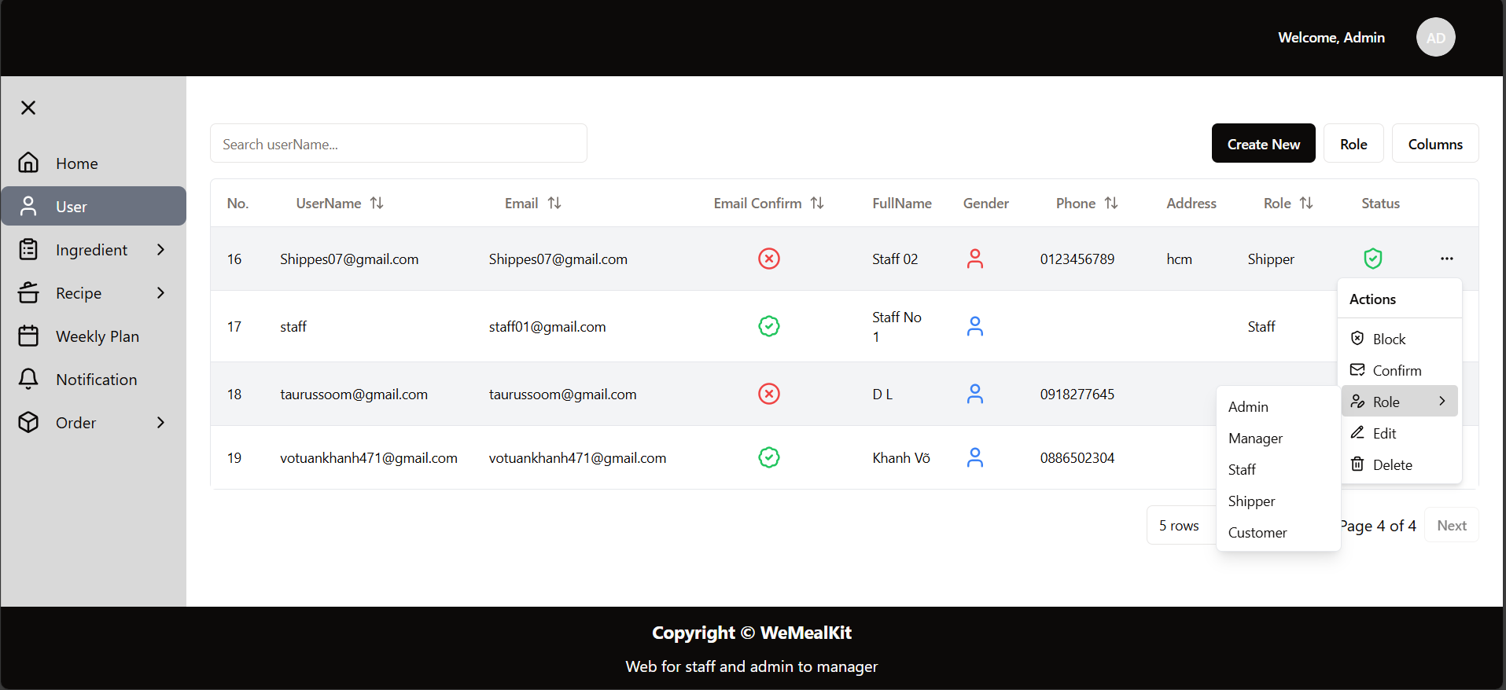

***3.2.3 Block user (for Admin)***

1. Click button



to open Action Menu

1. Choose Block

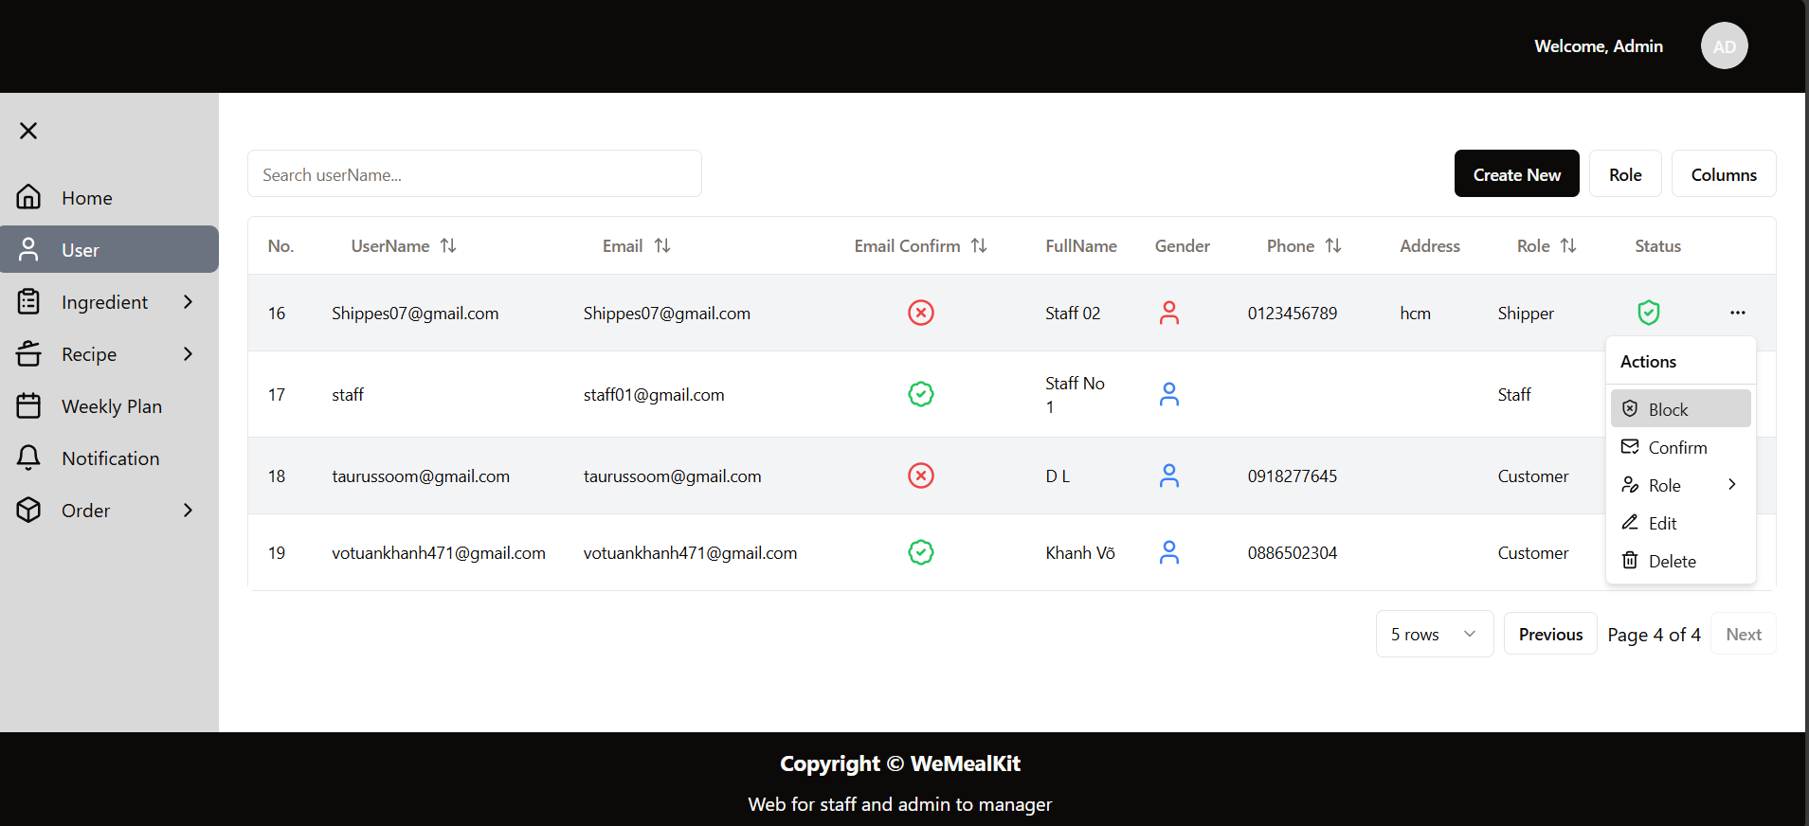

### 3.3. Workflow 3

***3.3.1. View list ingredients (for Admin, Manager, Staff)***

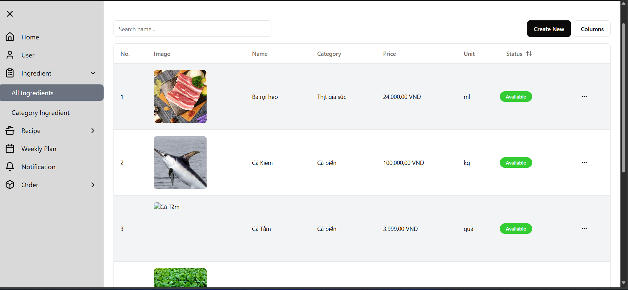

***3.3.2. Create new ingredient (for Staff)***

1. *Click button* ***Create New***
2. *The form for input* ***General Info*** *and* ***Nutrition Info*** *will display*

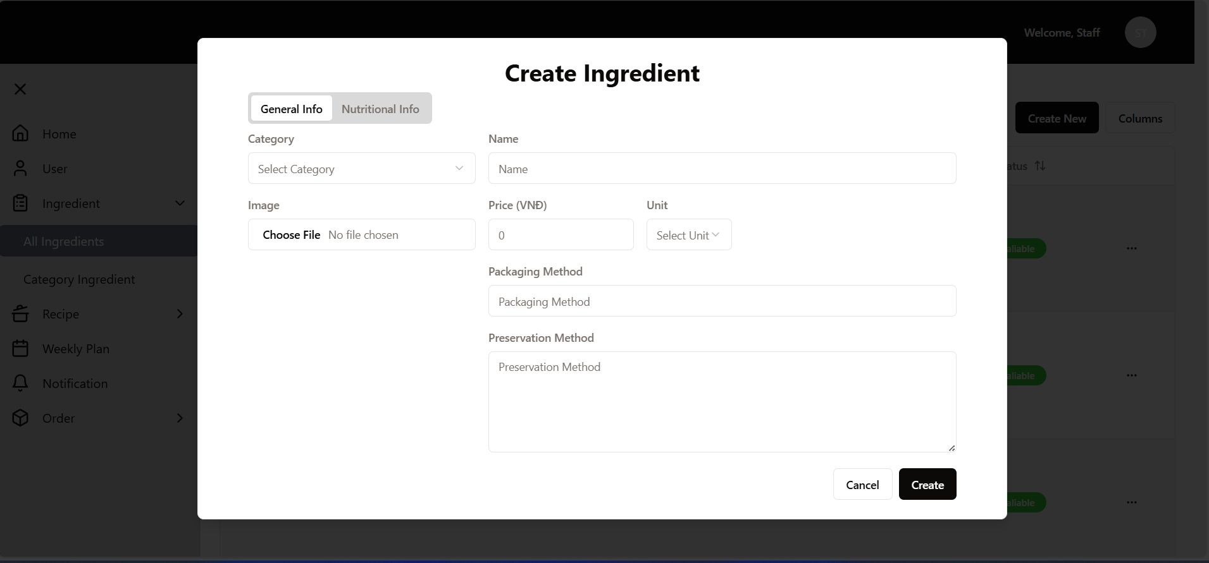

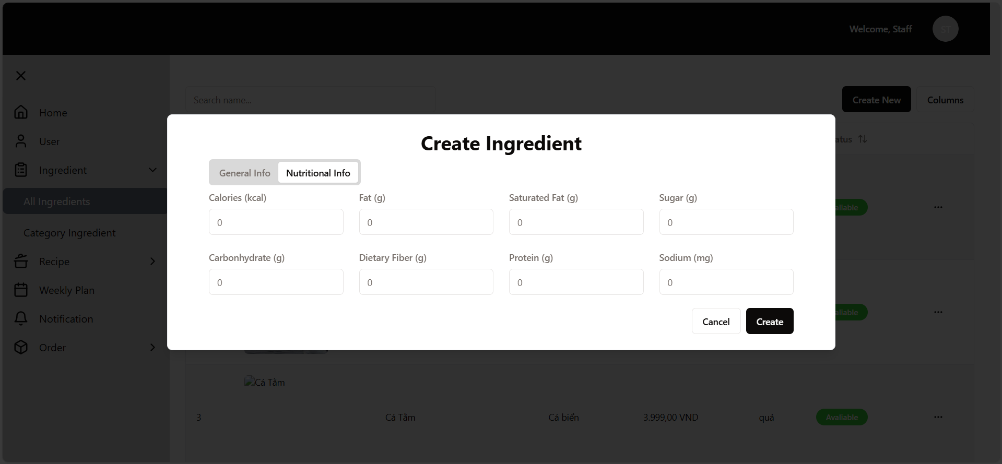

1. After input into fields, click button **Create** to complete create ingredient process

**3.3.3. View ingredient’s details (for Admin, Manager, Staff)**

1. Click button



1. The Action Menu will display

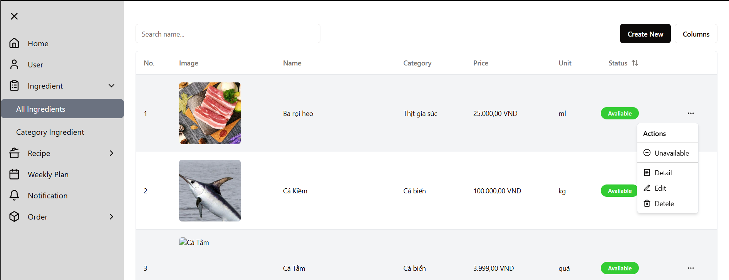

1. Choose **Details**
2. The ingredient’s info will be displayed

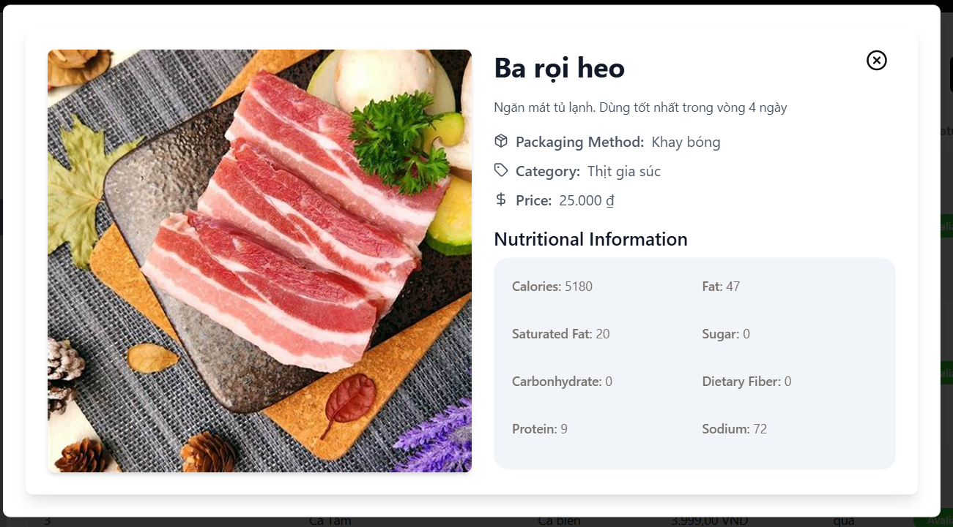

**3.3.4. Edit ingredient’s info (for Staff)**

1. Click button



1. The Action Menu will display



1. Choose **Edit**
2. The form for modify General Info and Nutrition Info will be displayed

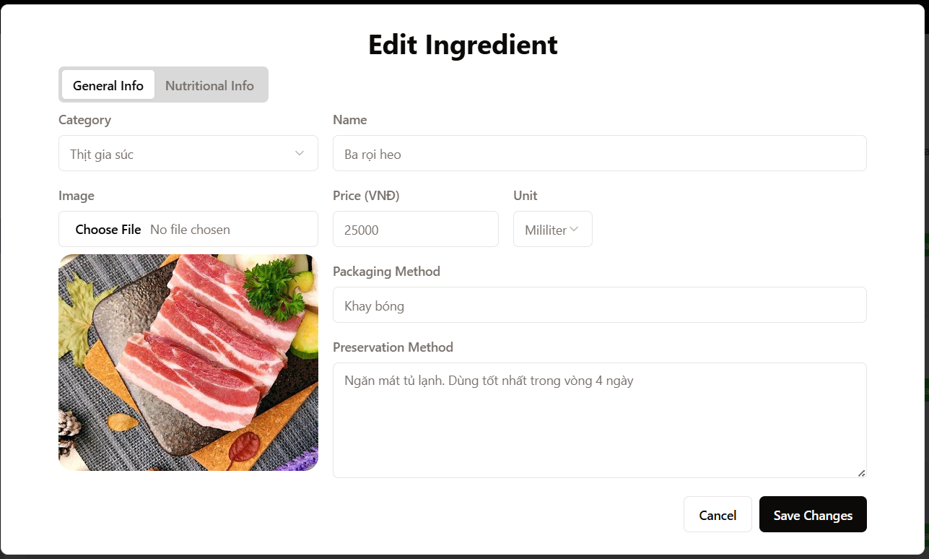

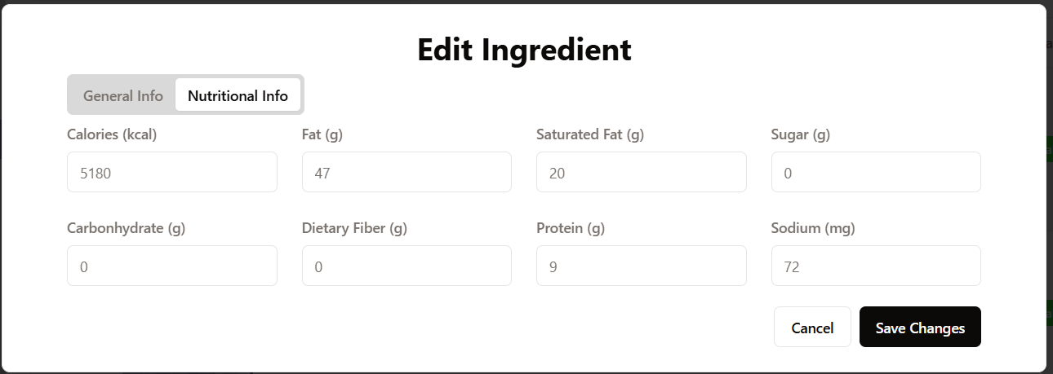

1. After complete modifying info, click **Save Changes** to complete

### 3.4. Workflow 4

***3.4.1. View list recipe (for Admin, Manager, Staff)***

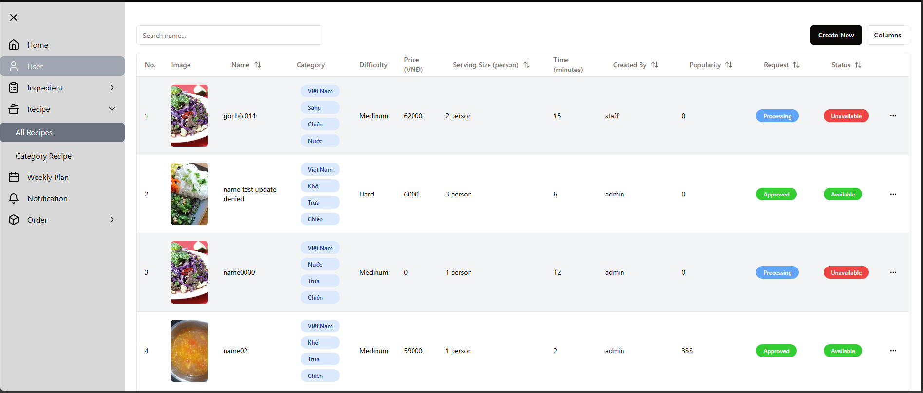

***3.4.2. Create new recipe (for Staff)***

1. Click the button **Create New.**
2. The form for input General Info, Ingredient Info, Step Info will be displayed.

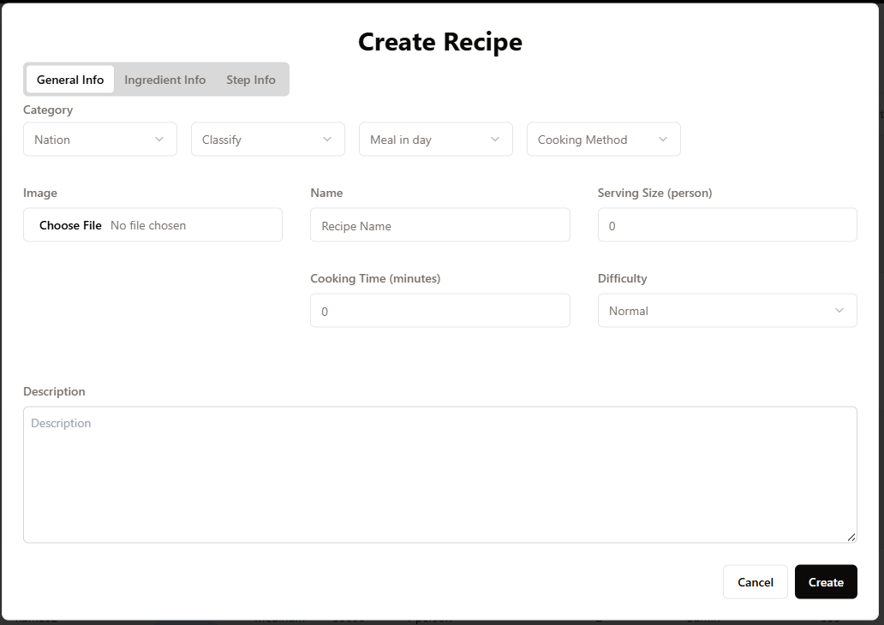

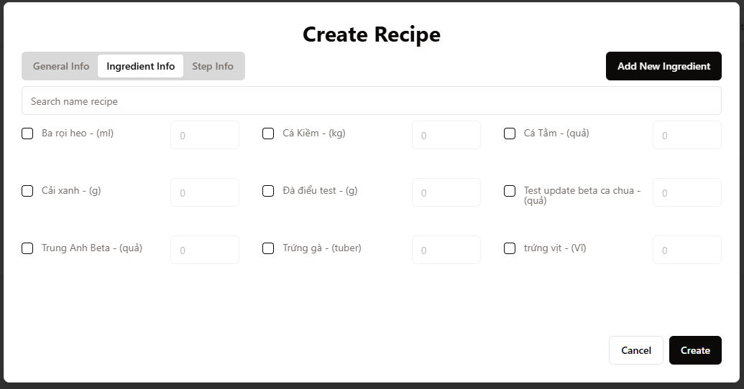

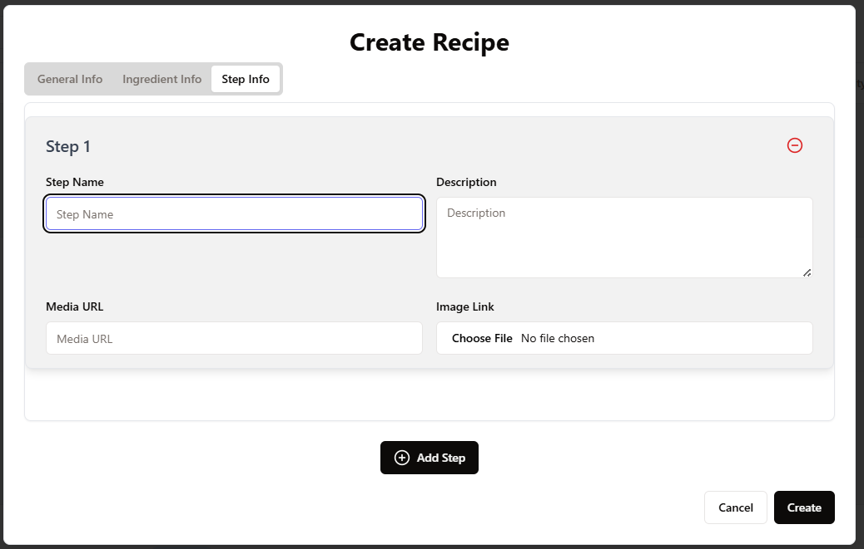

1. After complete input recipes info, click the **Create** button to complete.

***3.4.3. Edit recipe’s info (for Staff)***

1. Click button



to open **Action Menu**

1. Choose **Edit**

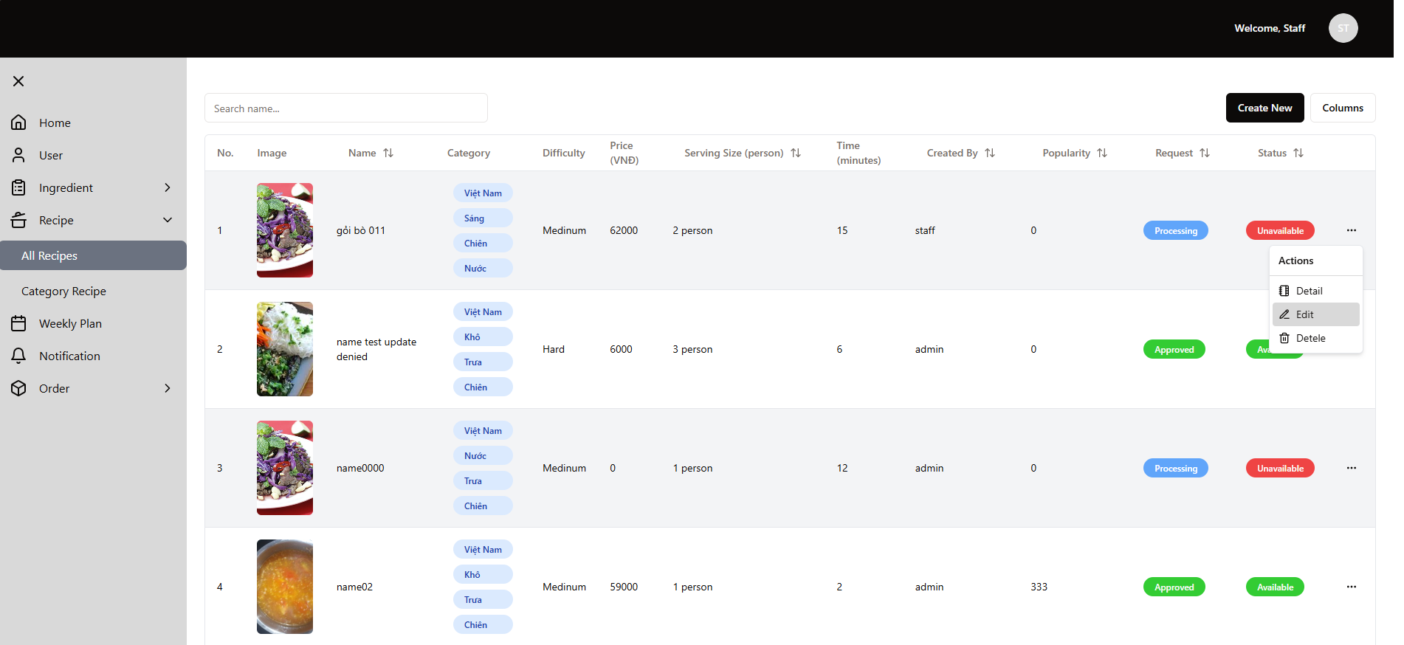

1. The form to modify recipe’s info will be displayed

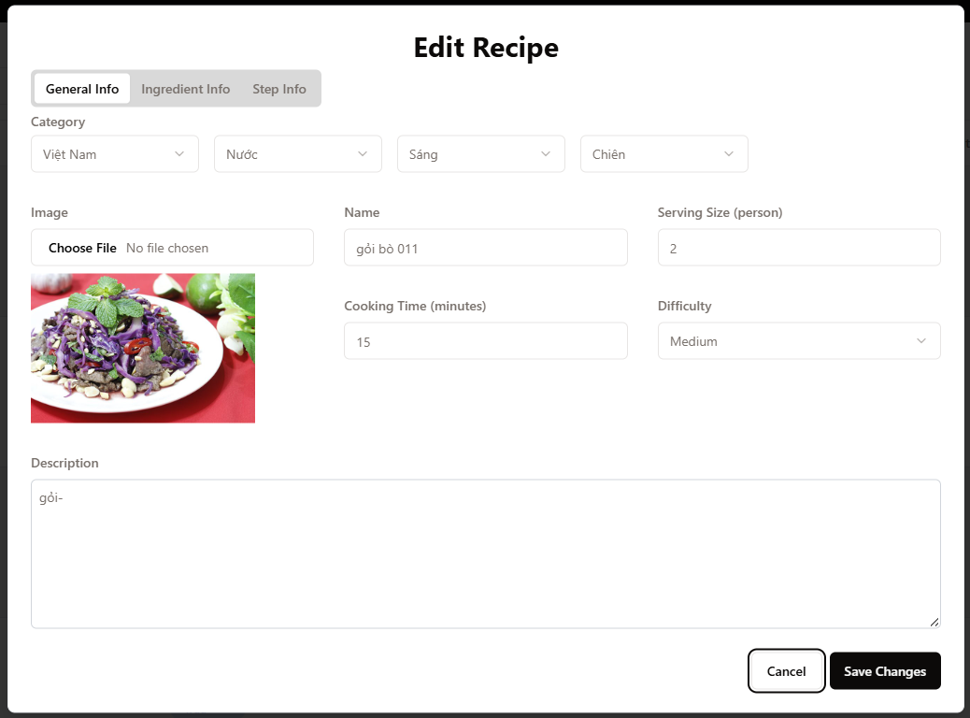

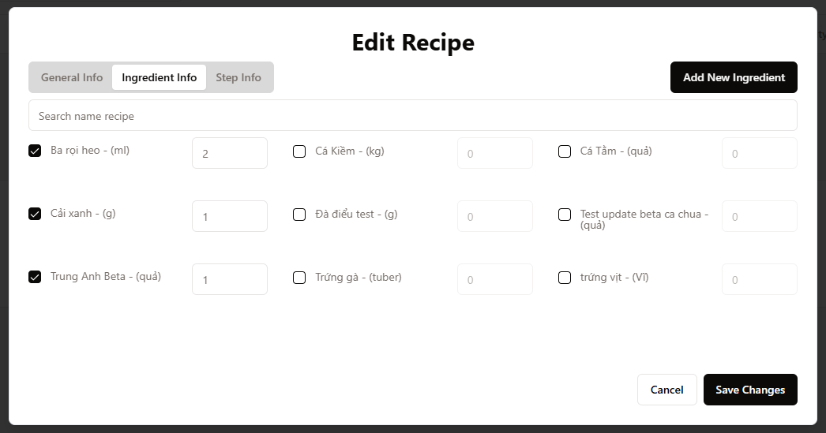

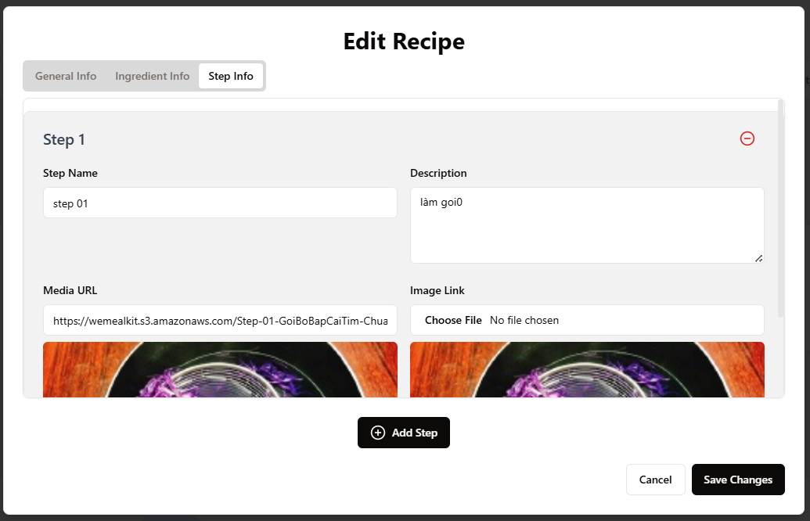

1. After modifying recipe’s info, click **Save Changes** button to complete.

***3.4.4. View recipe’s details (for Admin, Manager, Staff)***

1. Click button



to open Action Menu

1. Choose **Details**



1. The recipe’s info will be displayed

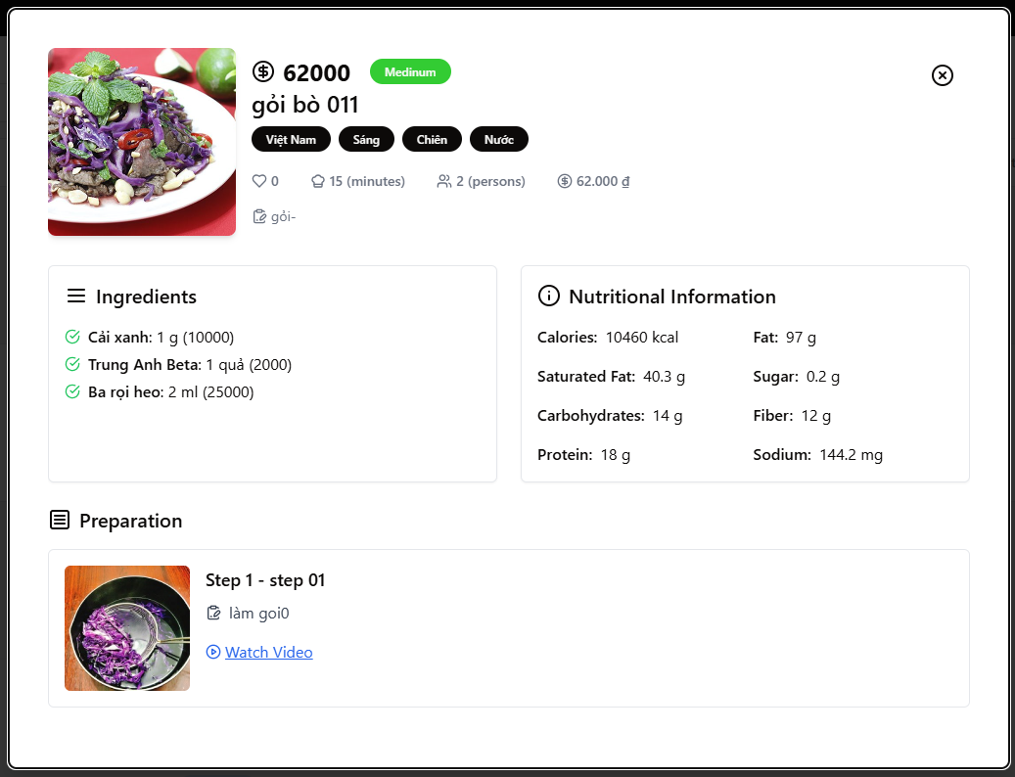

### 3.5. Workflow 5

***3.5.1. View list weekly plan (for Admin, Manager, Staff)***

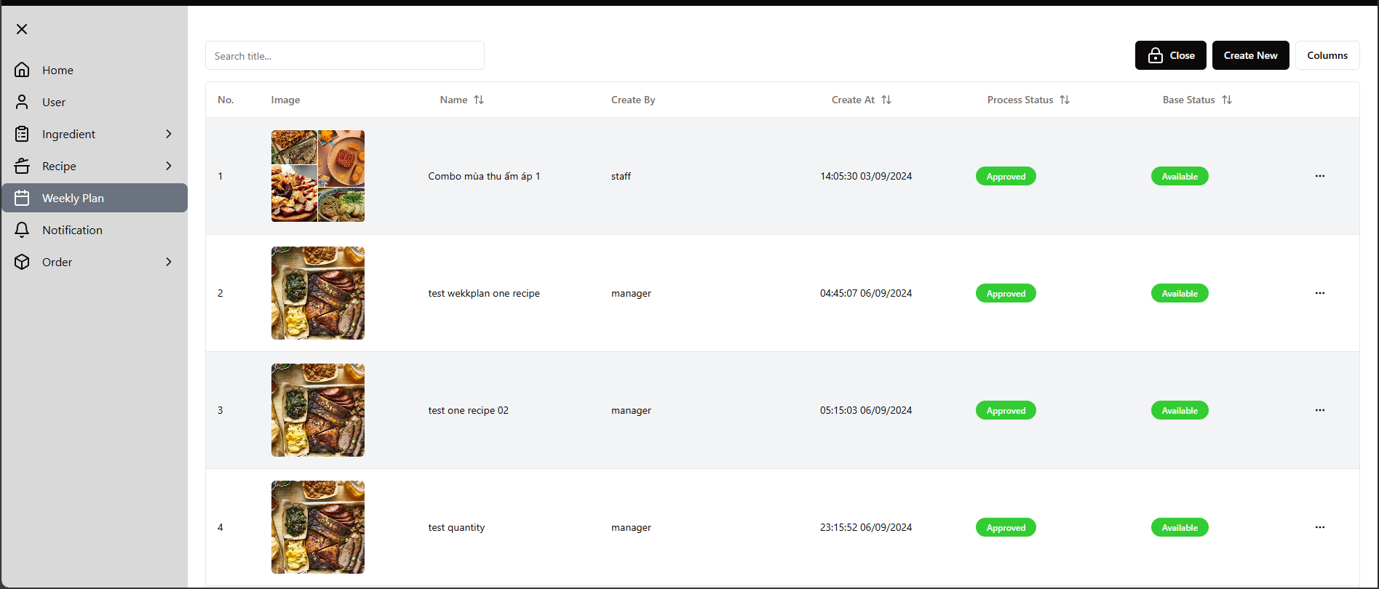

***3.5.2. Create a weekly plan (for Staff)***

1. Click button **Create New**
2. The dialog will be displayed with **General** and **Recipes** section to input info and add recipes

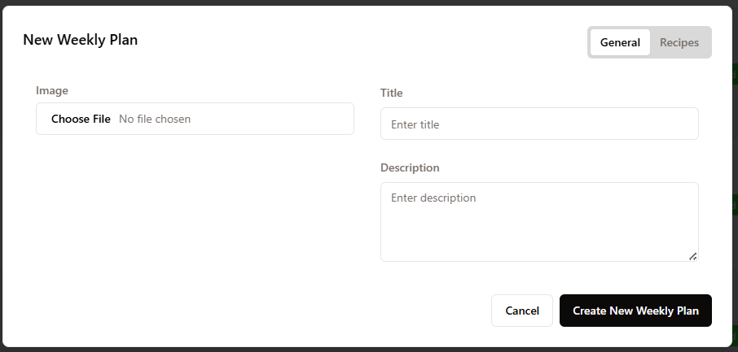

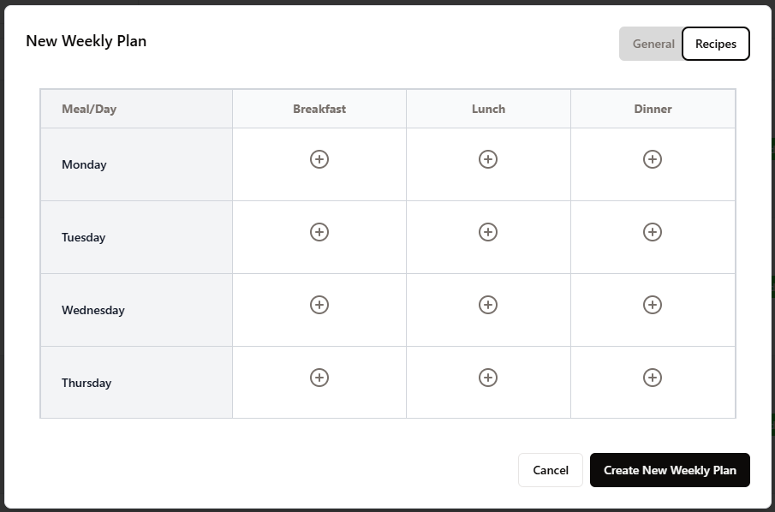

1. After finishing input info and adding the recipe to the weekly plan, click **Create New Weekly Plan** to complete.

3.5.3. Edit weekly plan (for Staff)

1. Click button



to open **Action Menu**

1. Choose **Edit**

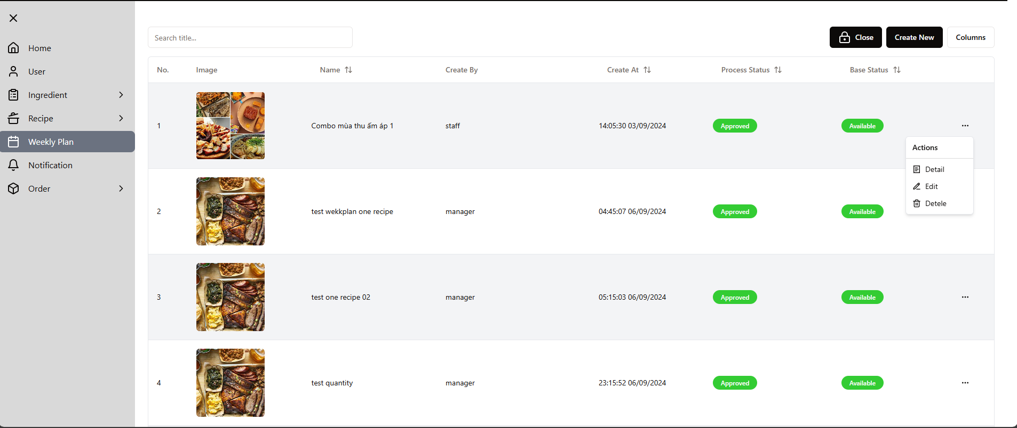

1. The form to modify weekly plan’s info will be displayed

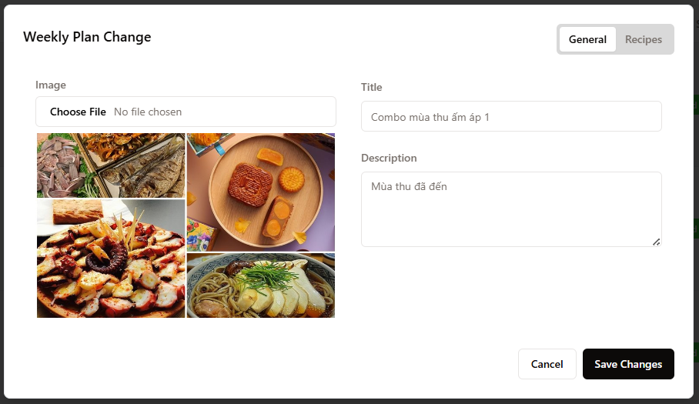

1. After finishing modifying the weekly plan’s info, click the **Save Changes** button to complete.

***3.5.4. View weekly plan’s details (for Admin, Manager, Staff)***

1. Click button



to open **Actions Menu**

1. Choose Details



1. The weekly plan’s info will be displayed

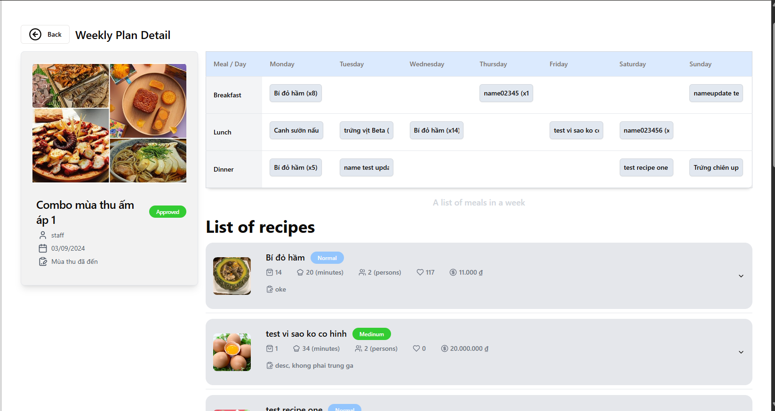

### 3.6. Workflow 6

***3.6.1. Approve/Deny recipe (for Manager)***

1. At **Notification** in the navigation menu, the list for Recipe and Weekly plan created by staff will be displayed.

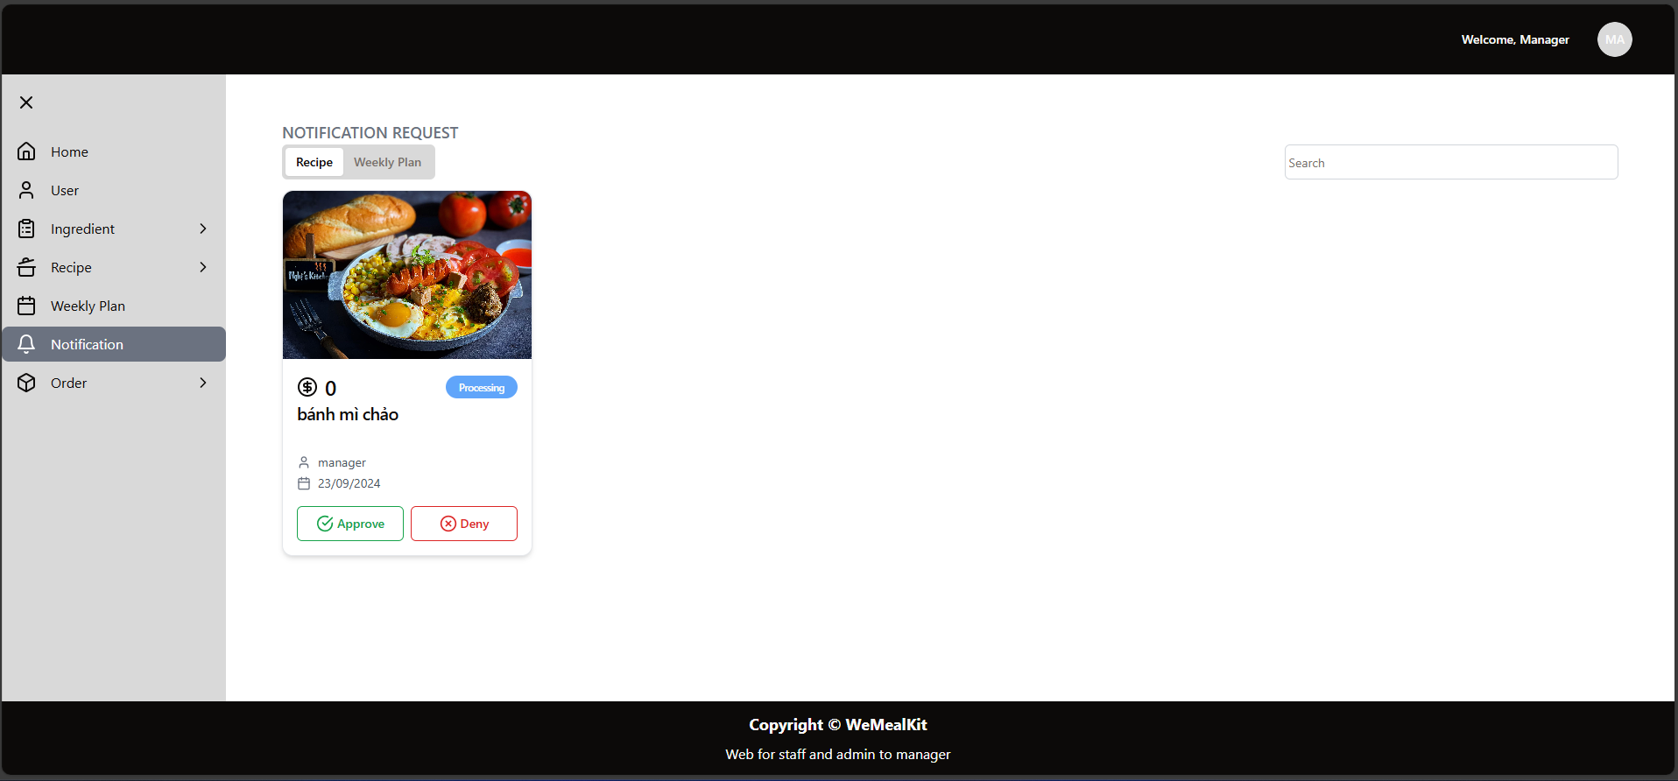

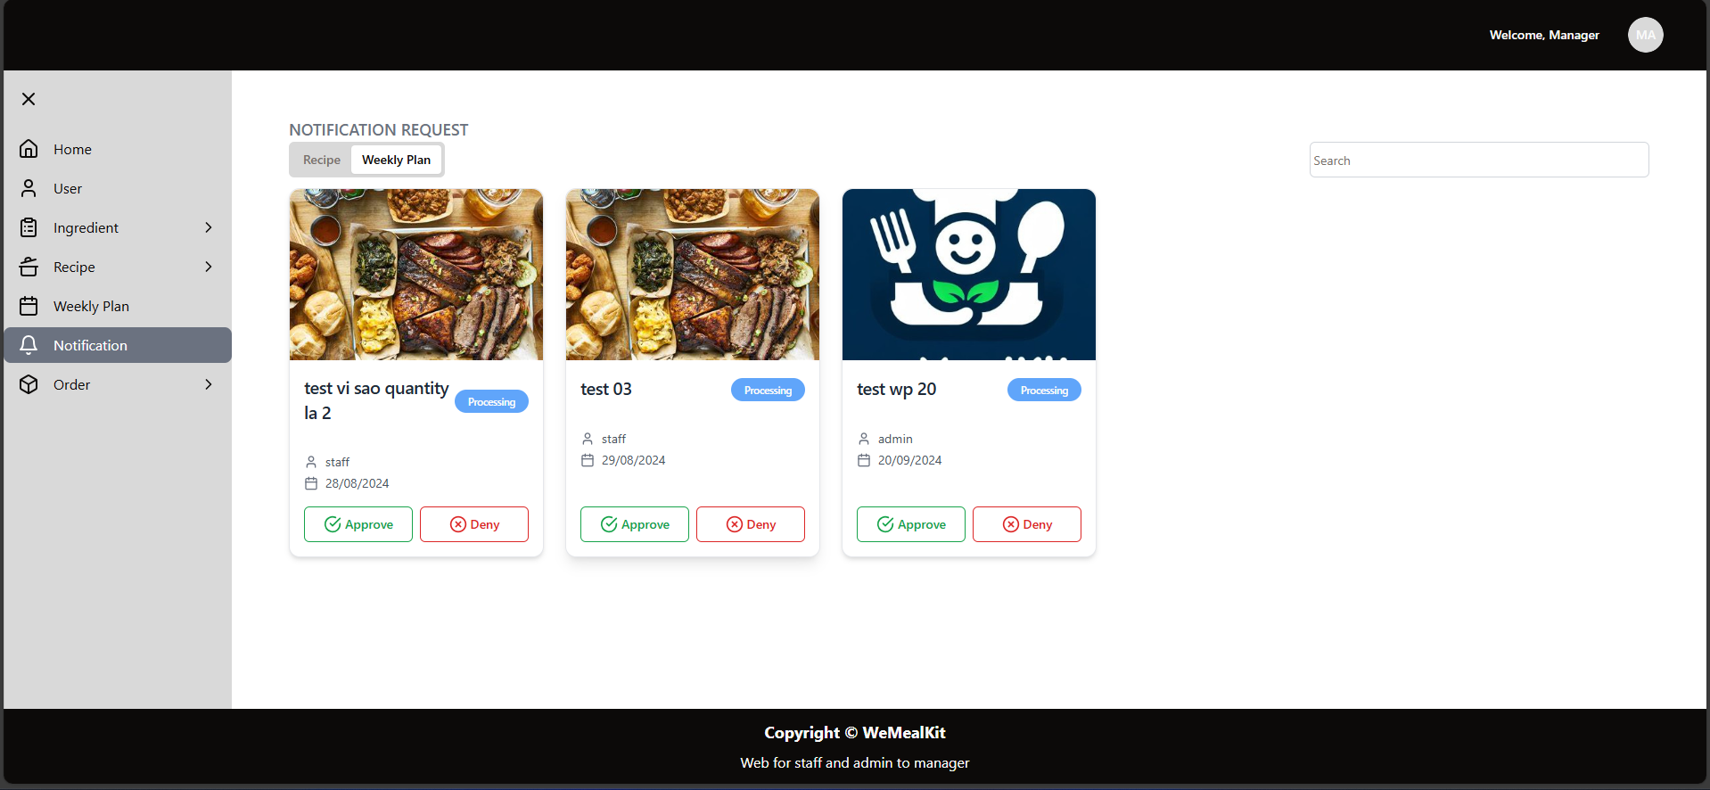

1. If click button **Approve**, the pop-up to confirm will be displayed, click **Save** to confirm.

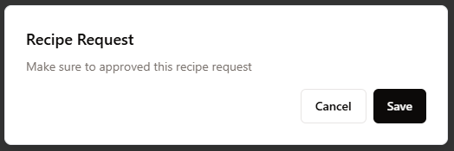

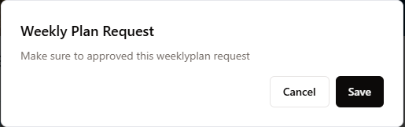

1. If click button **Deny**, the pop-up to input reason (Note) will be displayed, the click button **Save** to confirm.

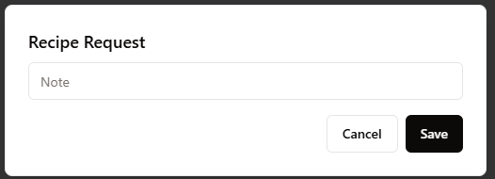

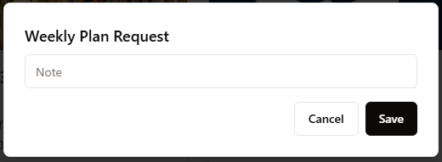

### 3.7. Workflow 7

**3.7.1. View list order (for Admin, Manager, Staff)**

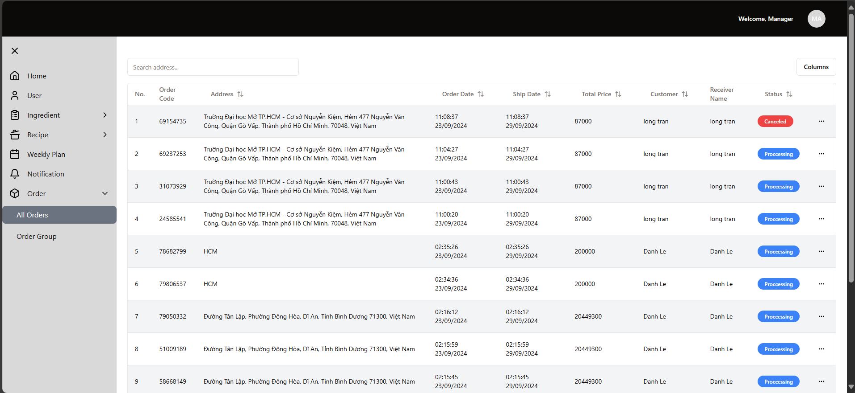

**3.7.2. View order’s details (for Admin, Manager, Staff)**

1. Click button



to open **Actions** menu

1. Choose **Detail**, then the dialog to display order’s details

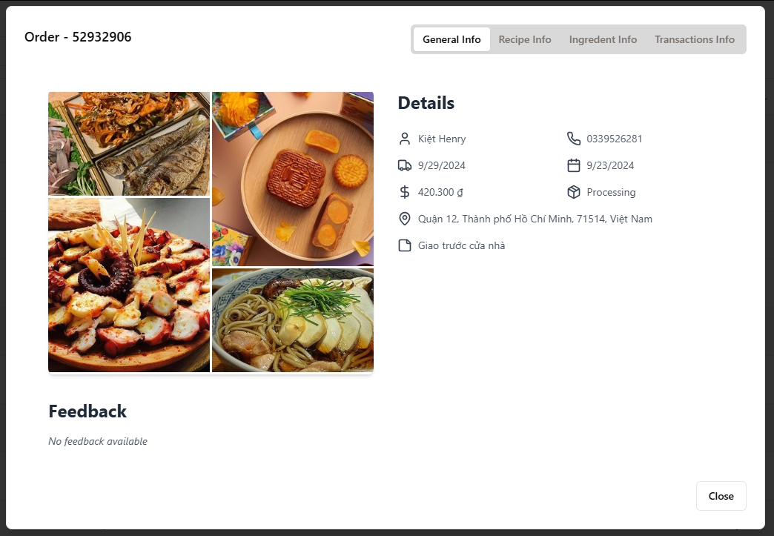

**3.8. Workflow 8**

**3.8.1. Change order’s status (for Manager)**

1. Click button



to open **Action** menu

1. Choose **Confirm** or **Cancelled** to change order’s status

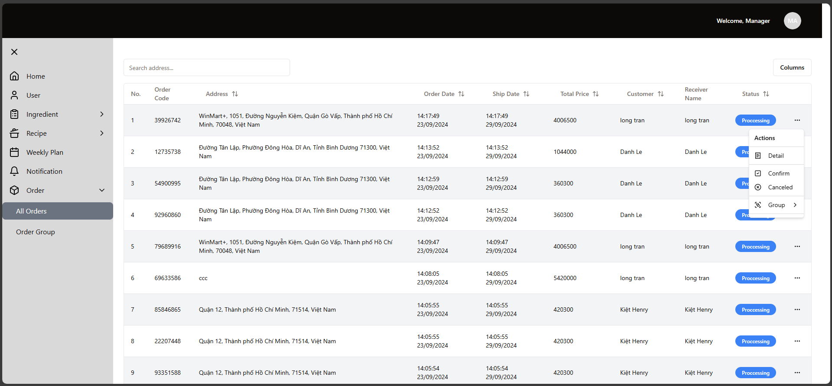

1. The pop-up will be displayed

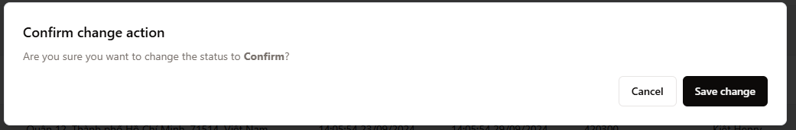

1. Click **Save changes** to confirm changes.

**3.8.2. Group orders (for Manager)**

1. Click button



to open **Actions** menu

1. Choose **Group** action, then choose location to group.

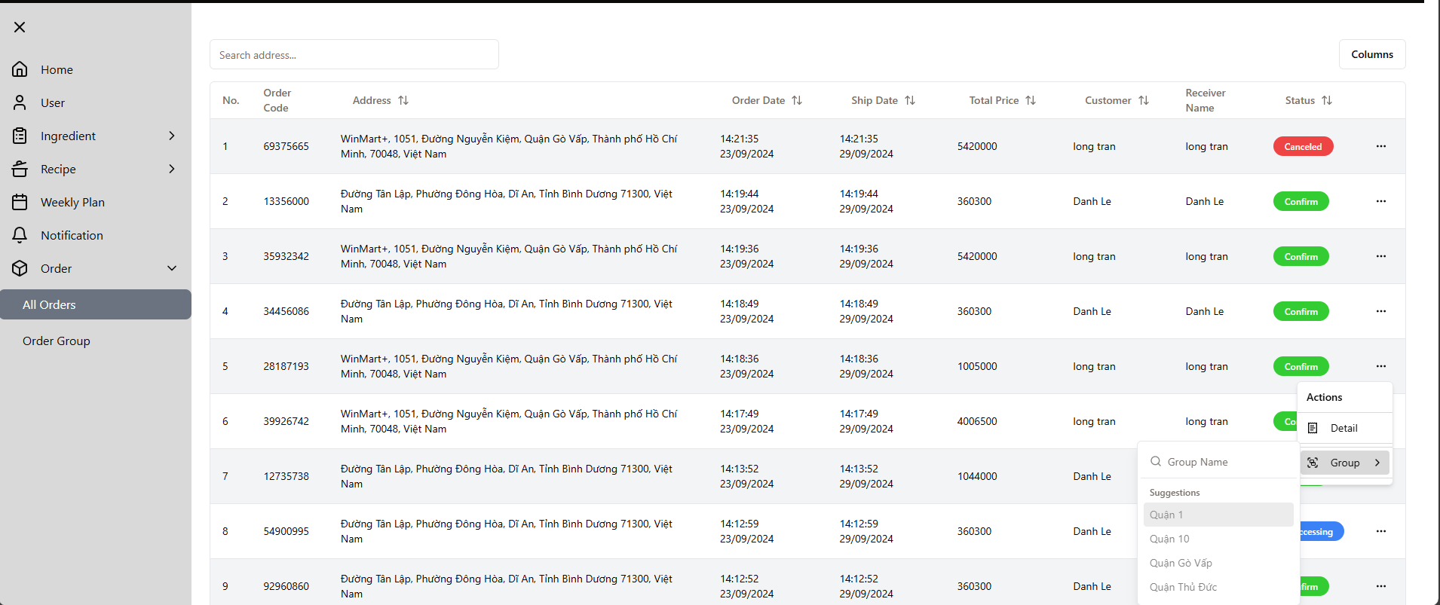

1. The order will be grouped by location for assign to shipper.

**3.8.3. View list order group (for Admin, Manager)**

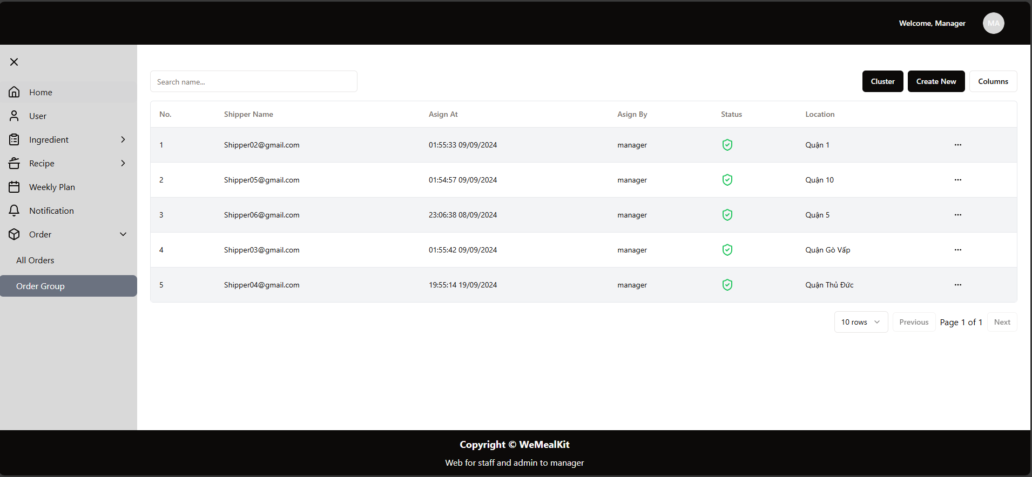

**3.8.4. View an order group’s details (for Admin, Manager)**

1. **Click button**



to open **Actions** menu

1. Choose **Details**

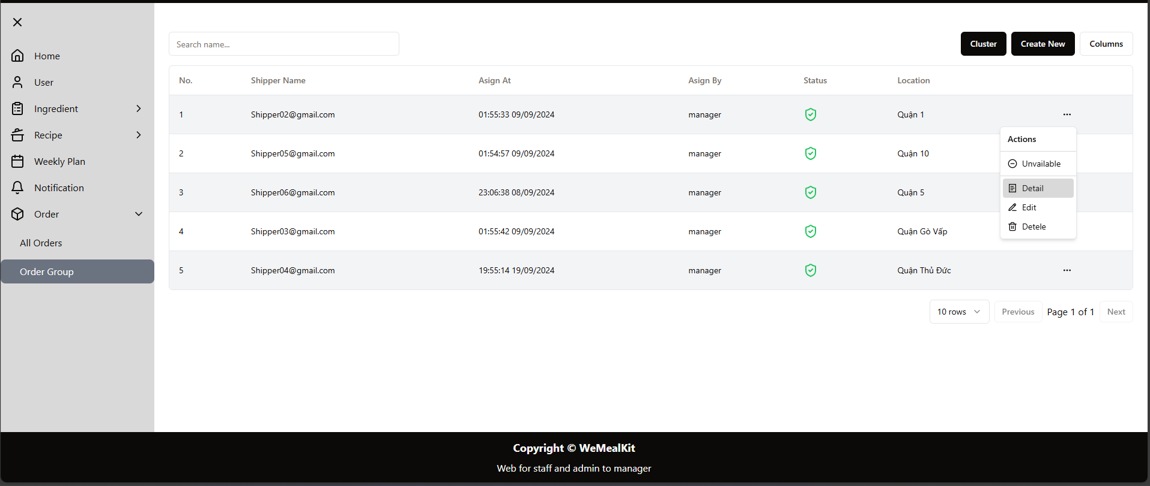

1. The pop-up will display details of order group

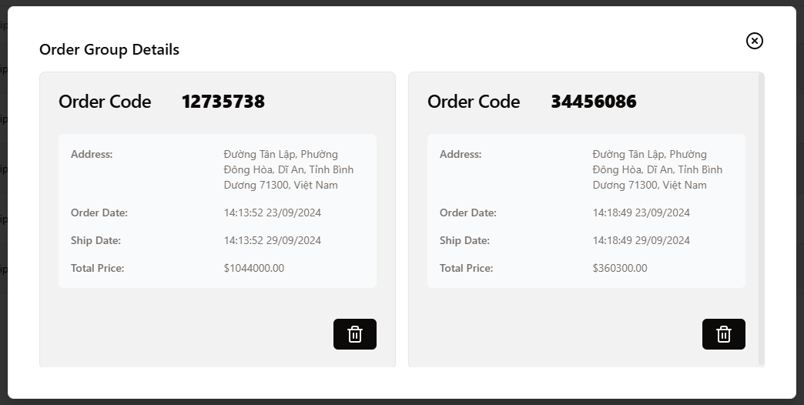

**3.8.5. Assign order to shipper by group (for Admin, Manager)**

1. Click **Cluster** button

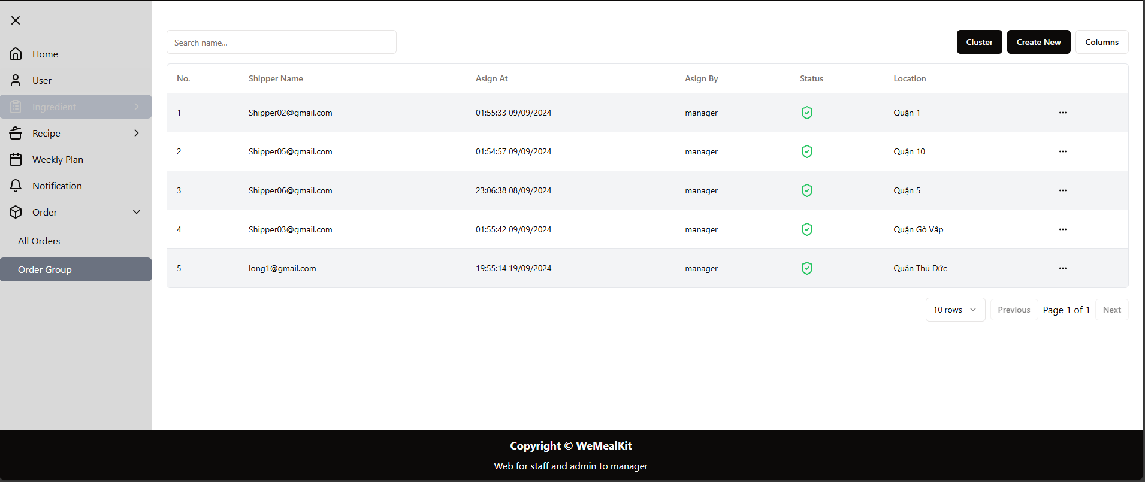

1. The pop-up to confirm will be displayed

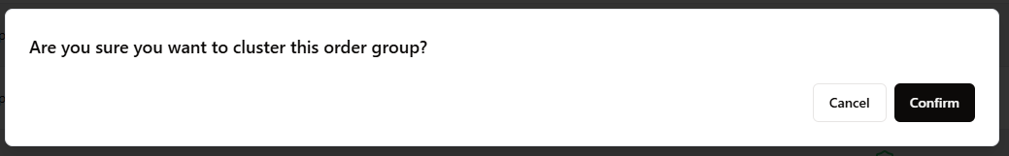

1. Click **Confirm** to assign the order group to shipper by location.
2. The successfully will be displayed

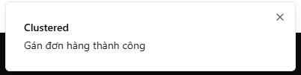

**3.8.6. Edit order group (for Admin, Manager)**

1. Click button



to open **Actions** menu

1. Choose **Edit**

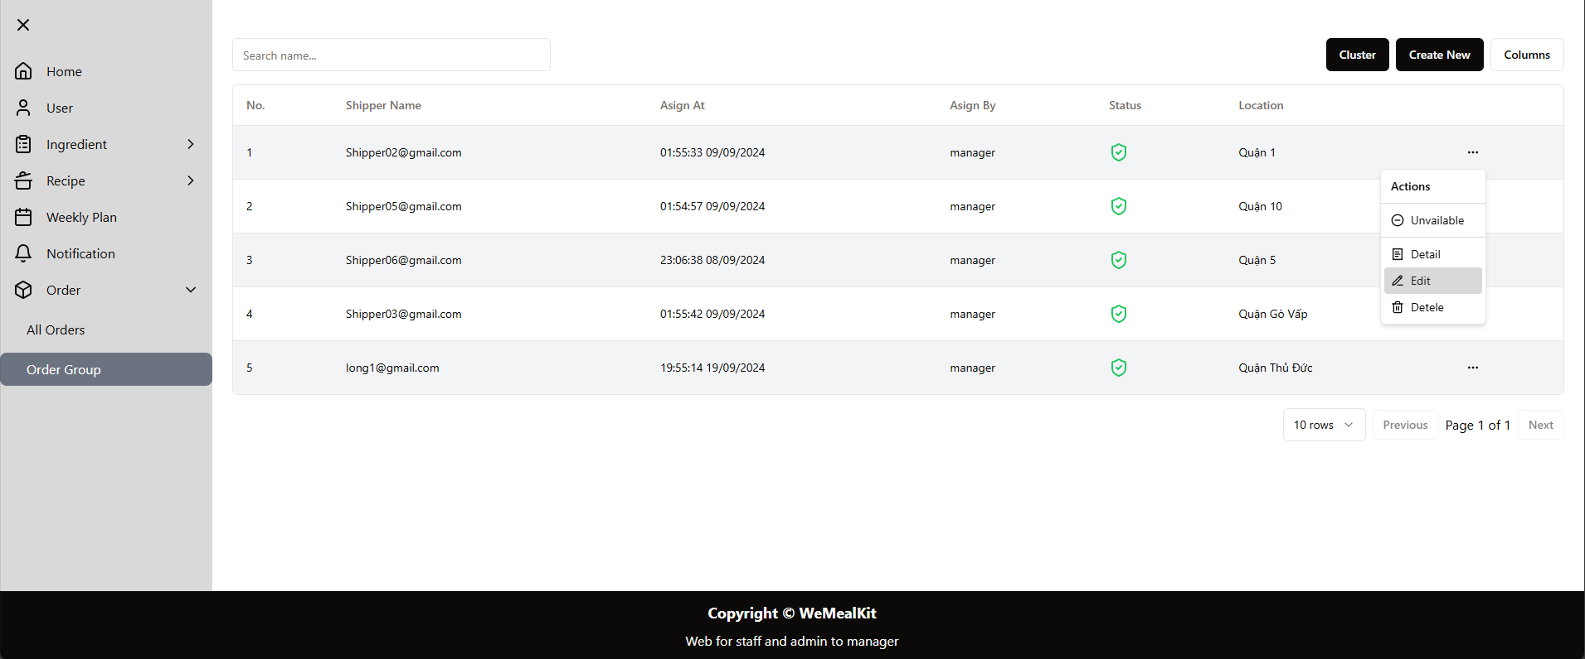

1. The dialog to modify order group by Shipper and Regional location

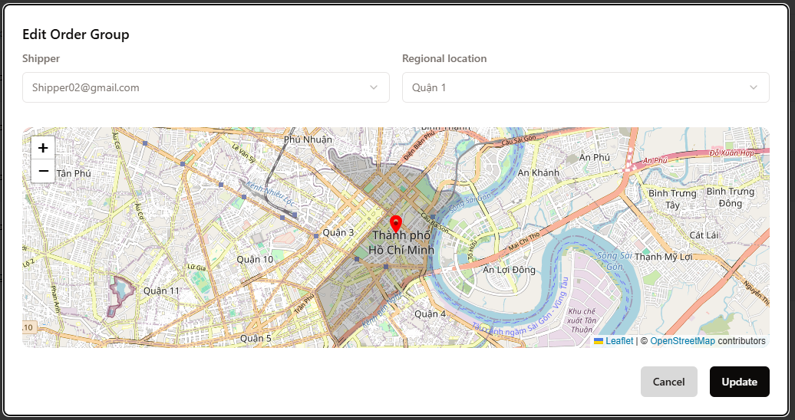

1. Click **Update** button to confirm modify
2. The success pop-up will be displayed after modify

